Benchmarking the Background Forecast in
Rapidly Updated Surface Temperature Analyses.

Part 1: Stations

Thomas M. Hamill

NOAA Earth System Research Lab, Physical Sciences Division
Boulder, Colorado 80305

Submitted to Monthly Weather Review

19 July 2019

Corresponding author information:

Dr. Thomas M. Hamill
NOAA Earth System Research Lab
Physical Sciences Division
R/PSD 1
325 Broadway
Boulder, Colorado 80305
e-mail: tom.hamill@noaa.gov
phone: +1 (303) 497-3060
fax: +1 (303) 497-6449

ABSTRACT

High-quality, high-resolution, hourly unbiased surface (2-m) temperature analyses are needed for many applications, including training and validation of statistical post-processing applications. These temperature analyses are often generated through data-assimilation procedures, whereby a background short-range gridded forecast is adjusted to newly available observations.

Despite frequent updates to newly available observations, surface-temperature analysis errors and biases can be comparatively large relative to errors and biases of mid-tropospheric variables, especially over land, despite more near-surface in-situ observations. Larger near-surface errors may have several causes, including biased background forecasts and the spatial heterogeneity of surface temperatures due to sub-grid scale surface, vegetation, land-use, and terrain variations. Are biased background forecasts the predominant cause of surface temperature analysis errors?

Part 1 of this two-part series describes a simple benchmark for evaluating the error characteristics of short-term (1-h) background surface temperature forecasts. For stations with a relatively complete time series of data, it is possible to generate an hourly, diurnally and seasonally dependent observation climatology at a station. The deviation of the current hour’s temperature observation with respect to this hour’s and Julian day’s climatology is added to the climatology for the next hour. For contiguous US stations in July 2015, the station benchmark was lower in error than interpolated 1-h high-resolution numerical predictions of surface temperature from NOAA’s High-Resolution Rapid Refresh (HRRR) system. For August 2018, 1-h HRRR forecasts were much improved when tested against the station benchmark.

1. Introduction.

Many weather and climate applications require high-quality hourly surface (2-m) real-time temperature analyses and retrospective analyses (reanalyses). For example, an accurate retrospective time series of surface temperature analyses on a high-resolution grid may be used to provide the analyzed training data for the statistical post-processing of surface temperature forecasts, such as in Flowerdew (2014). Other applications include the diagnosis of climate and weather variations and trends, the validation of surface-temperature forecasts from numerical weather prediction guidance, and situational awareness of current conditions. Users seek analyses with low error and bias as well as realistic spatial and temporal detail, including smaller diurnal temperature ranges near water bodies and elevation-dependent and terrain slope-dependent temperature variability in mountainous regions. If the analyses are biased, have large errors, or insufficient spatial and temporal detail, they may be unsuitable for these applications.
How accurate and unbiased are the current hourly surface temperature analyses? Many are generated with data assimilation algorithms, whereby a first-guess “background” forecast is adjusted to newly available observations, as in de Pondeca et al. (2011). Data-assimilation algorithms commonly are formulated under the assumption that the background forecasts are unbiased (e.g. Daley 1991, chapter 4). This assumption should be checked rather than taken as a given. For example, significant systematic analysis increments (analysis minus background) were identified in the NOAA High-Resolution Rapid Refresh (HRRR; Benjamin et al. 2016) short-range surface temperature forecasts during July 2015. The HRRR is a fully non-hydrostatic forecast modeling system that utilizes a modern land-surface model (LSM) for estimating surface-energy fluxes and diagnosing surface temperature. Time-averaged analysis increments (analysis minus forecast) for 00 UTC during July 2015 and 00 UTC during August 2018 are shown in Figs. 1(a) and (b) respectively. Warm biases are evident in much of the eastern and central US during July 2015. Biases were substantially reduced in August 2018, perhaps due in part to the introduction of a procedure for making adjustments to the soil state based on surface observations (Benjamin et al. 2016, section 2g). Of course, biased surface-temperature background forecasts and hence biased analyses are not unique to the HRRR system; they can be observed in many data assimilation systems.
What causes systematic errors in short-term predictions of 2-meter temperatures? If there are systematic errors in ground-heat flux or the soil-water budget, perhaps due to a mis-estimation of precipitation, soil moisture, or soil texture or a deficiency in the land-surface model, these may accumulate in the absence of a corrective soil-state data assimilation procedure. The biased soil temperature states may in turn result in biased estimates of fluxes of thermal energy and moisture between the ground and the air above it, affecting surface temperature. There may also be prediction system issues that are traced back to model deficiencies above the ground surface. Perhaps surface downward solar radiation is systematically mis-estimated due to an inappropriate forecast of cloud cover and optical depth, or perhaps there are systematic errors in the surface-layer or boundary-layer physical parameterizations that result in mis-estimations of vertical mixing.
Could bias in the background state be removed prior to the assimilation step? Conceptually, yes, there is literature that discusses the problem and possible approaches (e.g., Dee and Da Silva 1998; Dee 2005, Baek et al. 2006, Lei and Hacker 2015, Lorente-Plazas and Hacker, 2017). However, removing background bias is especially challenging for surface temperature given its spatial heterogeneity. Whereas one might pool samples of, say, stratospheric temperatures across many locations to increase the sample size for bias estimation, this may be counterproductive with surface temperatures.
It would be helpful to understand whether background surface-temperature biases in rapidly updated surface data assimilations are a minor nuisance or a major problem. Best et al. (2015, hereafter B15) discussed the use of benchmarks to provide baseline performance expectations for a system; the benchmark might be a previous model version or a simple statistical model. In B15, the hypothesis was that sophisticated land-surface models would be able to provide more accurate forecasts of sensible and latent heat fluxes when compared to simple statistical-model benchmarks. Fluxes were benchmarked at a range of sites with high-quality observed data (e.g., time series of surface temperature and humidity, insolation, and soil temperature and moisture). The hypothesis was not confirmed; surface sensible and latent-heat flux estimates from LSMs were generally less accurate than a statistical benchmark based on 3 simple predictors, the surface temperature, relative humidity, and downward solar-radiation at the surface. As surface temperature is strongly related to the partitioning of fluxes at the earth’s surface, this motivated the development of a simple statistical benchmark of surface temperature to compare against one-hour forecasts from a sophisticated prediction system. Given the results of B15, the hypothesis to be tested that a station-based statistical one-hour forecast of surface temperature, hereafter called the “station benchmark” will provide a challenging reference standard for short-range surface temperature forecast from a high-resolution numerical model.
This article is inspired by B15 and the first of a two-part series. This first part discusses the development of the station benchmark for CONUS surface temperature. The article intends both to further demonstrate the relevance of benchmarking and to demonstrate the substantial challenges in developing numerical weather prediction capable of ameliorating short-term forecast bias. As an ancillary research result, the article will demonstrate the utility of a careful definition of a diurnally dependent climatology.
Admittedly, the evaluation of gridded model guidance relative to a station benchmark may be misleading. The observation site for a station benchmark may reflect conditions unique to that particular location rather than the surrounding grid-box mean that the prediction system represents. Still, if a station benchmark does not set a competitive standard for the model guidance, then one would not expect a statistically generated and rigorously cross-validated gridded benchmark to be competitive with model guidance. As we will see, the station benchmark does provide a competitive reference standard, which motivates further development of the gridded benchmark discussed in the second part of this series, Hamill and Scheuerer (2019).
The remainder of this first article is organized as follows. Section 2 describes the data used in this experiment and the methods for evaluation of the forecast and station benchmark. Section 3 describes the numerical procedure used to generate the station benchmark. Section 4 provides results, and section 5 provides a discussion and conclusions.

2. Data and evaluation methods used in this experiment.

The observation data set used in this experiment was the National Center for Atmospheric Research (NCAR) data set 472.0, an archive of quality-controlled hourly surface observations over North America. Data were originally synthesized and quality controlled at the US National Weather Service Meteorological Development Lab. These data are available at https://rda.ucar.edu/datasets/ds472.0/ . Surface temperatures were used for the period 00 UTC 1 Jan 2004 to 23 UTC 28 Feb 2019. The author chose to further limit use of surface temperatures in this data set to only those observation sites where data was available at 97 percent or more of the hours, days, and years in the analysis period. This observation availability cutoff was made based on the importance of an accurate estimation of the climatology to this procedure. With this availability criterion, 1118 station locations were available in the area of study, the CONUS.
When comparing the benchmarking procedure against numerical forecasts, for the July 2015 data, 1-h forecasts of background surface temperatures were extracted from version 1 of the operational High Resolution Rapid Refresh (HRRR) limited-area prediction system described in Benjamin et al. (2016). The forecast value at the ~3 km² grid point nearest the station was used. For the 2018 data, the operational version 3 HRRR predictions were extracted. The HRRR system generates hourly analyses and numerical forecast guidance to +15 h lead time. It is used for many applications in the NWS, including severe weather prediction, short-term precipitation prediction, and aviation applications. The underlying prediction system is the Weather Research and Forecast (WRF) Advanced Research WRF (ARW), with a 3D-ensemble-variational data assimilation system. See Benjamin et al. (2016) for more details. Comparative validation of station benchmark and HRRR forecasts were limited to July 2015 and Aug 2018, a limitation of this study.
Experimental July 2015 HRRR forecasts were sometimes unavailable; in particular, 1-h forecasts initialized on the dates (year/month/day/UTC hour) 2015070115, 2015070210, 2015070305, 2015070314, 2015070514, 2015070612, 2015070621, 2015070808, 2015071003, 2015071108, 2015071116, 2015071814, 2015071821, 2015072213, 2015072311, 2015072613, and 2015072821. This represents 17 of the 744 analysis times, or approximately 2.3 percent. The validation of both the HRRR and the station benchmark did not include these data. No data were missing in 2018.
Standard methods of evaluation of deterministic forecasts were used, including root-mean-square error (RMSE), mean absolute error (MAE), and bias, all following standard definitions in Wilks (2011). 5th and 95th percentile confidence intervals of a distribution consistent with the null hypothesis of no differences are provided on the comparative plot of errors from the two systems, recentered on the benchmark forecast errors. The confidence intervals were determined through a paired block bootstrap algorithm following Hamill (1999), assuming error statistics were independent from one day to the next (ibid).

3. Methods used in the generation of the statistical benchmark.

a. Generation of a diurnally and seasonally dependent temperature climatology at stations.

In order to determine a current hour’s deviation from climatology at a particular station, an accurate estimate of that climatology is needed. In this application, the climatology was estimated to be a function of the hour of the day (which permitted diurnal dependence) and of the Julian day of the year (which permitted seasonal dependence). With such estimates, it was straightforward to generate the station benchmark for 1-h dynamical surface-temperature forecasts; the current hour’s observed anomaly with respect to that hour’s climatology was determined. This anomaly was added to the next hour’s climatology to generate the 1-h station benchmark.
Figures 2 and 3 illustrate the procedure for generating the seasonally and diurnally dependent temperature climatology for a particular station, in this case the airport at Albany, NY, USA (KALB). Figure 2 shows the 00 UTC observations at KALB (dots) as a function of the Julian day of the year. Plotted over the top of these is a cubic-spline fit estimate (Press et al. 1992, section 3.3) of the mean temperature as a function of the Julian day. To generate this curve, data were repeated below Julian day 1 and after Julian day 365, and the cubic-spline procedure was applied using eight knots equally spaced through the calendar year. The choice of eight knots was based on trial and error for what appeared to provide a reasonable, smooth fit to the data. Figure 3 next shows the cubic-spline fitted yearly climatologies at KALB every third hour over the diurnal cycle. The diurnal temperature range was smallest in the boreal mid-winter and largest in mid summer. Minimum temperatures were most commonly closer to 12 UTC in mid-winter, but with the earlier sunrise were nearer to 09 UTC during the summer. These climatologies were generated for each of the 1118 CONUS stations and for every hour of the day, cross validated, so that when a data analysis was performed for 2004, the climatology was defined with the 2005-2019 data. Possible systematic changes in climate from anthropogenic global warming were not considered in the definition of the climatology.
With the climatology defined, it was straightforward to evaluate the potential validity of this persistence of the deviation from climatology as a station benchmark. Figure 4 provides scatterplots of this station temperature anomaly relative to the temperature anomaly in the previous hour for eight chosen hours through the diurnal cycle, again for July at KALB. There were uniformly large 1-h lag Pearson correlations of the anomalies at all hours, modest RMS differences on the order of 1°C and an evident lack of bias. The procedure for generating the station benchmark appears to be rigorous across the diurnal cycle for this station. Though not shown, these general characteristics were confirmed when the analysis was repeated at other stations and other times of the year.
Figure 5 illustrates both the procedure for generating these deviations from climatology. Panel (a) shows both the hourly and Julian-day dependent climatology (thick blue line) and the hourly time series of observations (red line) for 1 to 15 July 2015. The observed deviations from the climatology are plotted in panel (b). Deviations exhibited a modest autocorrelation, which may be due to synoptic-scale variability on a time scale of a week and the persistence from one hour to the next of environmental conditions that affect surface temperature such as cloudiness or soil-moisture and soil-temperature anomalies.
Given the autocorrelations, a more complicated benchmark was developed with linear-regression corrections to the persistence of the anomaly. Predictors included the relative humidity and temperature trends above the surface from a forecast model. This further decreased the error of the station benchmark by approximately 5 - 10 percent. However, this more complicated model was not used as a benchmark -- the focus hereafter is on the simplest of procedures, direct persistence of the anomaly from climatology.

b. Verification of the benchmark for 2004-2019.

Before comparing the benchmark to the HRRR data, a figure is provided to illustrate that the benchmark has modest error and bias when validated at many different stations in different climatological regimes and when validated over yearly and diurnal cycles. Figure 6 shows that CONUS-averaged benchmark RMSE, MAE, and bias were all modest over the yearly and diurnal cycles. Errors tended to be largest during the time of maximum heating, which was later in the day during the wintertime. It is during the period of maximum heating when the accuracy of the partitioning of the downward solar and thermal energy into surface sensible heating, latent heating, and ground heat flux has the most consequence. If the partitioning is mis-estimated, perhaps due to errors in the analysis of soil moisture or the forecast of cloud cover, then the rate of warming will in turn be mis-estimated. Another characteristic shown in Fig. 6(c) is that the bias is consistently near zero for all months and for all hours across the diurnal cycle.

c. Verification of HRRR 1-h surface temperature forecasts against the benchmark.

Figure 7 synthesizes the comparative verification of the HRRR forecasts against the station benchmark during July 2015 (panels a, c, and e) and August 2018 (panels b, d, and f). During July 2015, the station benchmark was statistically significantly lower in RMSE and MAE, roughly slightly less than a factor of two over the diurnal cycle. The station-based benchmark was unbiased, while the HRRR system was commonly too warm during the daytime hours. This result was consistent with the averaged analysis increments from cycled data assimilation previously shown in Fig. 1. August 2018 benchmark errors were very similar to July 2015 benchmark errors, but the August 2018 HRRR errors were notably reduced relative to the July 2015 values.
Figure 8 provides a plot of RMSE errors at each station location. Again, note that the Aug 2018 HRRR RMSEs (panel b) were notably reduced relative to those in July 2015 (panel a). The July 2015 HRRR errors were largest in the upper Great Plains and at selected locations in the mountainous western US. Panels c and d of Fig. 8 provide the respective maps of station benchmark RMSEs, which are generally uniformly low, though with a few scattered points in the Rocky Mountains with higher errors.
Figure 9 presents spatial maps of HRRR and station benchmark biases for the two summer months. While the station benchmark biases are generally lower, the HRRR bias is markedly reduced in August 2018 relative to its July 2015 values. Note that the pattern of July 2015 HRRR bias strongly resembles the time-mean analysis increment shown in Fig. 1(a). Finally, Fig. 10 provides a scatterplot of the station benchmark RMSE (panel a) and bias (panel c) against the HRRR at 00 UTC in July 2015 and in August 2018 (panels b and d). Again, the majority of station benchmark forecasts were lower in error for July 2015, though the proportion of benchmark RMSEs that were lower were reduced in August 2018. Station benchmark biases averaged to near zero and were mostly confined to between -1 and 1 C. HRRR forecasts in July 2015 were much more commonly too warm than too cold, though the HRRR biases were notably reduced in August 2018. Overall, the results of the station benchmark provide enough evidence to confirm the original hypothesis, that a reasonable statistical benchmark is capable of improving upon dynamical short-term forecasts of surface temperature.

4. Discussion and conclusions.

In this article a simple procedure was developed to produce a benchmark for the evaluation of 1-h forecasts of surface temperature from a numerical weather prediction system. Such forecasts are commonly used as the background in hourly “rapid update” data assimilation. The procedure began with the development of a climatology for the station that varied with the Julian day of the year and hour of the day. Observed deviations from the current hour’s climatology were added to the next hour’s climatology to produce the 1-h forecast station benchmark. This procedure was used during July 2015 to benchmark 1-h forecasts from the HRRR system. The benchmark had statistically significantly lower errors and biases than the HRRR system. An admitted limitation of the study was that cool-season forecasts were not evaluated.
The use of a station-based benchmark of a numerical weather prediction is of course problematic for the reasons discussed earlier. A station does not directly measure a grid-box averaged value, and that is all that one can reasonably expect a numerical weather prediction system to produce. A more realistic benchmark would thus be a gridded statistical benchmark, ideally one where the validation of a 1-h forecast at a station location did not use the information from that station during the previous hour. That is precisely what part 2 of this article will construct and evaluate.
Despite the reservations about the validation against station data, this simple benchmark of surface temperatures, like the B15 benchmark of surface fluxes, is thought provoking. The perceived advantage of using a numerical weather prediction system in forecasting future states is of course its ability to predict changes in air masses and associated weather conditions, demonstrated in innumerable studies. The station-based results suggest that the advantages in predicting very short-term changes in weather conditions may be overwhelmed by the substantial numerical challenges involved in successfully analyzing and predicting the diurnal evolution of the surface state. These challenges include vertical interpolation and potential systematic errors in the atmospheric forecasts of solar radiation or mixing of winds near the ground. They may also include biased initial estimates of the soil state (temperature, moisture, snow cover) and a sub-optimal representation of the physical processes that govern the interaction of the land with the atmosphere.
The reader is now directed to part 2, Hamill and Scheuerer (2019). This will discuss the development of a statistical procedure for generating a 1-h gridded forecast of surface temperatures over land and the comparative evaluation of these relative to the HRRR guidance and discuss the implications of the two articles.

Acknowledgments

This work was partially supported by ESRL Physical Sciences Division base funding provided by NOAA’s Office of Oceanic and Atmospheric Research, and partly by US NWS Office of Science and Technology Integration (through the Meteorological Development Lab) projects R8MWQML-P00 and T8MWQML.P00. Eric James of the ESRL Global Systems Division is thanked for assisting with the extraction of the HRRR data from the tape archive. Stan Benjamin and one other anonymous scientist are thanked for their constructive peer reviews.

References

Baek, S.-J., B. R. Hunt, E. Kalnay, E. Ott, and I. Szunyogh, 2006: Local ensemble Kalman filtering in the presence of model bias. Tellus, 58A, 293–306, doi:https://doi.org/10.1111/j.1600-0870.2006.00178.x
Benjamin, S. G., and others, 2016: A North American Hourly Assimilation and Model Forecast Cycle: The Rapid Refresh. Mon. Wea. Rev., 144, 1669-1694.
Best, M. J., G. Abramowitz, H. R. Johnson, A. J. Pitman, G. Balsamo, A. Boone, M. Cuntz, B. Decharme, P. A. Dirmeyer, J. Dong, M. Ek, Z. Guo, V. Haverd, B. J. J. van den Hurk, G. S. Nearing, B. Pak, C. Peters-Lidard, J. A. Santanello Jr., L. Stevens, and N. Vuichard, 2015: The Plumbing of Land Surface Models: Benchmarking Model Performance. J. Hydrometeor, 16, 1425–1442. doi: http://dx.doi.org/10.1175/JHM-D-14-0158.1
Daley, R., 1991: Atmospheric Data Analysis. Cambridge University Press, 457 pp.
Daly, C., M. Halbleib, J. I. Smith, W.P. Gibson, M. K. Doggett, G. H. Taylor, J. Curtis, and P. P. Pasteris, 2008: Physiographically sensitive mapping of climatological temperature and precipitation across the conterminous United States. International J. Climatology, DOI: 10.1002/joc.1688.
Dee, D. P., and A. M. da Silva, 1998: Data assimilation in the presence of forecast bias. Quart. J. Royal Meteor. Soc., 124, 269-295.
Dee, D. P., 2005: Bias and data assimilation. Quart. J. Royal Meteor. Soc., 131, 3323–3343. doi:10.1256/qj.05.137
de Pondeca, M., G. S. Manikin, G. DiMego, S. G. Benjamin, D. F. Parrish, R. J. Purser, 2011: The Real-Time Mesoscale Analysis at NOAA's National Centers for Environmental Prediction: Current Status and Development. Wea. Forecasting, 26, 593-612. DOI: 10.1175/WAF-D-10-05037.1
Flowerdew, J, 2014: Calibrating ensemble reliability whilst preserving spatial structure, Tellus A: 66:1, DOI: 10.3402/tellusa.v66.22662
Glahn, H. R., and D. P. Ruth, 2003: The new digital forecast database of the National Weather Service. Bull. Amer. Meteor. Soc., 84, 195–201, doi:10.1175/BAMS-84-2-195.
Hamill, T. M., 1999: Hypothesis tests for evaluating numerical precipitation forecasts. Wea. Forecasting, 14, 155-167.
Hamill, T. M., 2018: Practical aspects of statistical postprocessing. Chapter 7 in Statistical Postprocessing of Ensemble Forecasts. Elsevier Press, 347 pp.
Hamill, T. M., and M. Scheuerer, 2019: Benchmarking the background forecast in rapidly updated surface temperature analyses. Part 2: gridded benchmark. Mon. Wea. Rev., Available at https://www.esrl.noaa.gov/psd/people/tom.hamill/Gridded_benchmark_MWR_Hamill_v2.pdf .
Lei, L., and J. P. Hacker, 2015: Nudging, ensemble, and nudging ensembles for data assimilation in the presence of model error. Mon. Wea. Rev., 143, 2600–2610, doi:https://doi.org/10.1175/MWR-D-14-00295.1.
Lorente-Plazas, R. and J.P. Hacker, 2017: Observation and model bias estimation in the presence of either or both sources of error. Mon. Wea. Rev., 145, 2683–2696, https://doi.org/10.1175/MWR-D-16-0273.1
Press, W. H., S. A. Teukolsky, W. T. Vetterling, and B. P. Flannery, 1992: Numerical Recipes in Fortran (2nd Ed.). Cambridge Press, 963 pp.
Wilks, D. S., 2011: Statistical Methods in the Atmospheric Sciences (3rd Ed). Academic Press, 676 pp.

Figure captions.

Figure 1: Illustration of potential systematic errors in 1-h HRRR forecasts and their change from 2015 to 2018. Mean analysis increments (analysis minus forecast) over the are shown for the 1-h forecasts (a) ending at 00 UTC during July 2015, and (b) ending at 00 UTC during August 2018.
Figure 2: Illustration of the cubic spline-fitting procedure to determine a climatology for a particular hour of the day for the station KALB (Albany, NY, USA). Surface temperature (dots) are shown for the period 00 UTC 1 Jan 2004 to 23 UTC 28 Feb 2019. The fitted spline curve estimate of the climatology for this hour is shown with the red curve, estimated as a function of the Julian day of the year. Only every fifth sample from the time series was plotted to aid clarity of presentation.
Figure 3: Spline-fitted estimates of the climatology at KALB for every 3 hours over the diurnal cycle and throughout the year.
Figure 4: Scatterplots of deviation T’ from climatology at station KALB (Albany NY USA) for a particular hour of the day (ordinate) vs the previous hour (abscissa). Data collected for dates in July from 2004 through 2018. Various panels show the relationships every 3 hours over the diurnal cycle.
Figure 5: Illustration of the process for development of the hourly benchmark. (a) Hourly time series of surface temperature and the surface temperature climatology at station KALB (Albany, NY). (b) Deviations of the hourly surface temperature from its climatology. The 1-hour lagged Pearson autocorrelation is also indicated for the data in this figure.
Figure 6. (a) Root-mean-square error, (b) mean-absolute error, and (c) bias for 1-h surface-temperature forecasts from the station benchmark for stations in the CONUS. Data used spanned 1 Jan 2004 to 28 Feb 2019. Errors were plotted as a function of the month of the year (abscissa) and the initialization time for the 1-h forecast (ordinate).
Figure 7. 1-hour surface temperature forecast-error statistics for CONUS HRRR forecasts interpolated to stations and for the station benchmark at those stations. (a) Root-mean-square error, July 2015; (b) root-mean-square error, August 2018; (c) mean absolute error, July 2015; (d) mean absolute error, August 2018; (e) bias, July 2015, and (f) bias, August 2018. Error bars are recentered around the station benchmark and represent the 5th and 95th percentiles from a paired block bootstrap distribution consistent with the null hypothesis of no differences in mean.
Figure 8: RMSEs of 1-h July 2015 forecasts initialized at 00 UTC. (a) July 2015 HRRR model forecasts; (b) August 2018 HRRR model forecasts; (c) July 2015 station benchmark; and (d) August 2018 station benchmark.
Figure 9: Biases of 1-h July 2015 forecasts initialized at 00 UTC. (a) July 2015 HRRR model forecasts; (b) August 2018 HRRR model forecasts; (c) July 2015 station benchmark; and (d) August 2018 station benchmark.
Figure 10: Scatterplot of errors and bias for HRRR vs. station benchmark (a) 1-h forecast RMSE, July 2015; (b) 1-h forecast RMSE, August 2018; (c) 1-h forecast bias, July 2015, and (d) 1-h forecast bias, August 2018.

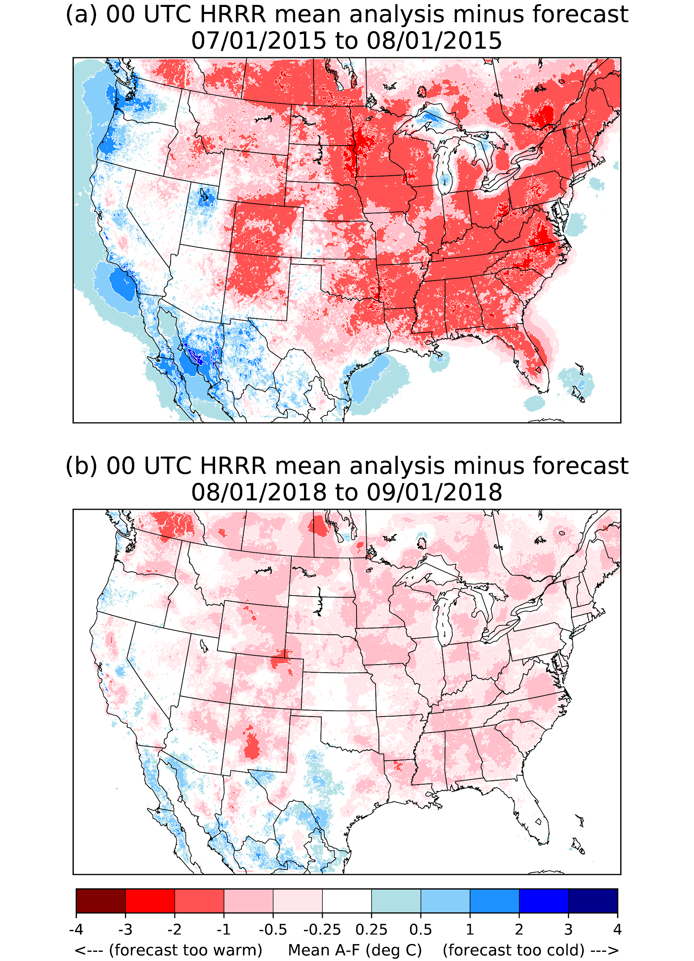
Figure 1: Illustration of potential systematic errors in 1-h HRRR forecasts and their change from 2015 to 2018. Mean analysis increments (analysis minus forecast) over the are shown for the 1-h forecasts (a) ending at 00 UTC during July 2015, and (b) ending at 00 UTC during August 2018.

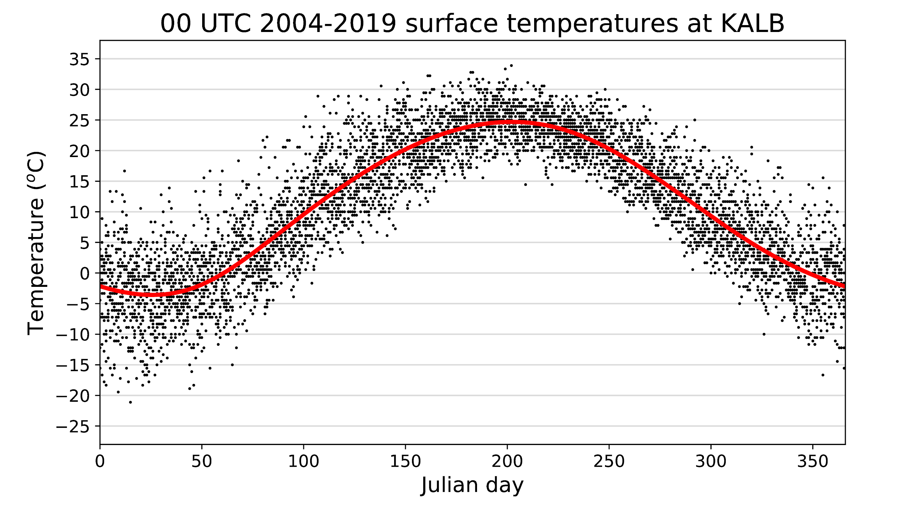

Figure 2: Illustration of the cubic spline-fitting procedure to determine a climatology for a particular hour of the day for the station KALB (Albany, NY, USA). Surface temperature (dots) are shown for the period 00 UTC 1 Jan 2004 to 23 UTC 28 Feb 2019. The fitted spline curve estimate of the climatology for this hour is shown with the red curve, estimated as a function of the Julian day of the year. Only every fifth sample from the time series was plotted to aid clarity of presentation.

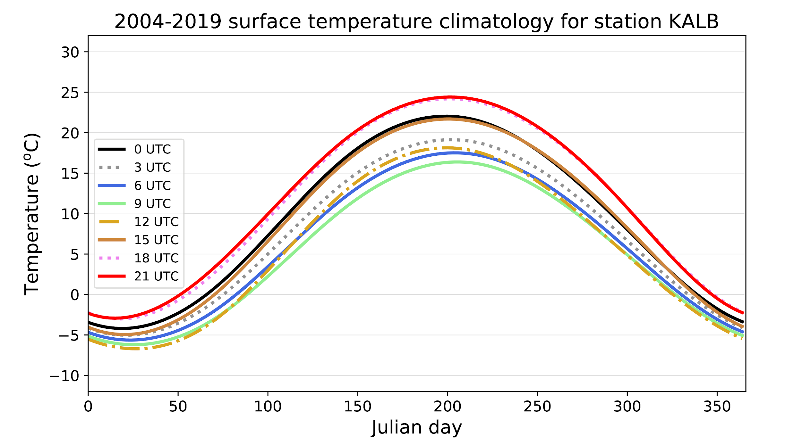
Figure 3: Spline-fitted estimates of the climatology at KALB for every 3 hours over the diurnal cycle and throughout the year.

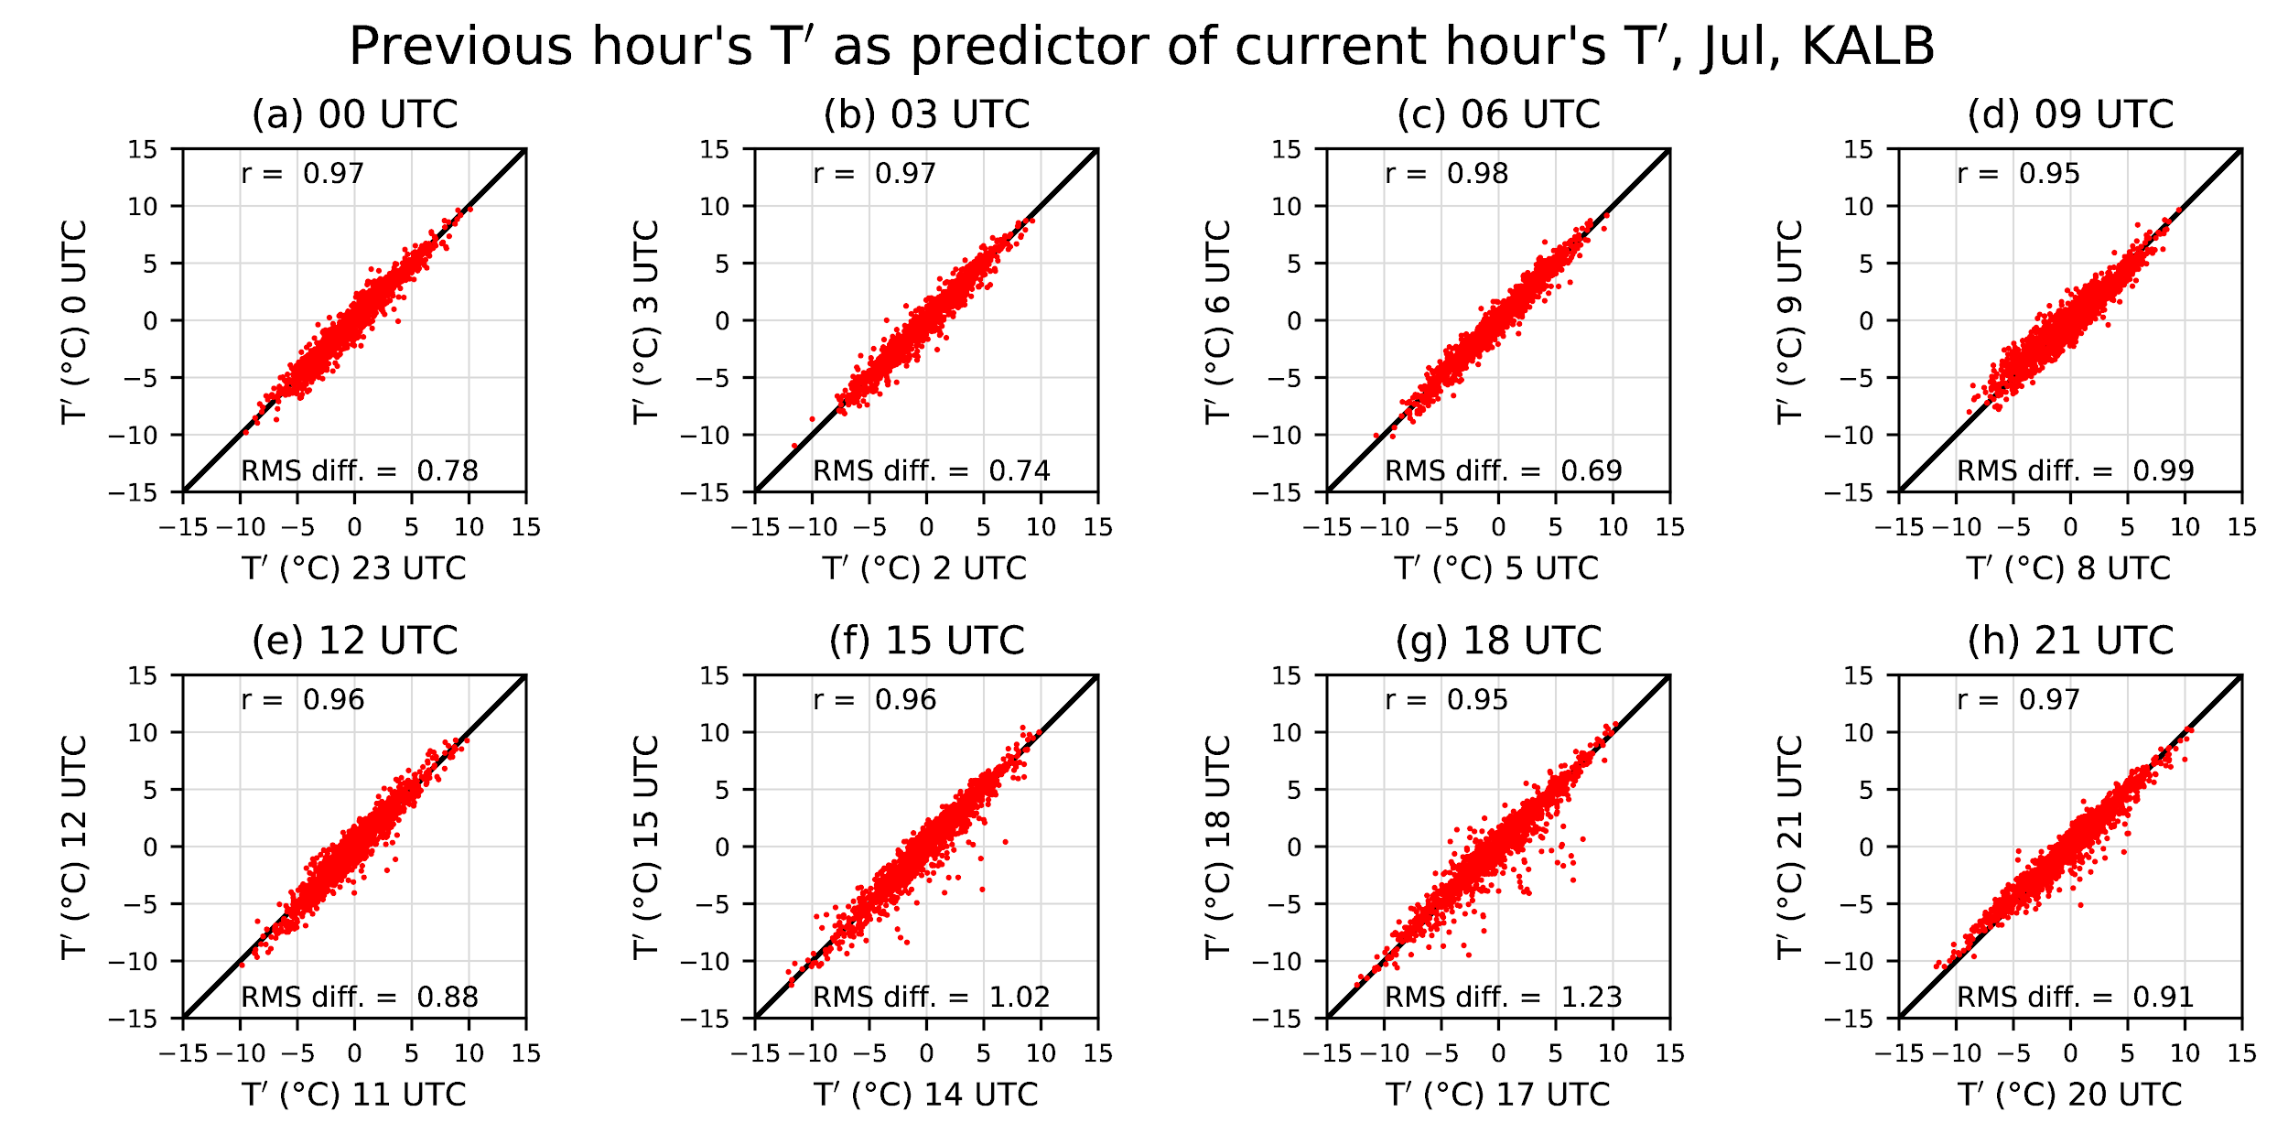

Figure 4: Scatterplots of deviation T’ from climatology at station KALB (Albany NY USA) for a particular hour of the day (ordinate) vs the previous hour (abscissa). Data collected for dates in July from 2004 through 2018. Various panels show the relationships every 3 hours over the diurnal cycle.

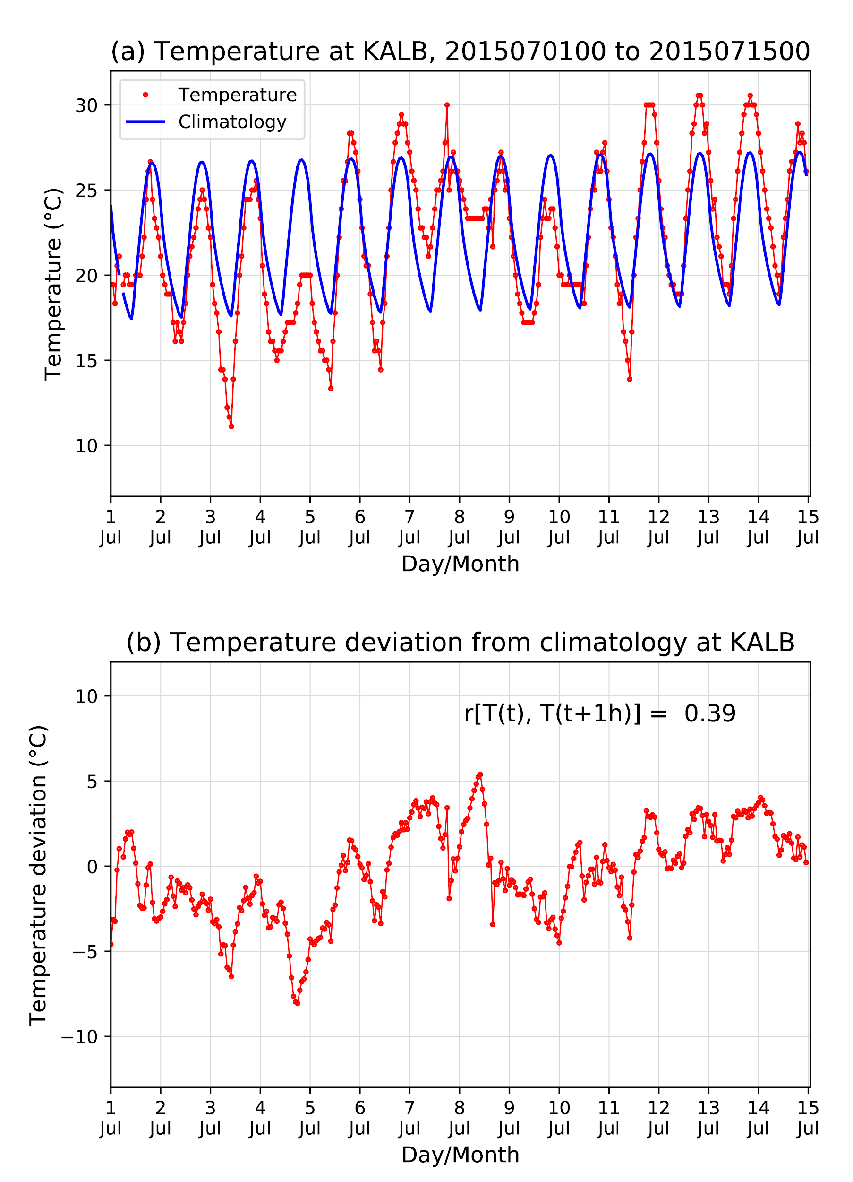
Figure 5: Illustration of the process for development of the hourly benchmark. (a) Hourly time series of surface temperature and the surface temperature climatology at station KALB (Albany, NY). (b) Deviations of the hourly surface temperature from its climatology. The 1-hour lagged Pearson autocorrelation is also indicated for the data in this figure.

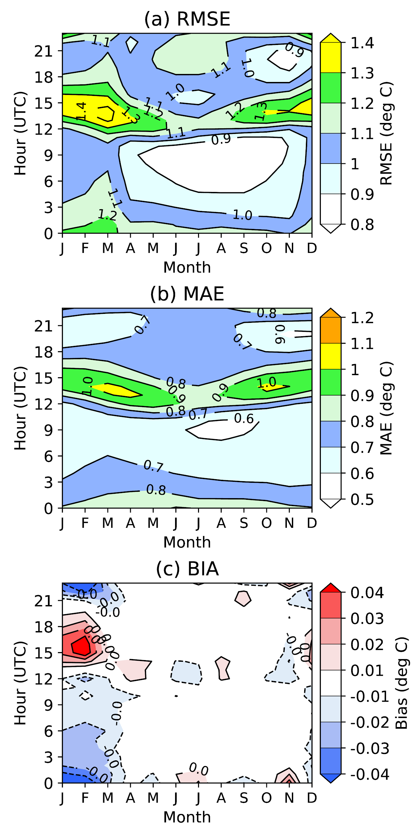
Figure 6. (a) Root-mean-square error, (b) mean-absolute error, and (c) bias for 1-h surface-temperature forecasts from the station benchmark for stations in the CONUS. Data used spanned 1 Jan 2004 to 28 Feb 2019. Errors were plotted as a function of the month of the year (abscissa) and the initialization time for the 1-h forecast (ordinate).
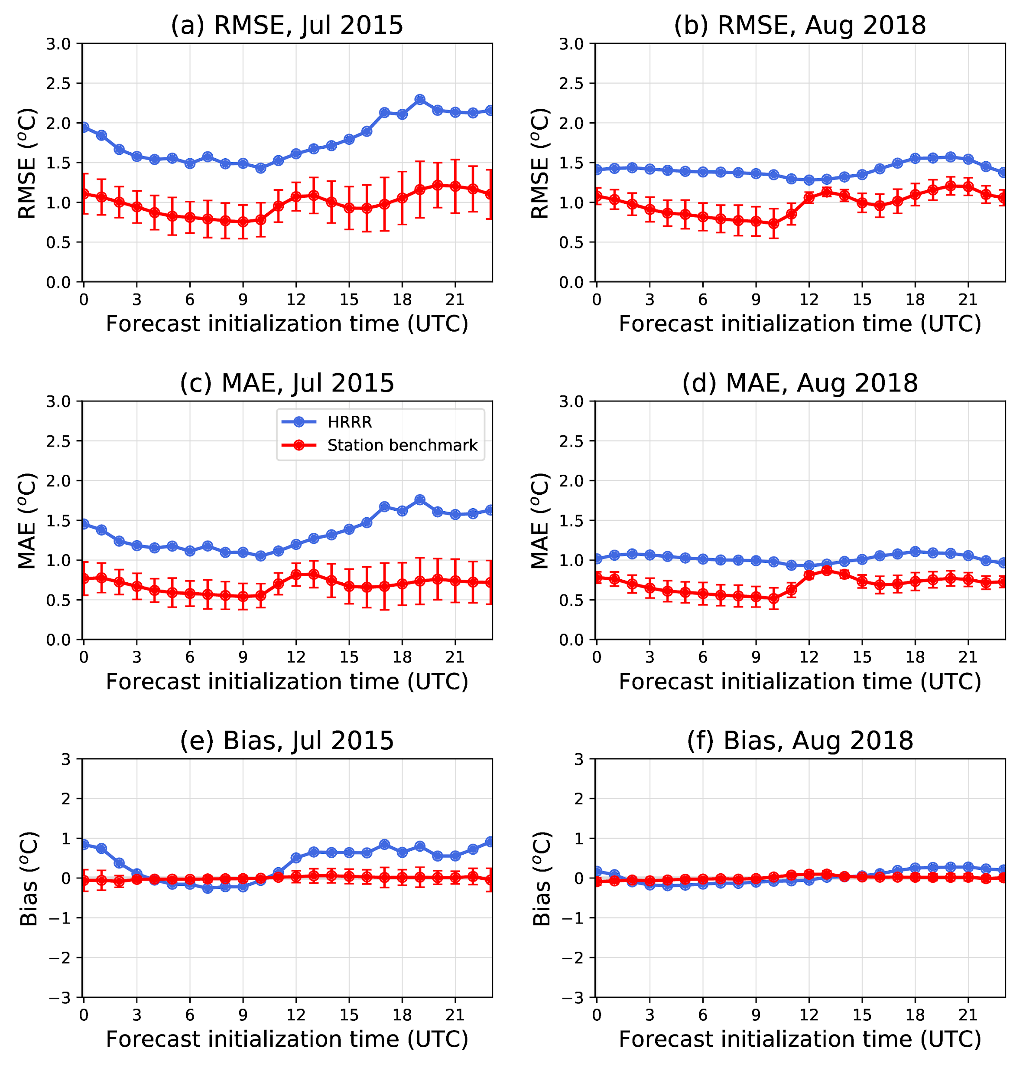
Figure 7. 1-hour surface temperature forecast-error statistics for CONUS HRRR forecasts interpolated to stations and for the station benchmark at those stations. (a) Root-mean-square error, July 2015; (b) root-mean-square error, August 2018; (c) mean absolute error, July 2015; (d) mean absolute error, August 2018; (e) bias, July 2015, and (f) bias, August 2018. Error bars are recentered around the station benchmark and represent the 5th and 95th percentiles from a paired block bootstrap distribution consistent with the null hypothesis of no differences in mean.

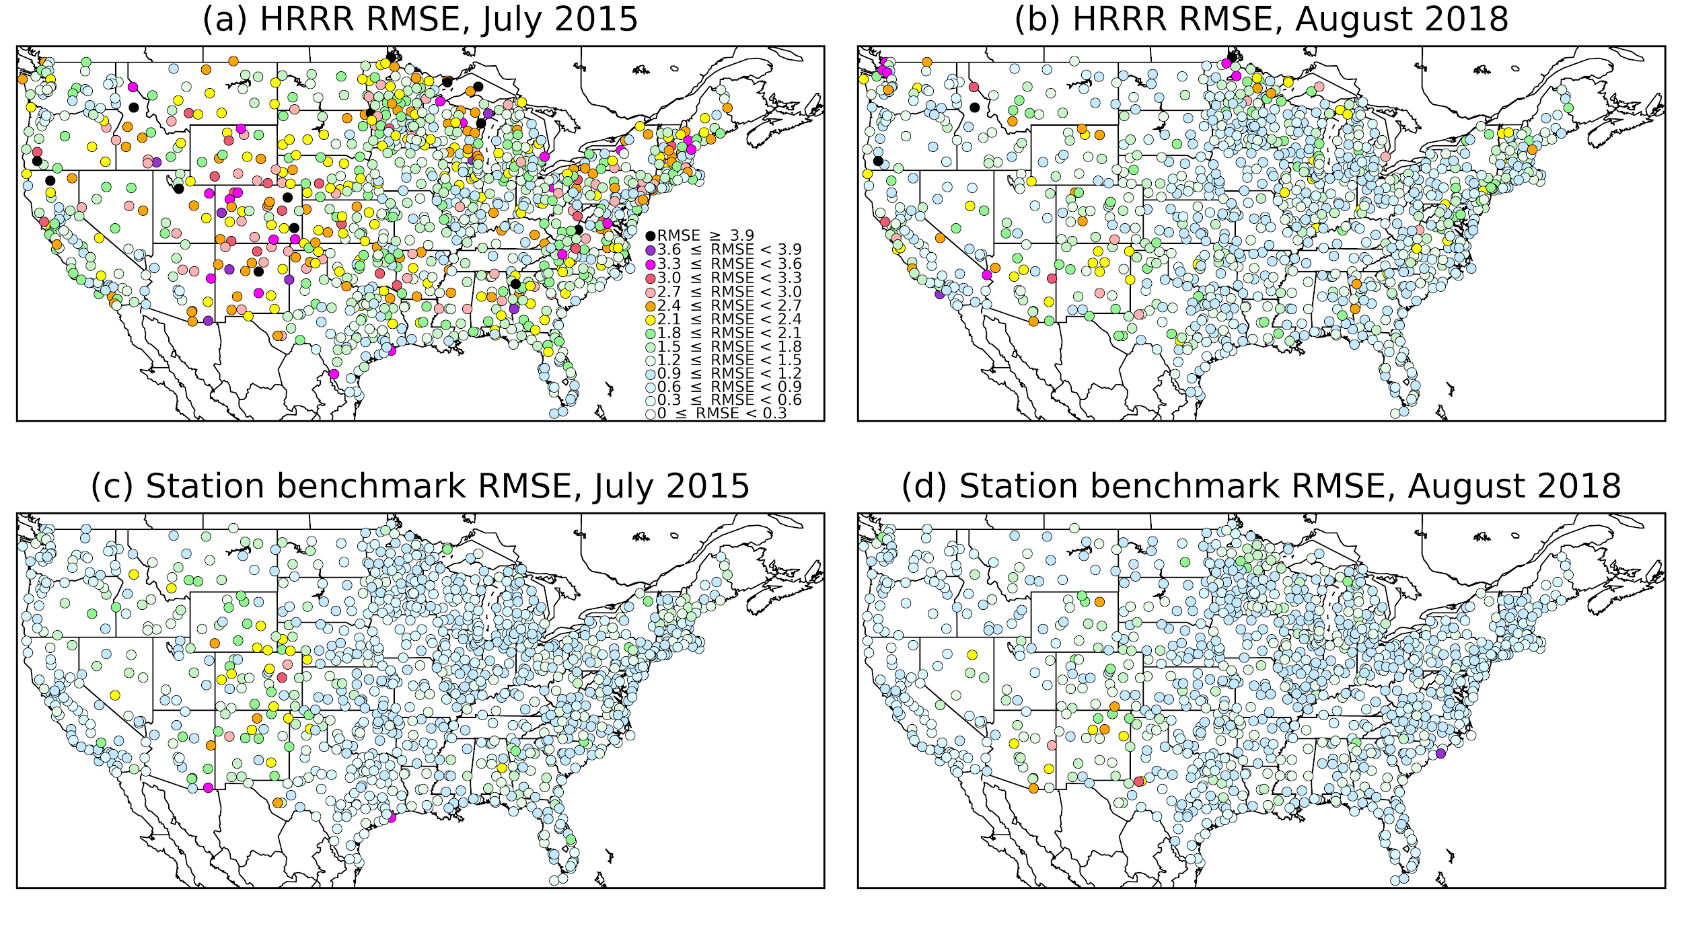
Figure 8: RMSEs of 1-h July 2015 forecasts initialized at 00 UTC. (a) July 2015 HRRR model forecasts; (b) August 2018 HRRR model forecasts; (c) July 2015 station benchmark; and (d) August 2018 station benchmark.

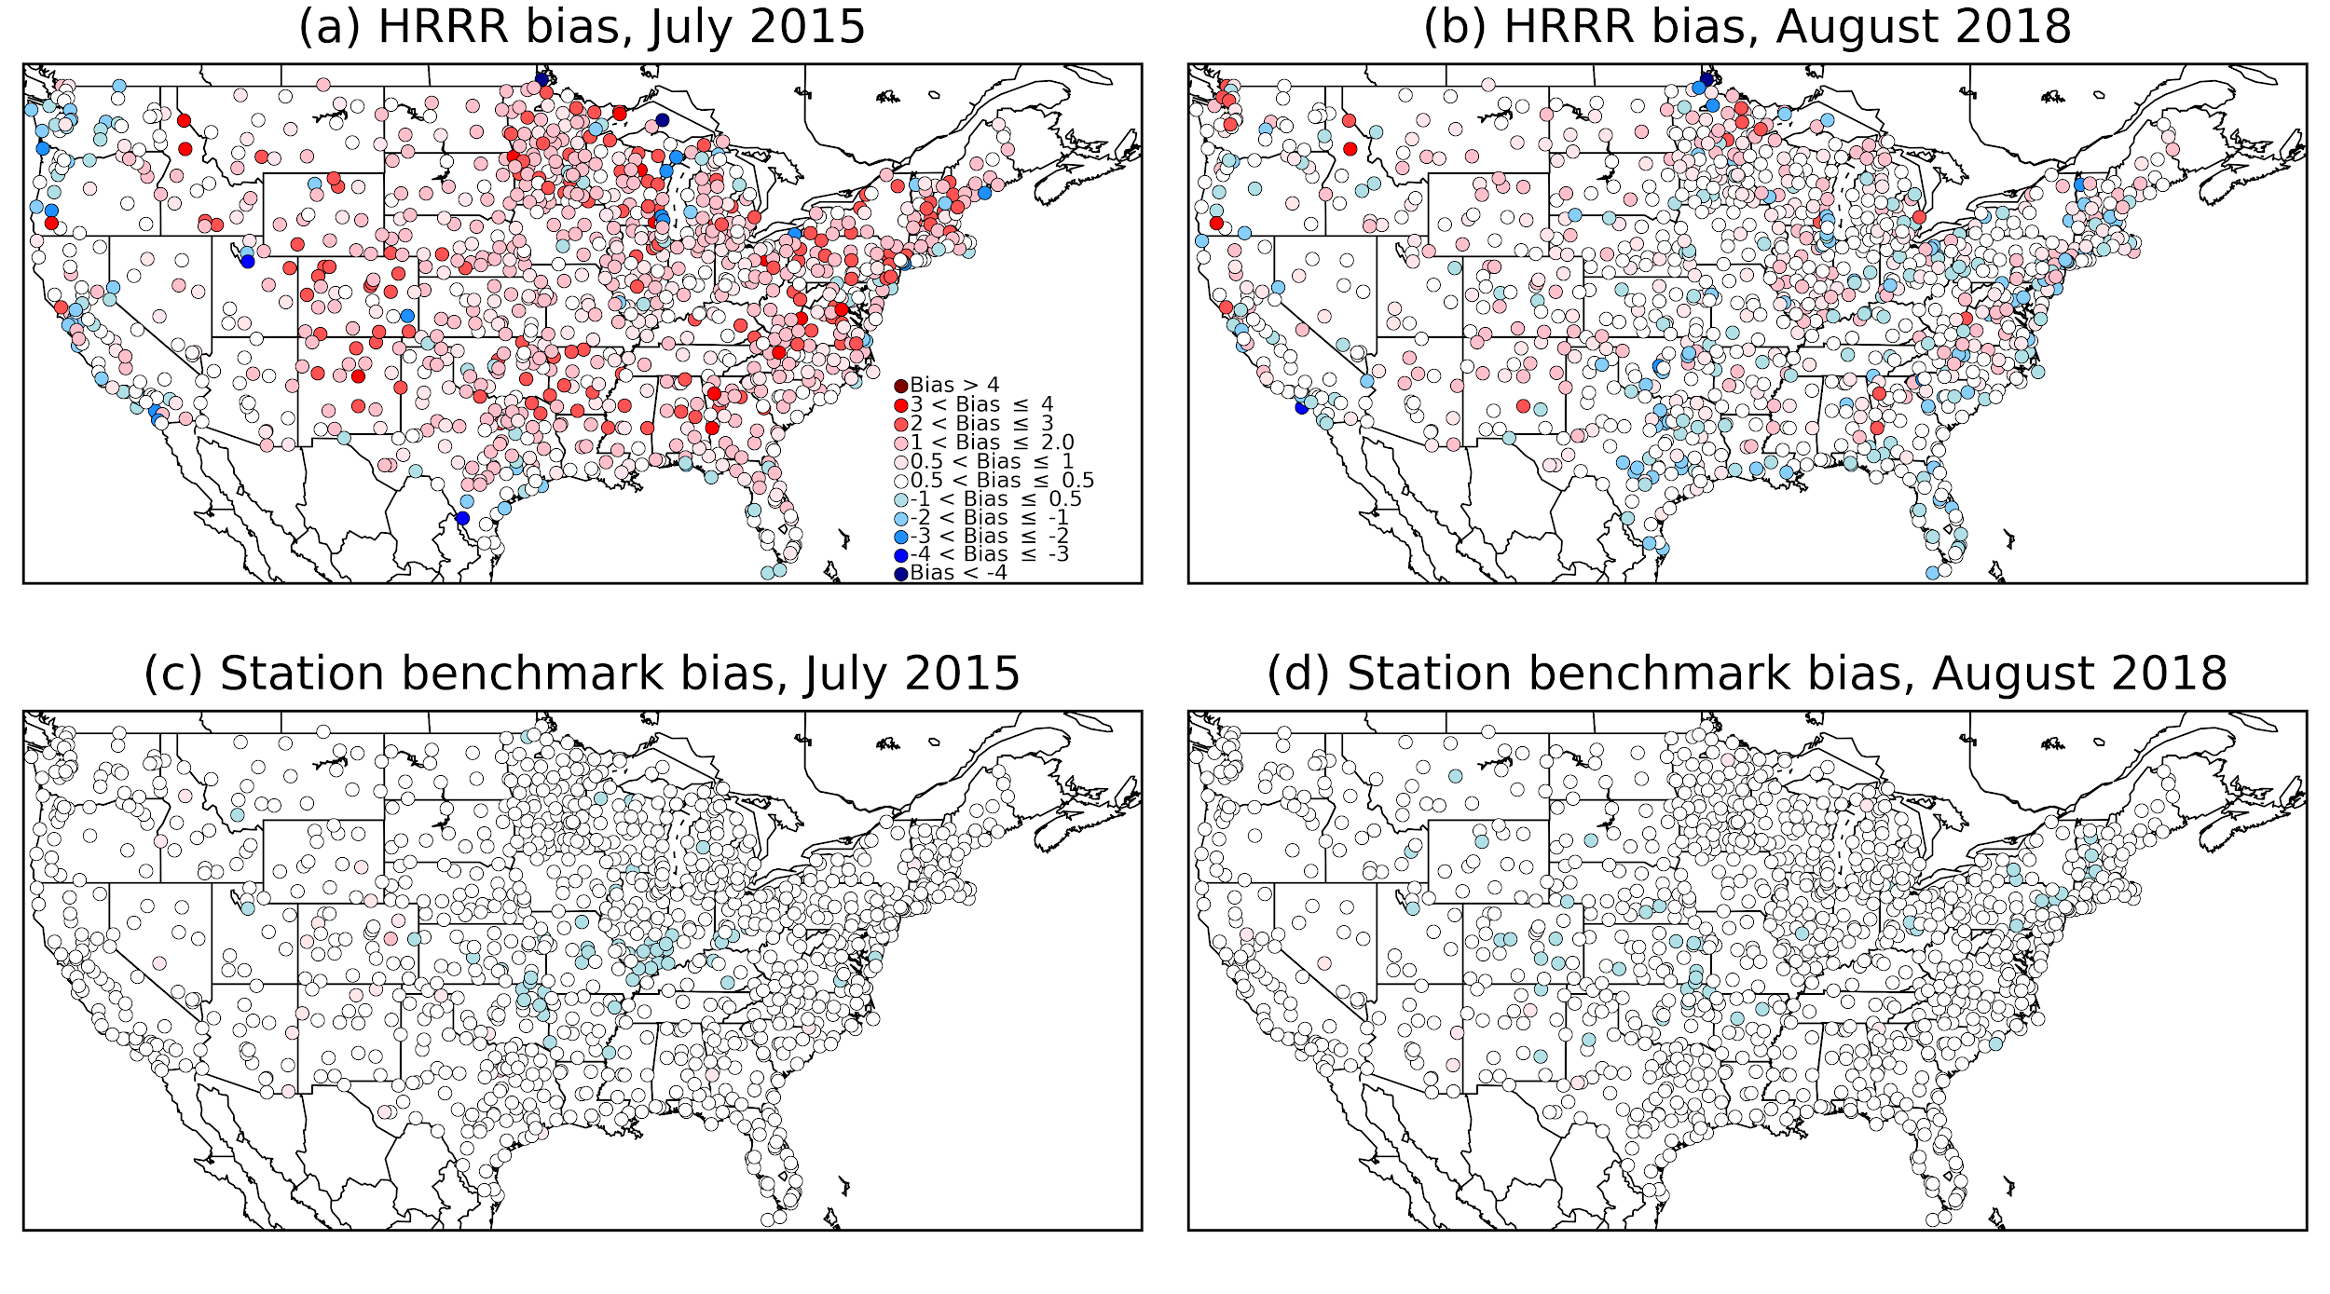
Figure 9: Biases of 1-h July 2015 forecasts initialized at 00 UTC. (a) July 2015 HRRR model forecasts; (b) August 2018 HRRR model forecasts; (c) July 2015 station benchmark; and (d) August 2018 station benchmark.

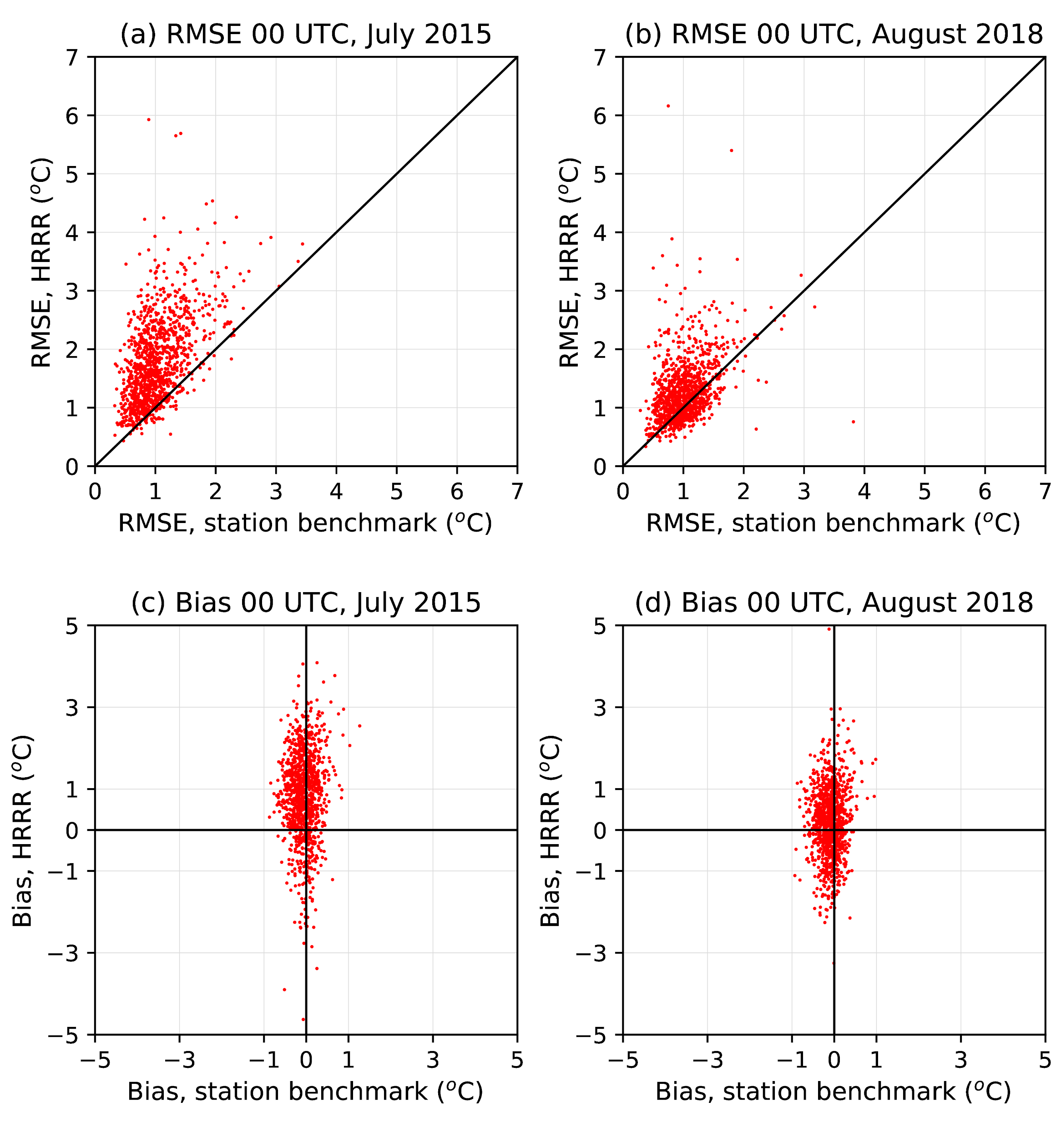
Figure 10: Scatterplot of errors and bias for HRRR vs. station benchmark (a) 1-h forecast RMSE, July 2015; (b) 1-h forecast RMSE, August 2018; (c) 1-h forecast bias, July 2015, and (d) 1-h forecast bias, August 2018.

