Operating Manual – CPD2 (work in progress!)

NOAA/ESRL/GMD Aerosol Sampling System
Last Updated – Dec. 21, 2011
Table of Contents
1. General description 2
1.0. Maintenance Checklist 5
1.0.1. Daily Tasks 5
1.0.2. Weekly Tasks 5
1.0.3. Monthly Tasks 5
1.1. GMD Contact information 5
2. Maintenance 6
2.1. Check System Parameters and Logging Status - (Daily Task) 6
2.0. CN counter fluid level - (Daily Task) 6
2.1. Changing the PSAP Filter - (Daily Task) 7
2.2. Check water level in humidifier reservoir - (Daily Task) 9
2.3. CCN Maintenance – supply and drain water bottles - (Daily Task) 9
2.4. CLAP filter change (Daily-to-Weekly Task) 10
2.5. Nephelometer Span Check - (Weekly Task) 13
2.5.1. Span Check Plumbing 13
2.5.2. Span Check Operation 13
2.6. Servicing impactors for nephelometer and PSAP - (Weekly Task) 14
2.6.1. Removal of Impactors 14
2.6.2. Cleaning of Impactors 15
2.6.3. Re-assembly of impactor box 16
2.7. System Leak Test - (Weekly/Whenever impactors are serviced) 16
2.8. Change Carousel Filters - (Weekly Task) 18
2.8.1. Preparation 18
2.8.2. Change the impactor films 19
2.8.3. Changing the filters 19
2.9. CCN maintenance - desiccant cartridge check (weekly task) 20
2.10. CN Butanol flush (monthly task) 20
2.11. Changing Nephelometer Lamp – (As needed, ~3-6 months) 21
2.12. Resetting Love PID controllers – (As needed) 21
2.12.1. Changing the setpoint 22
2.12.2. Resetting 22
2.13. System Clock 23
2.14. Instant Messenger 24
3. Computer Operation 24
3.0. General 24
3.1. Startup 25
3.1. Shutdown 26
3.2. Archiving and Backing-up Data 26
3.3. Other desktop icons 26
3.4. LiveCPD2 Documentation 27
3.5. Graphical Client Program (cpx2) 28
3.6. Aerosol Data Logger Program 28
3.6.1. General Operation 28
3.6.2. Display 29
3.6.3. Root Menu <enter> or <esc> 30
3.6.4. Input Channels Status Window and Monitor Menu <enter><A><M> 31
3.6.5. Nephelometer Status Window and Menu <enter><N><M> or <enter><O><M> 31
3.6.6. PSAP Menu <enter> <L> <M> or <enter><R> <M> 32
3.6.7. CLAP Menu <enter> <L> <M> or <enter><R><M> 32
3.6.8. Filters Menu <enter> <F> <M> 33
3.6.9. Humidograph Menu <enter> <arrow keys to ’humidograph’ option><M> 34
3.6.10. CCN Menu <enter> <D><M> 34
4. Safety 35
4.0. Heater Control 35
4.1. Electrical Safety 35
5. Specifications 35
5.0. Power Draw at 115 V AC 35
6. Additional Computer info 36
6.0. Data flow 36
6.1. Aerosol Server Program (cpd) 36
6.2. User account 36
6.3. Location of this document 36
7. Station specific appendix 37

General description
The GMD Aerosol Sampling System is deployed at a number of stations around the world (see Table 1). It is an automated system for measuring aerosol light scattering and absorption as a function of wavelength, plus aerosol number concentration. At several stations the light scattering as a function of relative humidity is also measured. Switched 1 and 10 um impactors are used to measure these properties for particles less than 1 and 10 um diameter, respectively. The main components are a three wavelength nephelometer (TSI model 3563), a light absorption photometer (Radiance Research PSAP or NOAA CLAP) and a Condensation Nucleus Counter (CNCs supported include TSI models 3760, 3010, 3022A, 3701, 3703, 3775, 3781, and 3783). At some stations filter measurements are also made in conjunction with NOAA/PMEL of the ionic composition of the aerosol, including sea salt, non-sea salt (nss) sulfate, methanesulfonate, NH₄⁺, nss K⁺, Mg⁺², and Ca⁺ for sub-micron and super-micron size ranges. Table 1 indicates which components are deployed at each station.

Table 1 Long term station list, locations and system components | 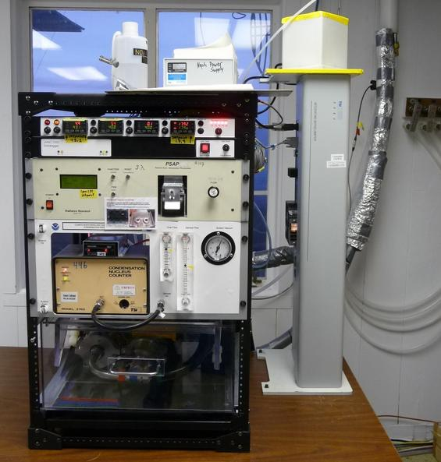  Basic rack system (MLO)
  Stn ID | Station Location | Neph | PSAP/CLAP | CNC | Chem filters | Humid-ograph | other
  ALT | Alert, Canada | X | X | X |  |  | AETH
  AMF | ARM Mobile Facility | X | X | X |  | X | CCN
  AMY | Anmyeon-do, South Korea | X | X | X
  APP | Appalachian State, NC | X | X | X |  | X | AETH
  ARN | El Arenosillo, Spain | X
  BEO | BEO Moussala, Bulgaria | X
  BND | Bondville, IL | X | X | X | X
  BRW | Barrow, AK | X | X | X | X | X | CCN,SMPS
  CPT | Cape Point,  South Africa | X | X | X
  CPR | Cape San Juan, Puerto Rico | X | X | X |  | X | AETH
  EGB | Egbert, Canada | X | X
  ETL | East Trout Lake, Canada | X | X | X
  GSN | Gosan,  South Korea | X | X | X
  KPS | K'puszta, Hungary | X | X | X
  LLN | Lulin, Taiwan | X | X | X |  |  | AETH
  MLO | Mauna Loa, HI | X | X | X
  SDZ | Beijing, China | X |  |  |  | X
  SGP | Lamont, OK | X | X | X |  | X | CCN,SMPS
  SMO | American Samoa |  |  | X
  SPL | Storm Peak, CO | X | X | X |  |  | SMPS
  SPO | South Pole | X |  | X
  THD | Trinidad Head, CA | X | X | X
  WHI | Whistler, Canada | X | X | X
  WLG | Waliguan, China | X | X | X

A basic system generates the first three pieces of information; an extended system with all the options generates all the following information:
- Total and backwards scattering coefficients time series at 450, 550 and 700 nm wavelengths in two size ranges
- Absorption coefficient time series at 467, 530 and 660 nm in two size ranges
- Condensation nuclei number concentration time series
- Total and backwards scattering coefficients time series at 450, 550 and 700 nm wavelengths in two size ranges as a function of relative humidity
- Mass concentration of sea salt, non-sea salt (nss) sulfate, methane sulfonate, NH₄⁺, nss K⁺, Mg⁺², and Ca⁺ for sub-micron and super-micron size ranges
- Cloud condensation nuclei concentration as a function of up to 7 super saturations
- Size distribution (diameter range depends on instrument)

From the measurements the following parameters can be calculated (1-4 for basic system):
- Single scattering albedo at 3 wavelengths in two size ranges
- Ångström exponent
- Hemispheric backwards scattering fraction in two size ranges
- Sub-um fraction of scattering and absorption
- f(rh) if a humidograph system is installed.
- CCN fraction (CCN/CN) if a CCN is installed

Some useful references describing NOAA system operations, measurements and analysis are:

Delene, D.J. and J. A. Ogren, Variability of aerosol optical properties at four North American surface monitoring sites, J. Atmos. Sci., 59, 1135-1150, 2002.

Sheridan, P.J., Delene, D.J. and Ogren, J.A., “Four years of continuous surface aerosol measurements from the Department of Energy’s Atmospheric Radiation Measurement Program Southern Great Plains Cloud and Radiation Testbed site”, J. Geophys. Res., 106, 20735-20747, 2001.

Maintenance Checklist
The system is mostly automated but there are some tasks that need to be performed on a daily, weekly or monthly basis. The tasks for a complete system are listed below and are described in more detail in Section 2 – Maintenance. More specific maintenance tasks for individual stations are described in each station’s appendix. Each station also has a binder of instrument manuals for each of the instruments and other system components to aid in more complicated trouble-shooting and maintenance (in consultation with station scientists).

Daily Tasks
1. Fill out daily checklist, and address any issues in emailed data report
2. Check logging status: letters at bottom of screen should be appropriate for that station (see appendix)
3. Check butanol level in CN counter and add butanol if needed
4. Change PSAP filter if transmittance will be below 0.7 before next station visit.
5. Add distilled water to humidifier rack reservoir (if less than half full)
6. Add water to CCN supply bottle and drain the drain bottle
7. Change CLAP filter if sampling on filter#8
8. Look at time series plots either on station laptop using cpx2 or station webpages to be sure nothing has changed or stopped working. Webplots are available at:
http://www.esrl.noaa.gov/gmd/aero/net/STN/index.html#plots
where you replace STN with the three letters for your station.

Weekly Tasks
1. Perform daily tasks
2. Change PSAP reference filter
3. Service nephelometer/PSAP impactors
4. Perform leak test (if weather permits)
5. Perform nephelometer span check (Don’t do during nephelometer/PSAP impactor servicing)
6. Change filter carousel and carousel impactor film (can be done during span check)
7. Mail carousel filter samples to NOAA/PMEL
8. Check CCN desiccant cartridge

Monthly Tasks
1. Mail PSAP filters and daily check lists to NOAA/ESRL/GMD
2. Check supply levels of PSAP filters, plastic bags, butanol, ethanol.
3. CN counter butanol flush.
4. Check integrity of external tubing, fittings, insulation, etc.

GMD Contact information
Betsy Andrews  Email: betsy.andrews@noaa.gov  Office Phone: 303-497-5171  Home Phone : 303-442-5142 | John Ogren  Email: john.a.ogren@noaa.gov  Office Phone:303-497-6210  Home Phone: 720-238-3066
Anne Jefferson  Email: anne.jefferson@noaa.gov  Office Phone: 303-497-6493  Home Phone: 303-579-9013 | Pat Sheridan  Email: patrick.sheridan@noaa.gov  Office Phone: 303-497-6672  Home Phone: 303-888-6602

Maintenance
This section describes the general maintenance/station tasks for a station with all the options. Not all tasks are applicable to each station, so each task includes a list of stations where it must be performed.

Check System Parameters and Logging Status - (Daily Task)
Stations applicable: ALT, AMF, AMY, APP, ARN, BEO, BND, BRW, CPT, CPR, EGB, ETL, KPS, LLN, MLO, SGP, SMO, SPL, SPO, THD, WLG
Time required: 5 minutes
Tools/supplies: Daily check list
Overview: There are a few system parameters that are not recorded and hence need to be checked manually. A daily checklist is used to record the values and is mailed back to GMD at the end of each month with the used PSAP filters.

1. Fill out daily checklist (and weekly/monthly on back of sheet if applicable)
2. Check that letters on bottom of computer screen match the letters listed in station specific appendix/checklist.
3. Address any issues in emailed status report, working with NOAA scientist as needed

CN counter fluid level - (Daily Task)
Stations applicable: ALT, AMF, AMY, APP, ARN, BND, BRW, CPR, ETL, KPS, LLN, MLO, SGP, SMO, SPL, SPO, THD, WHI, WLG
Time required: 5 minutes
Tools/supplies: butanol fill bottle
Overview: The CN counter condenses butanol or water vapor onto particles in the sample line to grow them to a size so that they can be seen and counted by the instrument optics. The condensed fluid goes out the exhaust stream along with the particles and fresh fluid must be added to the counter to replenish the supply.

Check the fluid level – it should be about ½ way up the view port. Do not overfill.
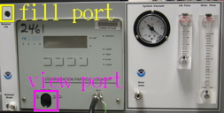 | 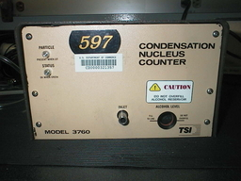
This is the new style CN box with a CN model#3010 in it. | This is a CN model#3760. It is filled the same way as the model#3010

If the CN counter sits in the NOAA designed CN box and butanol needs to be added, connect the fill bottle to the butanol fill port. Loosen the cap on the butanol bottle and fill the CN counter until the butanol level shown in the view port is acceptable. Otherwise, fill the CN counter according to the manufacturer’s instructions.

Changing the PSAP Filter - (Daily Task)
Stations applicable: ALT, AMF, AMY, APP, BND, BRW, CPT, CPR, EGB, ETL, KPS, LLN, MLO, SGP, SPL, THD, WHI, WLG
Time required: 5 minutes
Tools/supplies: PSAP Kit
Overview: The PSAP filter transmittance degrades as particles collect on it. To ensure valid measurements the filters need to be changed prior to a transmittance value<0.7.

If you think the PSAP filter transmittance is less than 0.7 or you think it will be before the next station visit then change the PSAP filter. If you are not sure – change the PSAP filter.

Transmittance value in this picture is Tr= 0.495 – the filter needs to be changed and some data were lost.
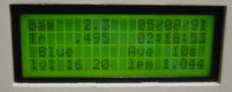
1. In the CPDclient (the blue screen), press <Enter><L><M><2> or <enter><R><M><2> to select the PSAP menu and signal start of a filter change. The bottom of the PSAP window will indicate that a filter change is taking place.
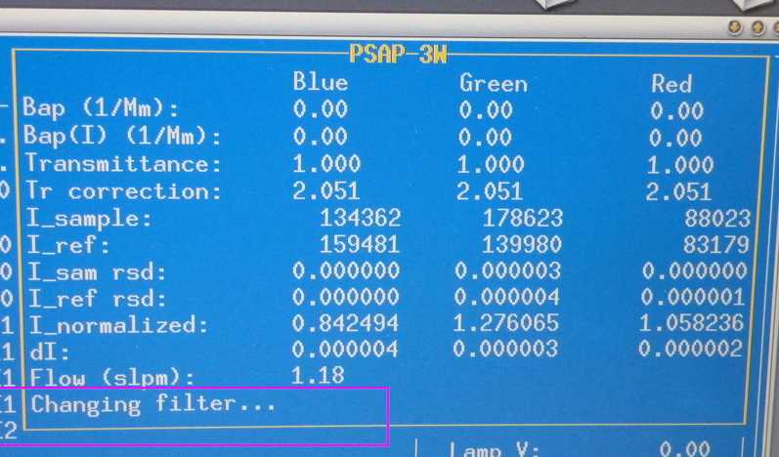

2. Unscrew the knob on the sampling head, raise the lockdown panel, and remove the filter holder.
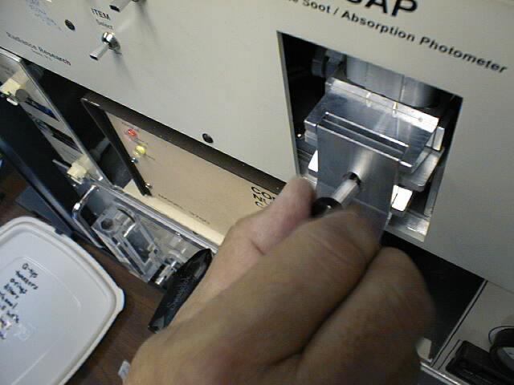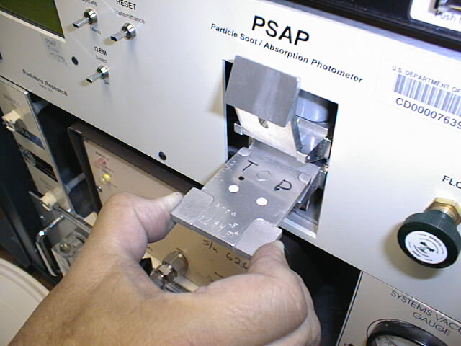
Sample
ref
Samplee
ref

3. Remove the filters. It is only necessary to replace the reference filter once per week. Place the sample filter (the left-hand one) in a small zip bag and label the bag with the station name and the date the filter was pulled out of the PSAP. The label should have the format: YYMMDD-stn (so December 13, 2000 at Trinidad Head would be labeled: 001213-THD). Write your initials on the bag.

4. Place new filters in the filter holder. The white side of the filter should be facing up.
Re-insert the filter holder into the sampling head; secure the lockdown panel with the black knob. Make sure the lower lip of the lockdown panel goes under the bottom edge of the sampling head.

5. Set PSAP flow to the following (in lpm): BRW=2; MLO=3; THD=1; BND=0.5; SGP=0.75; CPR = 1.0, APP=1.0, AMY=0.5 using the knob on the right side of the PSAP. The flow value you should look at is the one on the PSAP window in cpd2, NOT the flow on the PSAP instrument screen.
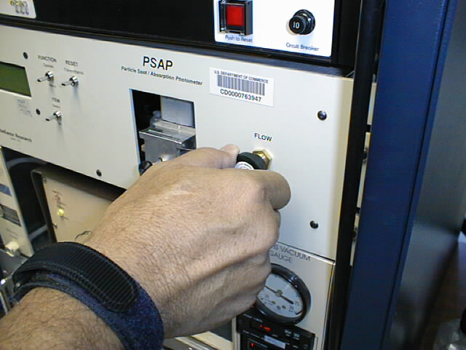

6. On the PSAP, press the “RESET Transmittance” switch up and verify that Tr=1.000 on the display of the PSAP.

7. Let the system autodetect the end of the filter change. A PSAP filter change causes a disturbance in the PSAP measurement that can last several minutes. Letting CPD2 determine when a filter change is over you will result in a less noisy/spikey data set. Note: If the PSAP window no longer says ‘Changing filter…’ then the system has automatically detected that the filter change is done.

Check water level in humidifier reservoir - (Daily Task)
Stations applicable: AMF, BRW, SGP
Time required: 5 minutes
Tools/supplies: distilled water
Overview: The humidifier condenses water vapor onto particles after they exit the reference nephelometer, but before they enter the humidified nephelometer. The condensed water vapor exits the system and must be replenished.

The water reservoir needs to be refilled whenever the level in the reservoir gets below ~1/2.
If reservoir has lost lots of water in a short period of time this may indicate a leak! Inspect for water around the system or for an RH value in the second nephelometer above 90%. If there is a leak a) turn off humidifier heater and preheater b) unplug the water pump c) enter a log message in the computer <enter><enter>reservoir leak!! <enter>

Lift the attached fill funnel above the top of the reservoir bottle. Slowly pour distilled water into the funnel. Do not fill reservoir above the bottom of the red tape line.
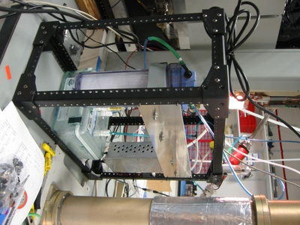 | Humidifiers have square box for water reservoir- see yellow arrow. | 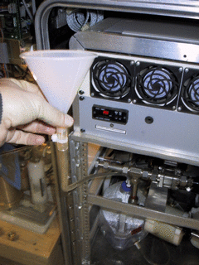 | Note at some stations you may be able to merely lift the lid and pour the water into the water reservoir. At others you may need a funnel and tubing to conveniently add water.

CCN Maintenance – supply and drain water bottles - (Daily Task)
Stations applicable: AMF, BRW, SGP
Time required: 10 minutes daily
Tools/supplies: distilled water
Overview: The CCN instrument creates supersaturated conditions inside its main column to activate particles into droplets, mimicking the processes that form clouds. To create these supersaturated conditions the main column must have a continuous supply of water coating its sides. Always drain the drain bottle when filling the supply bottle!

Open the door on the lower left of the CCN instrument (figure a). Check the water level in the supply bottle (the front bottle) (figure b). If the water level is lower than 100 mL then the supply bottle needs to be filled and the drain bottle needs to be drained. To remove bottles, first undo the long wingnut screw holding the collar on the bottle necks (figure c). Next hold the cap of the supply bottle in place (so as not to mangle the tubing!) and twist the bottle clockwise. Fill the supply bottle with distilled water to the fill line. Remove and empty the water from the drain bottle. Replace the drain bottle and then the supply bottle and tighten screw. If the drain bottle is not drained when the supply bottle is filled there is a risk of flooding the CCN optics.

(a) front view of CCN counter.  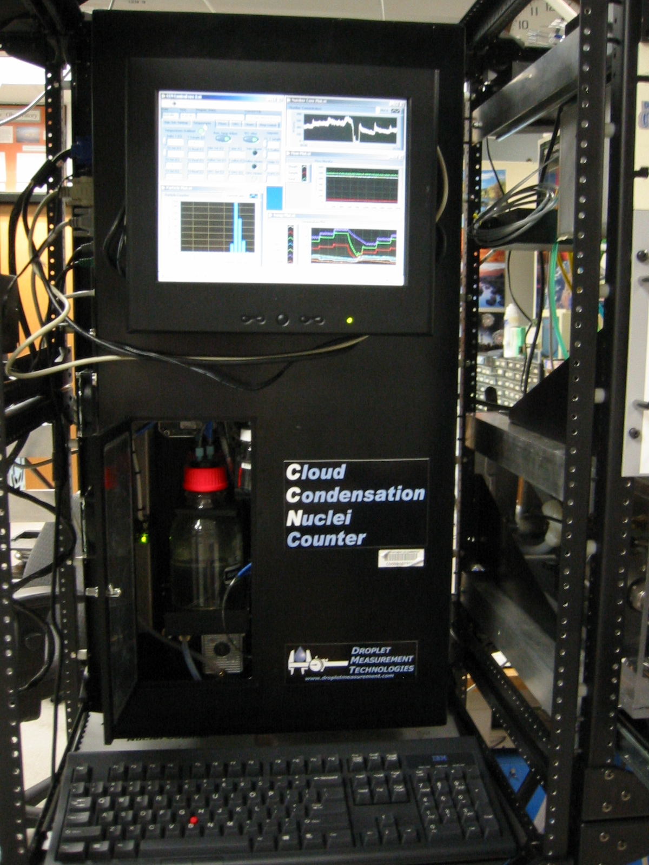 | (b) close-up of supply bottle and front of collar  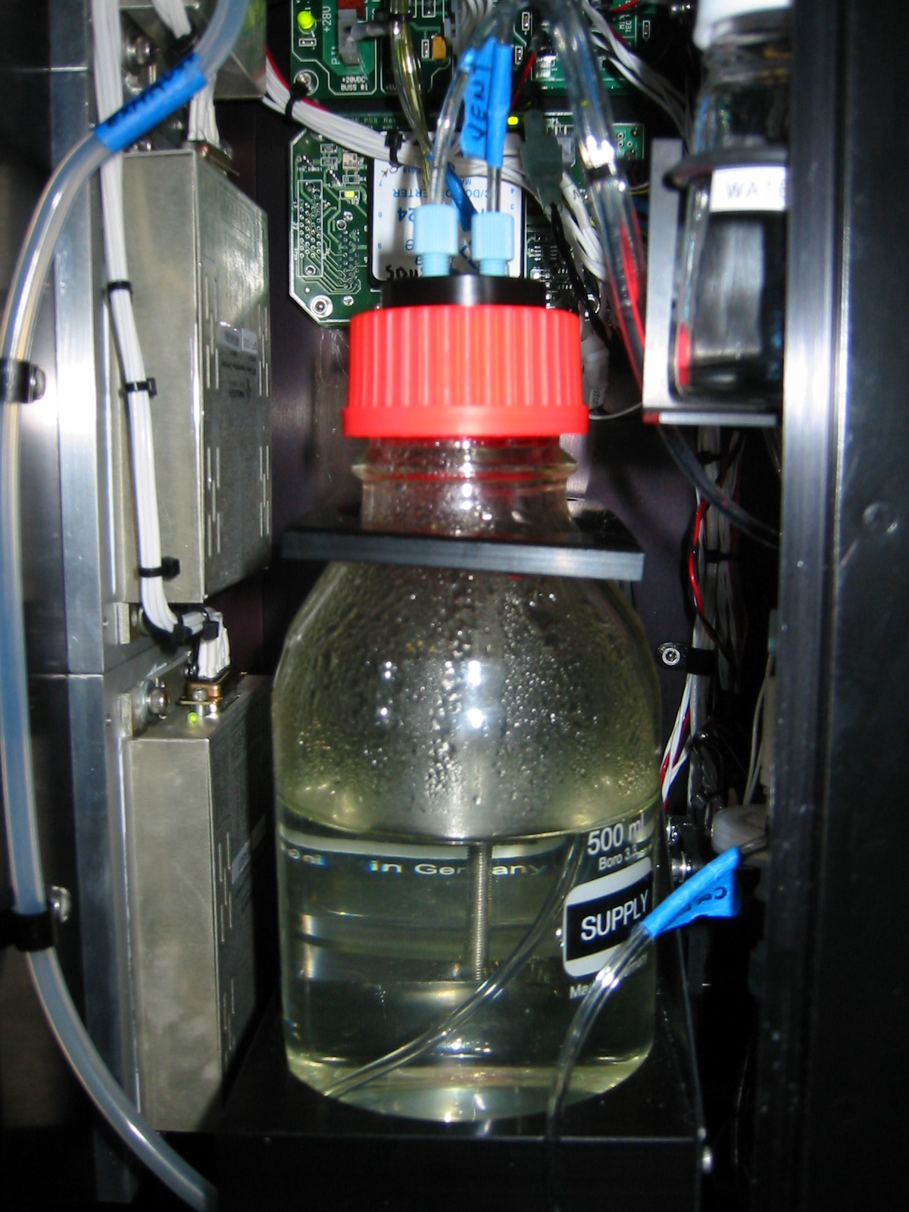   | (c) screw & both bottles  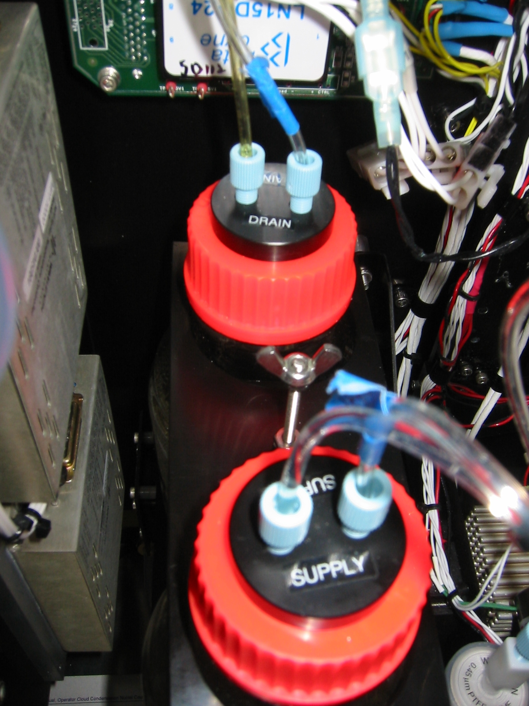  screw

CLAP filter change (Daily-to-Weekly Task)
Stations applicable: ALT, AMY, BND
Time required: Approximately 5 minutes
Tools/supplies: Filters, tweezers, baggies, permanent marker, torque driver
Overview: The CLAP (Continuous Light Absorption Photometer) is similar to the PSAP in that it is a filter-based light absorption measurement. It differs from the PSAP in that it utilizes solenoids to cycle through 8 sample filter spots and 2 reference filter spots, enabling the instrument to run at ideal conditions (Tr>0.7) eight times as long as the single sample filter spot PSAP. The CLAP uses 47 mm quartz-fiber filters (Pallflex type E70-2075W). The CLAP is typically installed so that it draws its sample air from through a modified TSI nephelometer blower plug.

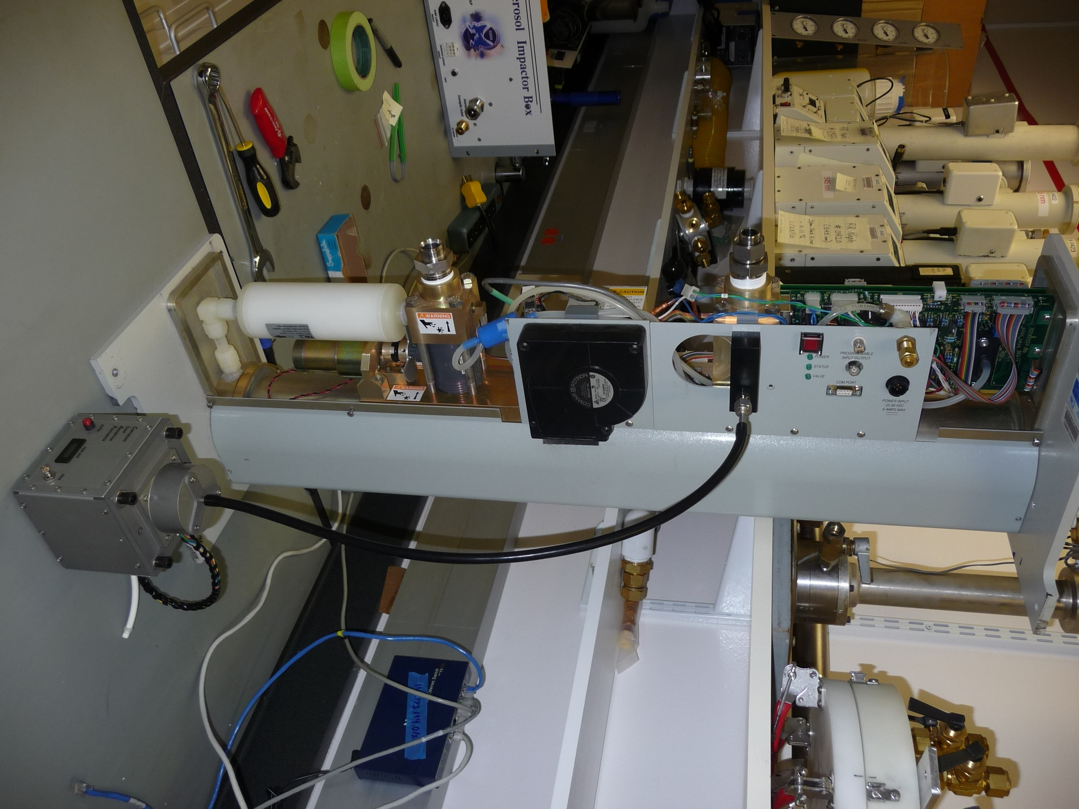 | 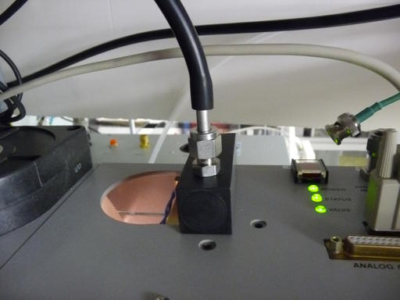
CLAP sampling from modified neph blower plug | Closeup of modified neph blower plug
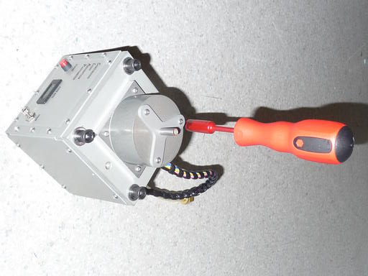 | 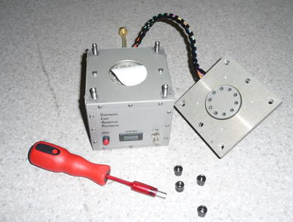
Side view of CLAP.  To open CLAP for filter replacement use the included torque drive to unscrew the four knobs on top. | Top view of CLAP with top removed and clean filter inserted. You can see the 10 holes (8 for sample + 2 reference in the CLAP lid. Red tool is torque driver.

- In the CPDclient (the blue screen), press <Enter><L><M><2> to select the CLAP menu and signal start of a filter change. The bottom of the CLAP window will indicate that a filter change is taking place. The red light on the side of the CLAP will be illuminated providing an additional indication that a filter change is occurring.

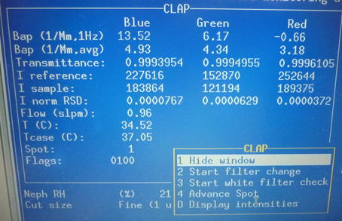 | CLAP main window and menu. To start a CLAP filter change you would choose <2> on the menu.

2. Unscrew the four knobs (indicated by the yellow arrows in the side view picture of the CLAP) on the top of the panel, remove the lid, and lay it carefully to the side of the instrument.

3. Remove the filter. Place the filter in a small zip bag and label the bag with the station name and the date the filter was pulled out of the CLAP. The label should have the format: YYMMDD-STN (so December 13, 2000 at Trinidad Head (THD) would be labeled: 001213-THD). Write your initials on the bag.
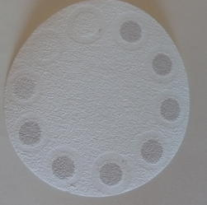  1  2  2  3  4  5  6  7  8  R  R  Photo of used CLAP filter. You can see the 8 sample spots (1-8) and the two reference spots (R) which only measure filtered air. Filter spots 1-7 were each utilized until the transmittance reached 0.7. The filter was removed from the CLAP when spot #8 had a transmittance of 0.84, which is why the #8 filter spot appears slightly lighter than 1-7 spots. | 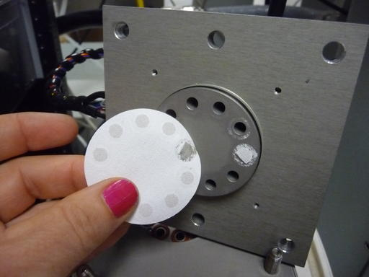  Here you can see some of the filter material stuck to the top of the CLAP. This should be cleaned off (use ethanol) when doing a clap filter change.

4. Make sure that the top and bottom surface of the filter holder are clean – use a tissue and ethanol to remove any dirt or obstructions. Place a new filter in the filter holder. The white side of the filter must be facing up. Secure the lid on the CLAP by replacing the lid and tightening the 4 knobs until the torque driver clicks and won’t tighten any further. Note: the lid only fits on one way.

5. Check that the CLAP flow is approximately 1 lpm. The flow value you should look at is the one on the CLAP window in cpd2, NOT the flow on the instrument screen.

6. Let the system autodetect the end of the filter change. A CLAP filter change causes a disturbance in the CLAP measurement that can last several minutes. Letting CPD2 determine a filter change is over you will result in a less noisy/spikey data set. Note: If red light on the CLAP is off or the CLAP window no longer says ‘Changing filter…’ then the system has used the autodetect function to determine the filter change is done.

The other thing to note about the CLAP is the value of the flags variable on the cpdclient screen. In the picture above the flags value is 0100. That is indicative of a lamp error. The table below lists the flags that might be shown on the cpdclient screen and their meanings. The flags are additive in the hexadecimal system so you could see a flag 07FE which would indicate temperature error, lamp brightness error, lamp error, all the transmittances are below 0.5 and there is a flow error. (i.e., lots of stuff is wrong!)

CLAP flags
0400 – temperature error (inlet or block) | 0010 – TrG<0.7
0200 – lamp brightness error | 0008 – TrB<0.5
0100 – lamp error | 0004 – TrB<0.7
0080 – TrR< 0.5 | 0002 – flow error
0040 – TrR < 0.7 | 0001 – filter changing
0020 – TrG < 0.5 | 0000 – all is good with instrument
See CLAP manual for more details about CLAP operations, flags and troubleshooting.

Nephelometer Span Check - (Weekly Task)
Stations applicable: ALT, AMF, AMY, APP, ARN, BEO, BND, BRW, CPR, CPT, EGB, ETL, KPS, LLN, MLO, SGP, SPL, SPO, THD, WHI, WLG
Time required: Approximately 40 minutes
Tools/supplies: None
Overview: The nephelometer span check confirms that the nephelometer calibration is correct. The procedure is mostly automated, although the valve on the CO₂ tank needs to be manually opened and closed. The system control code CPD automatically turns off the heaters on the systems that have humidographs (BRW, SGP, AMF), so that humidified air does not contaminate the span check.

Span Check Plumbing
The plumbing for a span check is as follows: CO₂ tank → Regulator→ Flow control Valve → Rotameter→ Copper tubing→ Plastic tubing→ filter → neph CO₂ inlet (wet neph inlet at sites with humidograph (AMF, BRW, SGP)
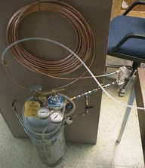

Span Check Operation
Open CO₂ tank valve. At stations with multiple nephelometers (typically stations with humidograph systems (e.g., BRW, SGP, AMF)) the CO₂ flow rate should be ~8lpm, at all other stations the CO₂ flow rate should be ~5lpm.

Press <enter> <N><M><5> to get to the span check window. Here you have the opportunity to change some of the span check parameters and identify which nephelometers will be span checked. These settings are pretty standard so leave them be unless there is a special occasion to change them. Use the <arrow keys> to choose begin and press <enter> (this will start the span check and CO2 flow through either the single nephelometer or both nephelometers). Note: for stations with multiple nephelometers you could instead press <enter> <O><M><5>.
The computer will prompt you for CO2 tank pressure and flow rate and will notify you when the span check is over and display the calibration results. You will need to toggle between nephelometer windows to check both nephelometer’s span check results. Typing these sequences: <enter> <N> and <enter><O> a couple times each will take you to each nephelometer’s window and the corresponding span check results.
Notes:
→If the span check error is ~60% this indicates that CO2 is not getting to the nephelometer. Check the tank (is it full? Was the regulator all the way open?); the CO2 lines (cracked tubing, broken connections); and flow through the nephelometer (did the 30 lpm get turned off for the CO2 portion of the span check? Did the CO2 flow rate remain at ~5 or ~8 lpm for the CO2 portion of the span check?)
→Conduct a second span check if the average error is more than 4% for either nephelometer. The point of the second span check is to make sure that the large error in the first span check wasn’t caused by operator error (e.g., forgetting to open the CO2 valve or not having the CO2 valve open enough).
→If the second span check is also higher than 4% then contact a NOAA scientist to discuss troubleshooting the problem.

Close CO₂ tank valve when finished.

Servicing impactors for nephelometer and PSAP - (Weekly Task)
Stations applicable: ALT, AMF, AMY, APP, ARN, BND, BRW, CPT, CPR, LLN, MLO, SGP, SPL, THD, WLG
Time required: 20 minutes
Tools/supplies: a 1 1/8” wrench, and the impactor kit
Overview: It is necessary to clean the impactor plate to ensure the impactor size cut is accurate. Cleaning the impactor plate involves disconnecting the impactors and disassembling them so that the impaction place can be accessed and cleaned. Cleaning should occur more frequently than weekly if large particle deposits are observed.

Removal of Impactors
- <enter><enter> Enter message "Starting impactor servicing". <enter>
- <enter> to bring up the main menu, then select “bypass status” using the arrow keys and press <enter>. The bypass status screen will appear. Then press <M><2>. Then use arrow keys to select “bypass” and press <enter>. This closes a solenoid valve and notifies the computer that impactors are off-line. Close the Manual ball valve. This is the valve upstream (behind) the 10 um impactor in the impactor box

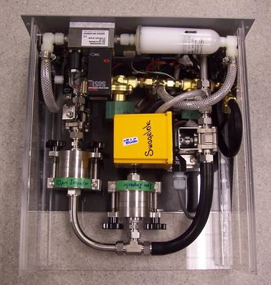 | This is a top view of the impactor box.  Manual ball valve is in upper left of picture in region of red box (hard to see). | Close the manual ball valve behind the 10 um impactor by rotating the handle 90 degrees to right (clockwise).

- Using 1 1/8” wrench, loosen the appropriate fittings and carefully remove impactors. Be careful of the tubing and cables in the impactor area so as not to disturb them.
- Place impactors on a flat clean surface. Use a large clean Kimwipe or printer paper.

Cleaning of Impactors
HINT: If you lay aside the cleaned pieces in order of removal, it will be easier to reassemble afterwards.
- Unscrew black knobs on 10-um impactor, and fold down the side arms.
- Remove top piece, clean inside (including inlet) with alcohol, tissue, and cotton swabs.
- Remove impactor jet plate, clean both sides with alcohol, tissue, and cotton swabs.
- Remove spacer ring, wipe clean.
- Remove impaction plate, clean both sides with alcohol, tissue, and cotton swabs.
- Remove bottom spacer ring that impaction plate sits in, wipe clean.
- Clean inside of outlet fitting.
- Replace bottom spacer ring.
- Spray the impaction plate with a thin coat of silicone lubricant spray. Wipe the excess silicone spray off the vertical edges of the plate
- Replace impaction plate.
- Replace spacer ring.
- Apply a generous coating of silicone vacuum grease to the impaction cup on the top surface of the impactor jet plate (only on 10-um impactor).
- Replace impactor jet plate.
- Replace top cover
- Tighten assembly back together with black knobs
Sketch of impactor
Side view Top view

Inlet

Impaction cup
Jet plate

Top spacer ring

Impaction plate

Bottom spacer ring

Outlet

Re-assembly of impactor box
- Reinstall impactors in system, being careful not to strip threads on fittings. Tighten all fittings by hand and then again with 1 1/8” wrench.
- Open Whitey valve by rotating handle 90 degrees to right (so it is parallel with flow).
- To unbypass the analyzers after the impactors have been re-installed: <enter>; use arrow keys to select “bypass status” and press <enter>; <M><2>; use arrow keys to select “unbypass”; <enter>.
- Press <enter> <N><M><3> to start a nephelometer zero cycle
- Enter a log message: <enter><enter> "System back on-line after impactor servicing and zeroing.” <enter>
- Do a leak check (see below, weather permitting) to make sure all fittings have been tightened and no leaks have been introduced into the system during the impactor change. Note: you need to wait until after the neph zero has completed (~6 min) to do the leak check.

System Leak Test - (Weekly/Whenever impactors are serviced)
Stations applicable: ALT, AMF, AMY, APP, ARN, BND, BRW, CPT, CPR, LLN, MLO, SPL, THD, WLG
Time required: Approximately 10 minutes
Tools/supplies: Large white HEPA filter with 2” cup fitting
Overview: It is important to test the aerosol system for leaks to ensure that measurements are made on outside/conditioned air and not on inside air. Two diagnostics are used to test the aerosol system for leaks: the pressure drop and the CN counts. Note this is easier/quicker with 2 people – one person to place and remove the filter at the saddle port and one person to enter the observed values for pressure drop and CN counts.
DO NOT attempt this procedure during stormy weather; SAFETY FIRST!! ☺

Enter a log message <enter><enter> ”Starting leak check” <enter>.

Bring up the input channels window <enter><A> and move it (if necessary) so you can see both the CN counts and the dp_neph_imp (unless otherwise noted Pd_P11 is the pressure drop across the neph impactor.)

Turn 3-way valve at CN inlet to ‘Neph’ position (i.e., it is perpendicular to flow into the CN counter inlet). Note: don’t do the leak check between XX:57 and XX:03 (3 minutes before the hour to 3 minutes after the hour) during that time the neph is zero-ing automatically and you will measure 0 particles when the valve is pointed towards the neph.

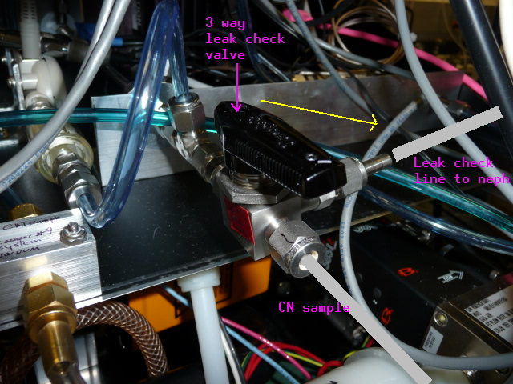 | Back of CN box. Photo shows 3-way leak check valve in ‘normal’ position.  For a leak check, rotate the 3-way valve clockwise 90º towards neph (as indicated by yellow arrow)  Note: don’t do the leak check between XX:57 and XX:03 (3 minutes before the hour to 3 minutes after the hour). During that time the neph is zero-ing automatically and you will measure 0 particles when the valve is pointed towards the neph.

Enter a log message <enter><enter> “Ambient CN count= value; dp_neph_imp= value” <enter>. The CN counts are the value for N_cncc in the main cpdclient window, or the CN counts can also be found by opening the CN window: <enter><c>. Unless otherwise noted, the dp_neph_imp value is ‘Pd_P11’ on the ‘input channels’ window.

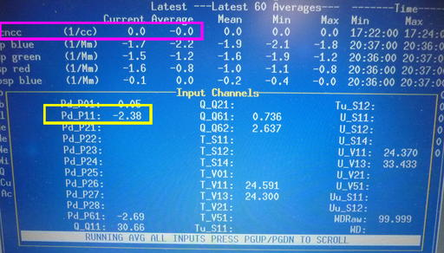 | The value you would enter for Ambient CN count is outlined in pink in this picture. The value you would enter for dp_neph_imp is outlined in yellow. Based on this picture, the message you would enter is: Ambient CN count=0; dp_Neph_imp= -2.38

Climb up to the saddle port at the base of the 8” PVC, undo the pins and remove the saddle port. Place the filter with the metal cup securely on top of the exposed 2” metal inlet stack.
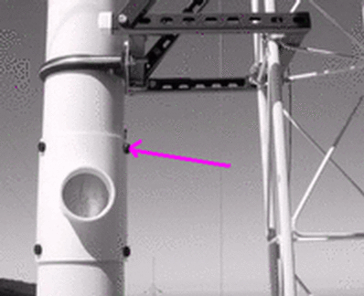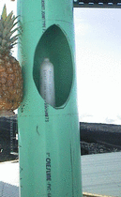

Enter a log message <enter><enter> “Filtered CN count= value; dp_Neph_imp= value” <enter>.
Acceptable ranges for these two variables when the filter is on the 2” sample inlet are:
dp_neph_imp > 20 CN_counts < 5% of ambient value
If the observed values are outside these ranges, there may be a leak in the system. A likely location to check is the connections on the impactors. If tightening those fittings doesn’t help, call the GMD contact person.

Remove the filter and replace saddle on 8" PVC.

Return the 3-way value to Inlet position (i.e., parallel to CN inlet sample).

Change Carousel Filters - (Weekly Task)
Stations applicable: BRW, BND
Time required: 30 minutes
Tools/supplies: Kimwipes, new canister of filters, old canister of filters, glovebox, 1 1/8” wrench, silicon spray.
Overview: Aerosol filters need to be removed from the carousel weekly and sent in to be analyzed.

Preparation
1. Prepare glovebox by putting down new Kimwipes and a new pair of outer gloves. Every other week or when you notice holes in the vet gloves replace them (you will need to tape these gloves on).
2. Turn on glove box pump.
3. Prepare a clean flat surface for changing the impactor films.
4. Type ‘<enter><F><M><2>’ to select filter change and notify the computer that the filters are off line.
5a. Close manual Whitey ball valve, which is above filter carousel, behind impactor by moving it 90 degrees clockwise so that it is perpendicular to the flow.
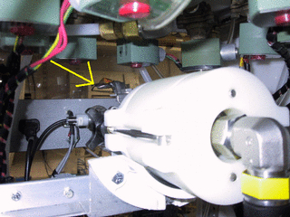
5b. Select option #2 to inform cpd that the ball valve is closed.
6. Release 8 white tubes with the quick connect/disconnect fittings, and disconnect the fitting at the elbow on the black tubing connecting the impactor to the carousel.
7. Place the carousel and a canister of filters (write start date on outside) in the glovebox, close the glove box and turn on the pump.
8. Back at the rack, disconnect fitting near valve so the impactor can be removed.

Change the impactor films
1. Wear gloves
2. Unscrew the black knobs and remove outer white sleeve. Make a note of the order of each section so that they can be put back in the correct order.
3. top section: clean out grease using methanol and Kimwipe; apply new grease
4. Section 2 (>10 μm particles): throw out film; clean section; spray a film from the plastic bag with silicon lubricant and place in holder with spacer ring on top
5. Section 3 (1-10 μmm particles): take out film with tweezers and place in old ‘S’ Petri dish. Clean section; Place new ‘B’ film on the stage, let sit for a minute and then return to ‘B’ Petri dish. This is the new ‘background’ film. Put new ‘S’ film on stage, place spacer ring on top and put impactor back together.
6. Place impactor back in rack.

Changing the filters
1. Take lid off carousel; black knobs first, then white knobs, turning knobs in counter-clockwise direction. (If you have difficulty doing this, try doing this outside of the glove box but put a note in the filter box when you do.)
2. Take out the red discs from the old container. Remove filters from carousel and stack in the old container in reverse numerical order (8 to 1), putting a red disc in between each filter. Put on the container cap and screw down.
3. Clean the carousel with alcohol. Place the new filter samples in the carousel, matching up the filter number with the carousel number.
4. Put top back on carousel, turn white knobs then black knobs
5. Put carousel back in the rack, attach the quick connects (orange-to-orange and black-to-black). Attach black hose to impactor.
6. Open Whitey valve by rotating handle 90 degrees clockwise so it is parallel to the flow.
7. Do a leak check (weather permitting) to make sure all fittings have been tightened
8. Type ‘<enter><F><M><2>’ to end filter change and begin filter sampling. When prompted, use the arrow keys and <enter> to select ‘manual valve is open’.
9. Record stop date on old sample container, put in box along with Petri dishes to mail to PMEL:
Kristen Schulz phone: 206-526-6220
NOAA/PMEL email: Kristen.Schulz@noaa.gov
7600 Sand Point Way NE
Seattle, WA 98115

CCN maintenance - desiccant cartridge check (weekly task)
Stations applicable: AMF, BRW, SGP
Time required: 30 min
Tools/supplies: 7/64” hex wrench, Phillips or straight screwdriver, spare desiccant cartridge
Overview: The CCN counter counts the number of droplets created in its main column using an optical particle counter (OPC). To protect the OPC optics from the wet environment the droplets are in, a dry air flow is passed over the OPC optics window. Occasionally (~2X/year) the desiccant cartridge which generates the dry air must be replaced.

To check the status of the desiccant cartridge, remove the CCN cover counter. First remove the computer screen –slide it up ~1/2” and then pull off and place somewhere (you don’t need to undo the cables). Move the keyboard out of the way. To remove the cover you will need a screwdriver to undo the screws holding the cover to the back of the instrument (figure a), there are ~10 screws: 3 on top, 4-5 on the left, 2 on the right. Next you will need to undo 3 hex nuts on the left side of the cover (figure b) using the 7/64” hex wrench. Finally, pull the cover out of the rack towards you so you can inspect the desiccant cartridge (figure c). The cartridge should show blue above the label at the bottom. If there is no blue showing (you only see pinkish-purplish colors) the cartridge should be replaced.

(a) some of the cover screw locations (pink) | (b) hex nut locations | (c) desiccant cartridge
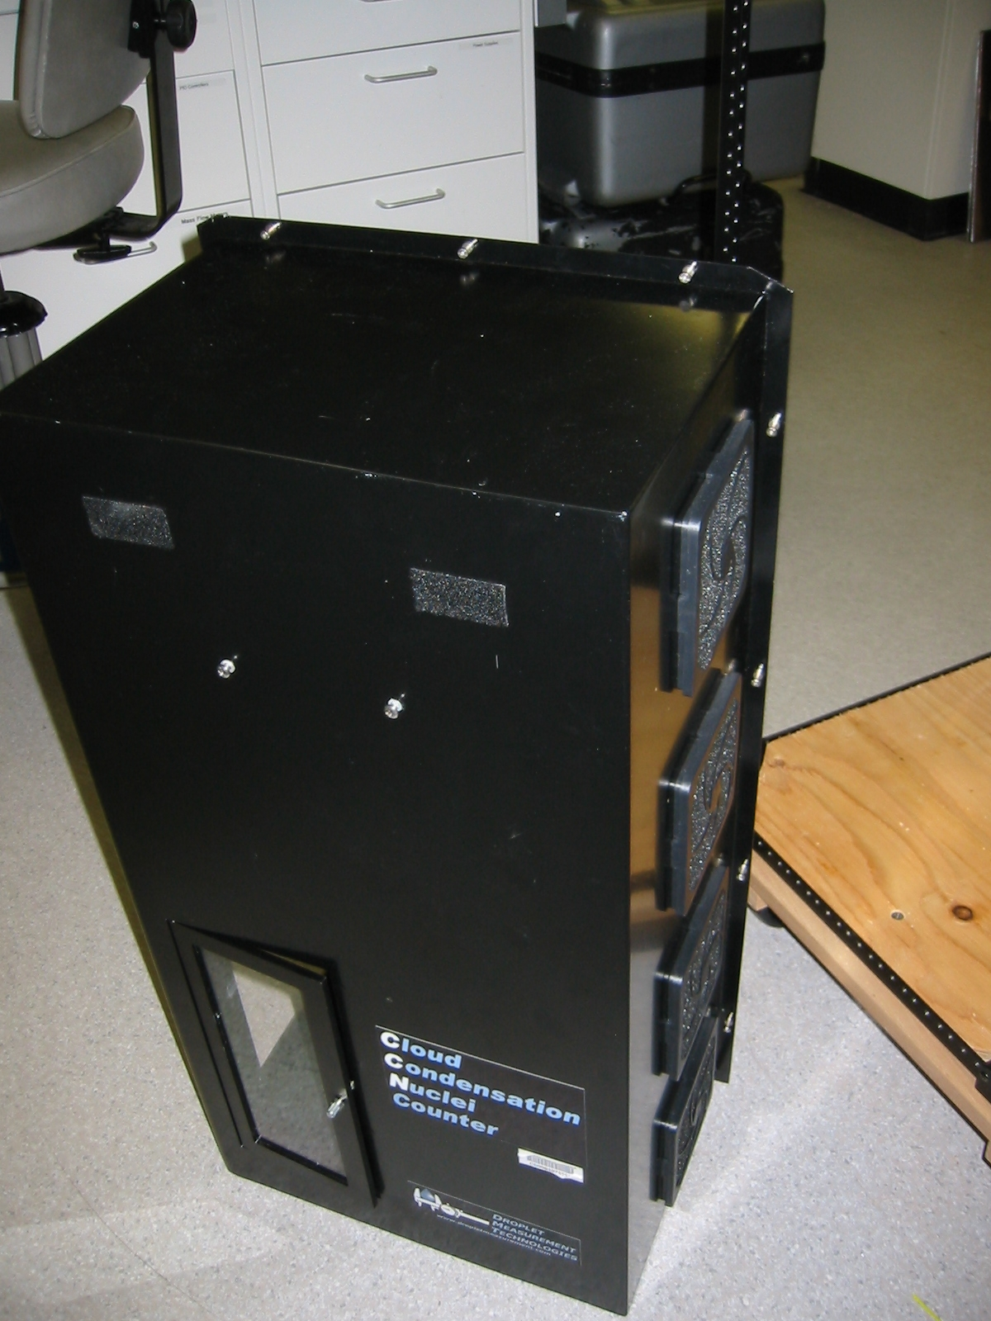  Computer mount screws | 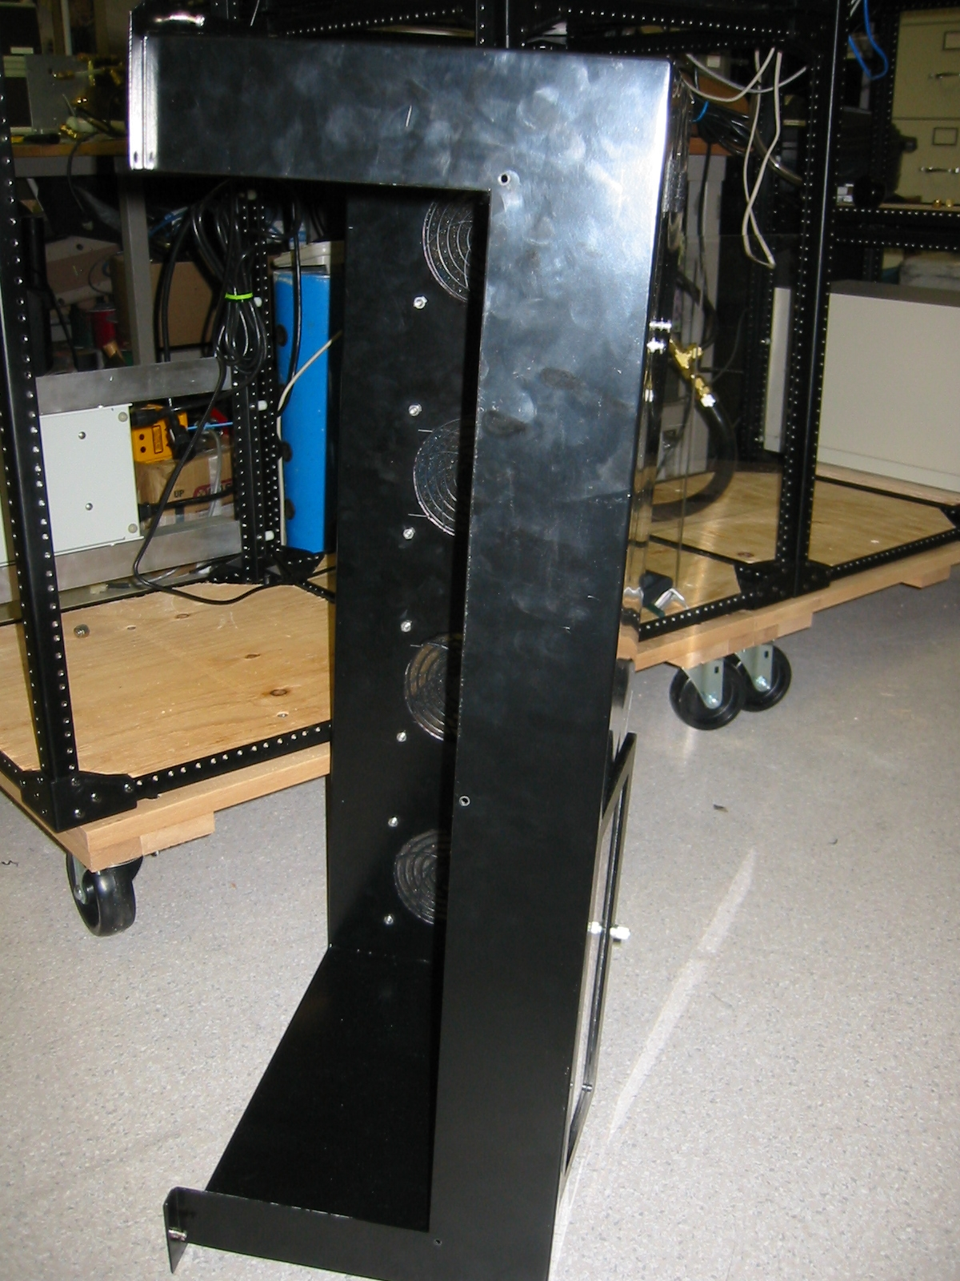 | 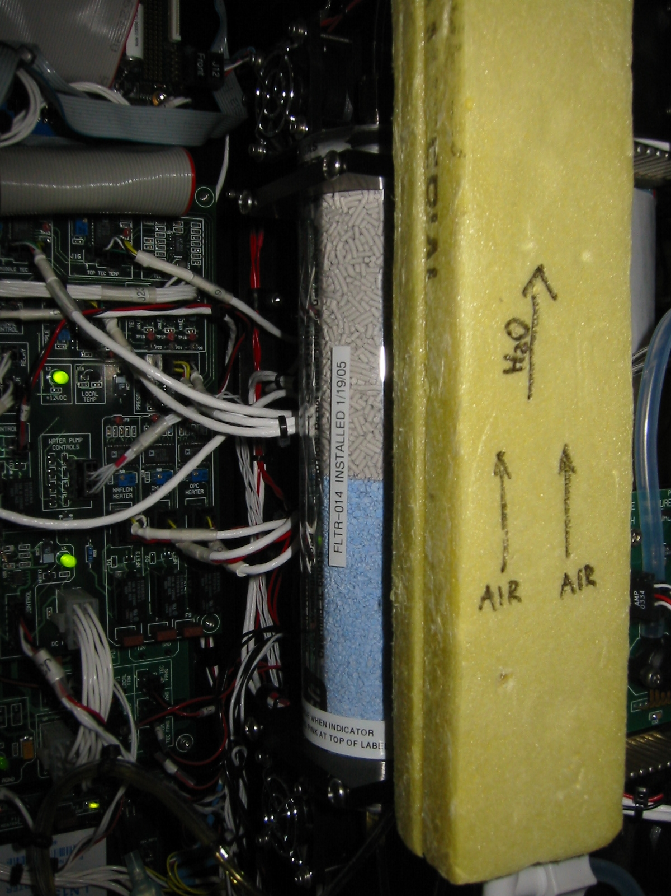  cartridge  label

CN Butanol flush (monthly task)
Stations applicable: AMY, ARN, CPR, THD (at CPR it’s a weekly thing!)
Time required: 15 min
Tools/supplies: 9/16” wrench Phillips, waste butanol drain bottle
Overview: The butanol in the CN counter absorbs water readily, so at humid sites the butanol should be flushed monthly to maintain the appropriate butanol properties and to keep the optics block clean.

Enter a log message: <enter><enter> "Doing a butanol flush.” <enter>
Detach the CN counter vacuum so no flow is going through the counter (at THD the vacuum line is accessed from the back of the rack – it is labeled CN vacuum). Attach the drain bottle to the CN drain port on the front of the rack and loosen the cap. Butanol should flow into the drain bottle. Note: if butanol does not seem to want to flow, (1) detach the drain bottle (2) squeeze the bottle with the cap loose (3) tighten the cap keeping the bottle squeezed (4) reattach the drain bottle to the drain port (5) loosen the cap. This procedure should create a small suction to the bottle and get the butanol flow started.

Inspect the butanol you’ve drained out. If it looks pretty clear and not yellowish, refill the CN counter with fresh butanol and reattach the vacuum line. If the butanol is not clear and/or has a yellowish tinge, refill and drain the CN counter several times to try to clean the gunk out of the instrument. Contact the station scientist if the butanol remains discolored despite multiple drains.

Changing Nephelometer Lamp – (As needed, ~3-6 months)
The system mentor will let you know if this needs to be done. The nephelometer lamp usually last about six months. Typically, scientists watching the station data (lamp voltage and current) at GMD can tell about a week ahead of time when the lamp is going to go. We like to change the lamp before it goes due to the possibility that when the lamp goes it could cause further damage to the nephelometer. Detailed instructions for changing the nephelometer lamp are given in the TSI nephelometer manual on page 8-13.

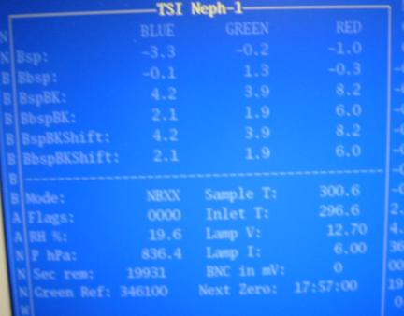  This is the neph window in the data acquisition program. You can see the lamp voltage (Lamp V) and current (Lamp I) at the lower right. | 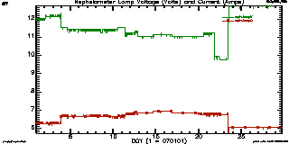  This is a plot of the neph lamp voltage (green) and current (red) as the bulb started to die at one of our ground based stations. It’s not instantaneous so you should be able to catch it if you keep an eye on it.

Resetting Love PID controllers – (As needed)
Love PID controllers are used in the aerosol system to control heaters (based on a relative humidity reading) and to control flow for the main sample line(s).

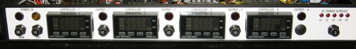 | Front of PID box show 4 PID controllers
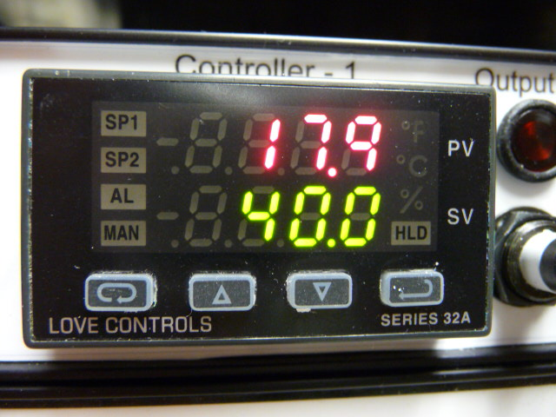 | The top value (red numbers) is the measured value. The bottom value (green numbers) is the set point.  The button on the far left is the INDEX button.  The button on the far right is the ENTER button.

Changing the setpoint
Typically the Love PID controllers require no maintenance or changes. However, at some point it may be necessary or useful to change a set point. Hit the INDEX button to get to the primary menu setting SP1. Use the up/down arrows (the two middle buttons) to adjust the setpoint to the desired value. Then hit ENTER to make the setpoint take effect.

Resetting
Occasionally (quite rarely) the Love PID controller will fail in a non-catastrophic way and need to be reset. If this happens, the factory default values should be restored and then the settings should be adjusted to those for the aerosol system. The procedure is described below.

This should be done if any strange messages (e.g., FAIL tESt) appear on the controller display)
- Turn off power to controller
- Turn on power to controller
- While controller is performing SELF tESt, press and hold the INDEX and ENTER keys.
- The controller will display the ROM ID code. Press INDEX.
- The controller will display FACt dFLt. If you wish to just restore factory settings, press ENTER and DOWN ARROW at the same time. The controller will be reset to the original factory settings.
- Press INDEX to display ACPt. Select YES or no.
YES -- Changes are accepted and control re-boots.
no -- Changes are discarded and control re-boots.

Once the controller has gone through the reset procedure and has the factory default settings in it you will need to set the settings to those that are used for the aerosol system. The table below describes the settings used by the aerosol system. There are 3 different PID menus that need to be adjusted.
- Primary Menu – access using the INDEX button
- Secondary Menu – access by pressing the up arrow button and the INDEX button at the same time.
- Secure Menu – access by pressing and holding the up arrow button and the INDEX button at the same time for 5 seconds

Once you are in a menu domain, use the INDEX button to move up or down; use the up/down arrows to change values and use the ENTER button to keep a changed value.

Settings for PID Controllers should be as listed in the table, unless otherwise noted. You may see some other parameters listed in your PID menus, but if they are not specifically listed below, they are not applicable and can be ignored. Pictures of a Love PID controlling showing each of the settings are in the document: /aer/doc/inst/pid/LovePID_settings.doc.

PID Menu settings for aerosol system
Love PIDs for heater control (#1,#2,#3) |  |  | Love PID for flow control (#4)
Primary | Secondary | Secure | Primary | Secondary | Secure
Auto = On | ALLo = 0.0 | SECr = 4 | Auto = Off | Out1 = ProP | SECr = 4
SP1 = 40.0 | ALHi = 100.0 | InP = diFF | SP1 = 30.00 | tun = nor | InP = Volt
 | Out1 = 1tP | Unit = none |  | ArUP = OFF | OSUP = OFF
 | Tun = nor | dPt = 0.0 |  | ArtE = OFF | Unit = none
 | ArUP = OFF | InPt = OFF |  | Fint = 0 | dPt = 0.00
 | ArtE = OFF | INPb = FAIL |  | Pct0 = OFF | InPt = OFF
 | Fint = 0 | APct = AdJ |  | Prog = OFF | InPb = FAIL
 | Pct0 = OFF | SEnC = OFF |  | PSEt = OFF | APct = rEAL
 | Prog = OFF | SCAL = -100.0 |  | InPC = 0.00 | SEnC = OFF
 | PSEt = OFF | SCAH = 100.0 |  | FiLt = 2 | SCAL = 0.00
 | InPC = 0.0 | SPL = 0.0 |  | LPbr = OFF | SCAH = 99.99
 | Filt = 2 | SPH = 100.0 |  | LOrE = rE | SPL = 0.00
 | LPbr = OFF | SP10 = OutA |  | Addr = 34 | SPH = 50.00
 | LOrE = rE | SISt = dir |  |  | SP10 = OutA
 | Addr = see note below | SIOL = 0 |  |  | SiSt = rE
 |  | SIOH = 100 |  |  | SIOL = 0
 |  | SILP = 0 on |  |  | SIOH = 100
 |  | AL = HiLo |  |  | SILP = 0 on
 |  | Alt = AbS |  |  | Addr = 34
 |  | ALrE = OnOF |  |  | bAUd = 9600
 |  | ALPi = OFF |  |  | nAt = OFF
 |  | AL iH = OFF |  |  | Stor = no
 |  | ALSt = OPEn
 |  | ALLP = OoFF
 |  | ALLb = OFF
 |  | Addr = see note below
 |  | bAUd = 9600
 |  | nAt = OFF
 |  | Stor = no
Note: Addr for PID #1, #2 and #3 should be 31, 32 and 33 respectively.

System Clock
The clock is synched automatically using the GPS unit or the local time server.
Table 2 Difference between local standard time (daylight savings) and UTC for some stations.
STN | APP | BRW | BND | CPR | MLO | SPO | SMO | SPO | SGP | THD
hrs diff | 5 (4) | 9 | 6 (5) | 4 | 10 | 0 | 11 | 0 | 6 (5) | 8 (7)

Instant Messenger
A text based instant messenger system is available within CPD. This is useful for troubleshooting with one person at the field computer and one person in Boulder. To use the instant messenger, both the person in the field and the person back in Boulder need to be logged into the field computer and running cpdclient.

Then both people follow these directions:
Bring up the main aerosol system menu: <enter>. Choose the option ‘Messaging’ using the arrow keys and hitting <enter>. This will bring up a box for typing in messages. Hit <enter> to send the typed message. When you are done with all the instant messaging, hit <esc> to close the window.

Computer Operation

General
The computer runs a live CD distribution of Linux based on Debian Squeeze. The data acquisition and instrument control is done with a family of programs, collectively referred to as 'cpd', which uses a client-server architecture to separate the continuous operating tasks (acquiring data, writing to disk, controlling instruments) from the user interface tasks. The server is called 'cpd'. There are currently two clients, 'cpd2.cursclient' for text-mode display (i.e., the screen with windows displaying values for different measurement parameters), and 'cpx2' for graphical (stripchart) display. The text-mode client allows the user to issue commands to 'cpd'.

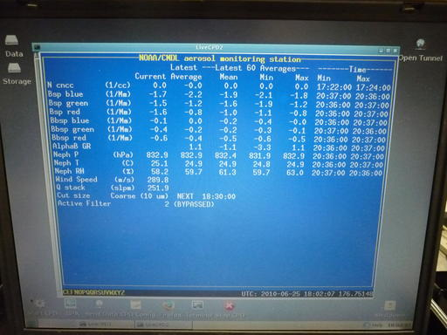 | 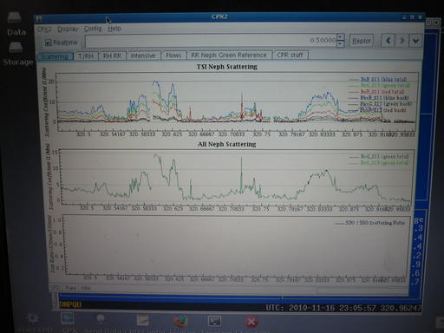  graphical (stripchart) display (CPX2)
cpdclient (text mode) display
also called aerosol data logger window
- Most icons on desktop (rather than in bottom toolbar.)
- Help icon on bottom toolbar pops up menu with useful documents (e.g., this operations manual) and contact info
- All desktop icons require double clicking to activate.

The system clock is set to UTC (7 hours different from Mountain Standard Time in Boulder). The clock is synchronized with a network time server using the 'ntp' protocol. If a network time server is not available, it is possible to use a GPS receiver directly connected to the computer as the time standard. The system clock is displayed in the lower right corner of the Aerosol Data Logger window.

Instruments are connected to the computer via RS-232C ports.

Startup
This assumes you have a USB stick which is already initialized and a LiveCPD CD. The CD contains everything you need to run CPD on the computer, while the initialized USB stick contains station specific configuration information (e.g., the cpd.ini file) and, depending on configuration, the USB stick is usually the location where data are stored.

Insert USB stick in USB port (either on back of computer or in edgeport module)
Turn on PC.
After a few minutes, the NOAA aerosol data logger window will appear.

There are eight at the bottom left of the screen. The shutdown icon is the ninth icon at the very far right of the screen. Position the mouse over each one to see its function.

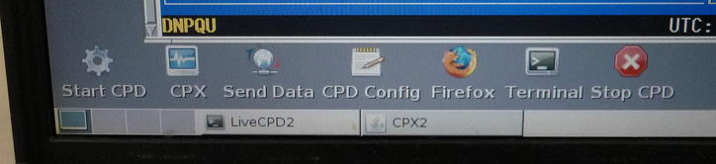 | Icons for cpd2 desktop

CPD2 desktop functions, left to right
These functions, from left to right, are:
1. Start data logger – the CPD program
2. Stripchart data – the CPX program
3. Send data to NOAA
4. Edit the cpd.conf file (using Nedit)
5. Web browser
7. Icon to bring up a terminal window
8. Stop data logger
9. Shutdown everything!
Click TWICE on the icon to activate

During normal operation you should never need to select 1 because the data logger starts up automatically when the computer is turned on. Number 3 also happens automatically, with a frequency between 1 and 4 times per day (an automatic email is generated at GMD detailing what data files have been processed. Occasionally there are some automated warnings based on system parameters in the email as well.

If for some reason you did need to start cpd and the data logger, here’s what to do:
To start the data acquisition program, click on the “Start cpd” icon. This will start 'cpd' in a background window, and several seconds later starts 'cpdclient' in the terminal window.
To start the graphical client 'cpx', click on the “Stripchart data” icon. This takes a little while to get started so don’t keep clicking if it doesn’t start right away!! To stop data acquisition and shut everything off, click on the “Shutdown” icon. The “Shutdown” icon will ask whether you want to shut everything down, reboot or cancel the request to shutdown.

These programs can also be started from a command line in a terminal window by typing one of the following commands:
cpd --client → starts the text mode client (blue screen)
cpd.--restart → starts both cpd and text mode client
cpd.--halt → stops cpd and text mode client
cpd --plot → starts the graphical client cpx2
cpd --help → get more command line options

Shutdown
To cleanly shutdown the computer follow these steps:
- Click on the “Shutdown” icon on the lower right of the screen
- This will pop up a small window in the upper left corner saying ‘Shutdown’, ‘Reboot’, and ‘Cancel’. Choose ‘Shutdown’ to shutdown.
- Wait for the computer to display “Power down”.
- Turn off power.

Archiving and Backing-up Data
Note: This is typically done automatically, these steps are needed only if manual archiving is required. The data archives are standard “tar.gz” format. The data files are plain ASCII, comma-delimited, with headers.

Other desktop icons
Two icons at the top-left corner of the desktop start a graphical file manager for browsing the file system. The "Open Tunnel" icon in the top-right corner of the desktop enables remote access to the LiveCPD system for troubleshooting and maintenance.
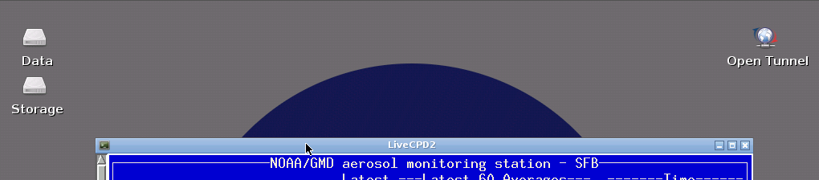
Clicking on the ‘Data’ icon opens a window with the file directory in which the current data are being logged (equivalent to /aer/stn/log), while clicking on the 'Storage' icon starts the graphical file manager at the root of the file system.

If you need to transfer data or other files from the field computer to another computer, insert a USB flash drive into the USB port on the back of the computer or in the Edgeport adapter. Double-click on the 'Storage' icon, and then click once on the icon for your USB flash drive in the side pane. This will bring up a window with the directory structure of the USB stick. (Note: you may need to refresh the directory window if a different USB stick had previously been inserted.) When you are done with transferring data (or whatever) remove the USB stick – the system will automatically dismount within 30 seconds or so.

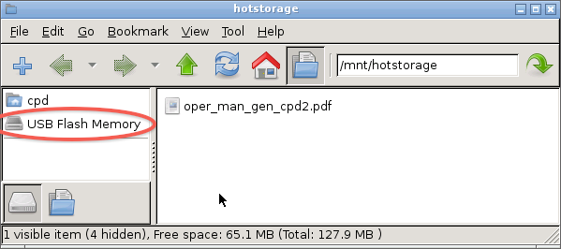
File manager window showing icon for USB flash drive

LiveCPD2 Documentation
There are documents on the desktop explaining how this all works.
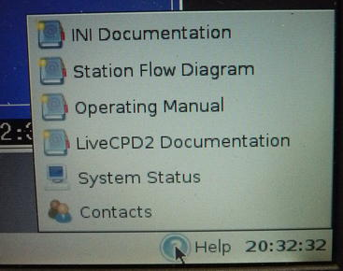
In cpd2 the help icon on the left of the bottom toolbar will bring up a menu with links to useful documents.

The “CPD Conf” icon opens a text document that describes all the options that can be put in the configuration file for cpd, cpd.conf. The README icon describes the LiveCPD Linux distribution in detail – how to configure the USB stick, more detailed descriptions of all the icons, etc. This document is called ‘LiveCPD2 documentation’ in CPD2. The LiveCPD/liveCPD2 documentation also explains the use of the icons in the lower right of the desktop.

Graphical Client Program (cpx2)
The graphical client is a work in progress. Please send suggestions for improvement to John.A.Ogren@noaa.gov. Documentation for cpx2 can be viewed by clicking on the “Help” item on the cpx2 menu bar. This graphical interface allows you to see what’s happening with the data over time, so, for example, you could use it to watch CN counts get much lower when you put the leak test filter on the stack. To start cpx2 double click on the CPX icon in the lower part of the screen

Aerosol Data Logger Program

General Operation
Press <enter> to access menus, <Esc> to abort from any menu or entry box without any changes, a second <Enter> to accept the current entry or highlighted item. Any instrument window can be displayed by the shortcut key <Enter><X>, where “X” is the code letter for the desired instrument. Windows are closed by pressing the <esc> key. Pressing the <Tab> key cycles the view among all the active windows. Windows can be repositioned on the screen using the arrow keys. Menu entries can be selected with the arrow keys or pressing the numerical digit for the desired selection.

The program will request an access code if you select a menu item that will result in a change to the data being logged to disk, in order to prevent inadvertent changes. The access code is ‘cmdl’ (lowercase is necessary).

Keystrokes | Action
<enter> | Shows root menu
<esc> | Shows root menu and hides any active menu
<Enter><X> | Selects root menu entry ‘X’ when root menu is not focused (X can be A,B,C,D,F,G,H,L,M,N,O,S,U,V,W or others depending on the station)
<enter><enter> | Online log entry (message window)
<F12> | Online log entry (message window)
<control><E> | Toggles red error window (if present)
<control><C> | Quit cpdclient
<M> | Shows menu for active window
<esc> | Closes active window
<tab> | Cycles through open windows
Arrow keys (in menu) | Move thru menu list
Number/letter (in menu) | Quick select on menu list
Keystrokes | Action
<enter> (in menu/dialog box) | Chooses or toggles selected item
<enter> (dialog box) | Begins ‘enter input’ mode, text will be bolded; pressing <enter> again will end input mode
<esc> | Exits menu/dialog box without applying changes
<enter> (with bottom entry selected in dialog box) | Closes dialog box and applies all changes
<enter><enter> | Brings up message window

Display
The “base” display consists of a “root” window for displaying current values for ambient measurements and a status line at the bottom left of the screen.
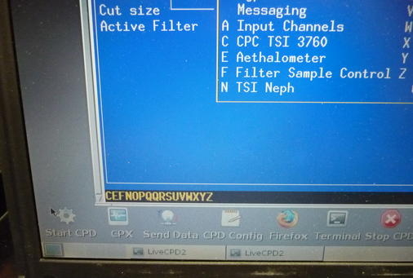 ←status line location (in pink box) in root window
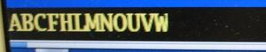 ←example status line

The bottom status line gives the code letters of the active instruments and the system date and time. If the code letter for an instrument is absent, then that instrument is not present or not responding.

The code letters are assigned in cpd.conf, and vary from station to station. Status windows for specific instruments can be displayed by pressing <enter> plus the code letter for that instrument. Note: the code letters are can be assigned to any instrument, however we try to be (mostly) consistent. Common assignments for code letters are:

A – Analog signals (e.g., flows, Ts, RHs, Ps, wind speed/direction)
B – Best UPS
C – CN
D – CCN
F – Filters
G – GPS
L – PSAP
M- contamination
N – nephelometer (reference/dry) active
O – nephelometer (humidified/wet) active
P – PID Box – this is box with T/RH and flow control
R – could be PSAP (esp. if it’s a 3-w PSAP), or for second PID box
T – TSI mass flow meter
U - μMAC1050 A/D I/O subsystem
V - μMAC1050 A/D I/O subsystem
W - could be CLAP or 3rd μMAC1050

Root Menu <enter> or <esc>
Pressing <Esc> or <enter> brings up the root menu, with the following choices (shortcut keys are in the left column). Use the arrow keys to highlight the desired action and then press <Enter>:
(Not all stations have all of these options – it depends what instruments are deployed.)
→ | Online log entry | allows the user to make an entry in the system log file. Think of this as an on-line logbook, and use it liberally. Each entry can be at most 8192 characters long, and each entry is recorded with a time stamp. Please make an entry for any deviations from normal operation, such as exceptions that you note on the daily checksheets. These logbook entries will be sent to the GMD aerosol group by email shortly after the data are sent to Boulder.
→ | Client Options | controls some features of the client program.
→ | Disk operations | allows the user to flush any buffered data to disk, and to change to a new set of data files
→ | Save configuration | Saves layout of windows if you have a cpdclient set-up you like
→ | Cutpoint Control | Allows to change size cut or disable cutpoint scanning
→ | Humidograph | Allows to change humidograph setpoints or disable humidograph scanning
→ | Bypass status | Allows to bypass/unbypass analyzers (e.g., during impactor service)
→ | Messaging | Starts Instant Messenger
A | Activate the analog signal window | 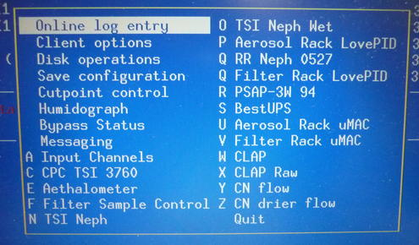  Example root menu. Note: two Q items – that will not work!
C | Activate the CNC status window (shows current concentration)
D | Activate the CCN status window
E | Activate Aethalometer status window
F | Activate the filter status window
G | Activate the GPS status window (Filter#2 at BRW)
L (or R) | Activate the PSAP status window (L or R depends on your system, only one will work)
N | Activate the nephelometer status window (Typically this is the ‘dry’ or ‘reference’ neph.)
O | Activate the second neph status window (Typically this is a ‘wet’ or ‘humidified’ neph.)
P | Activate the PID box status window. (PID box controls T/RH/flow)
U | Activate the umac status window (This is the main umac.)
V | Activate the 2nd umac status window (This is the umac that typically controls the filter carousel.)
W | Activate CLAP
→ | Quit | Quit cpd client

Input Channels Status Window and Monitor Menu <enter><A><M>
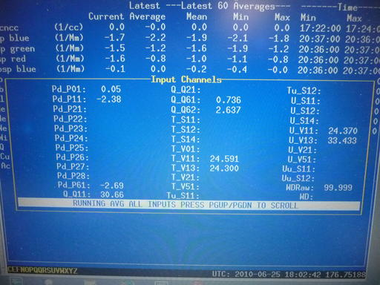  The input channels window shows the values of monitoring parameters like temperatures, humidities, pressures, flows and wind speed/dir. | 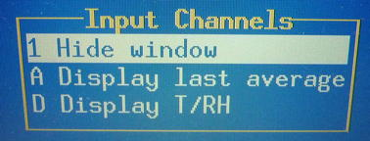  The input channels menu allows you to look at all the signals or just select signal types (temperatures and RH (T and U), pressures (P) , flows (Q)) by toggling through them. You can also display running averages or the last average value.

Window hide/Window unhide <1> changes visibility of status window

Averages <A> context-sensitive function to display averages, running averages or instantaneous values of analog input signals

Toggle <D> context-sensitive function to switch between screens with all parameters or screens with just one type of parameter (e.g., only pressures or only flows)

Nephelometer Status Window and Menu <enter><N><M> or <enter><O><M>
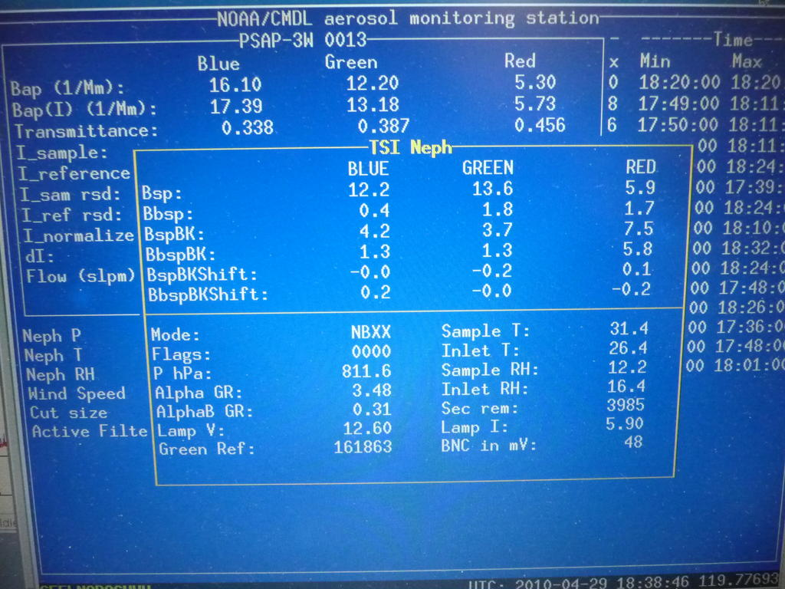  This window shows the current state of the nephelometer, including measured light scattering and back scattering at 3 wavelengths, neph monitoring parameters like temperature and voltage and neph state. |  | 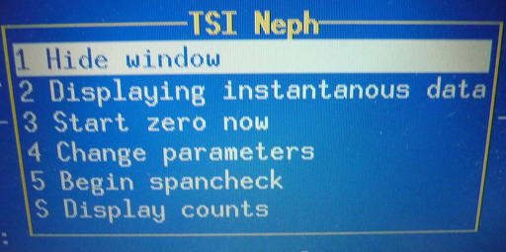  The neph menu allows the user to do a span check and change neph parameters.
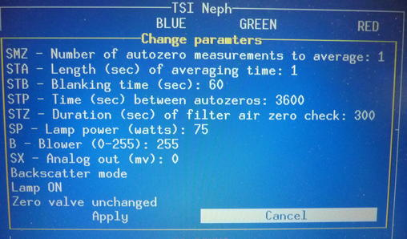  The change parameters menu lets the user talk directly to the neph | 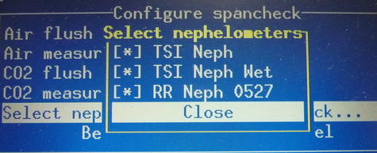  The select nephs option lets you choose which neph(s) to do a span check on. |  | 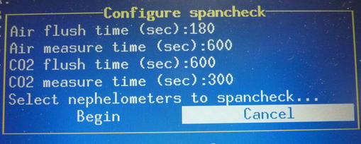  The configure span check option allows you to change span check parameters.

Window hide/Window unhide <1> changes visibility of status window

Display instantaneous/last average data <2> toggles between displaying 1-s data or running averaged data

Start Neph zero <3> starts neph zero

Change parameters <4> Activates a menu for sending selected commands to the nephelometer. Not normally used except for troubleshooting.

Span Check /Abort Span Check <5> context-sensitive menu to start/abort a CO₂ span check.

Display counts <S> toggles between nephelometer photon counts and nephelometer scattering

PSAP Menu <enter> <L> <M> or <enter><R> <M>
The PSAP window shows the light absorption flows, transmittance through the filter and various other monitoring parameters from the PSAP.  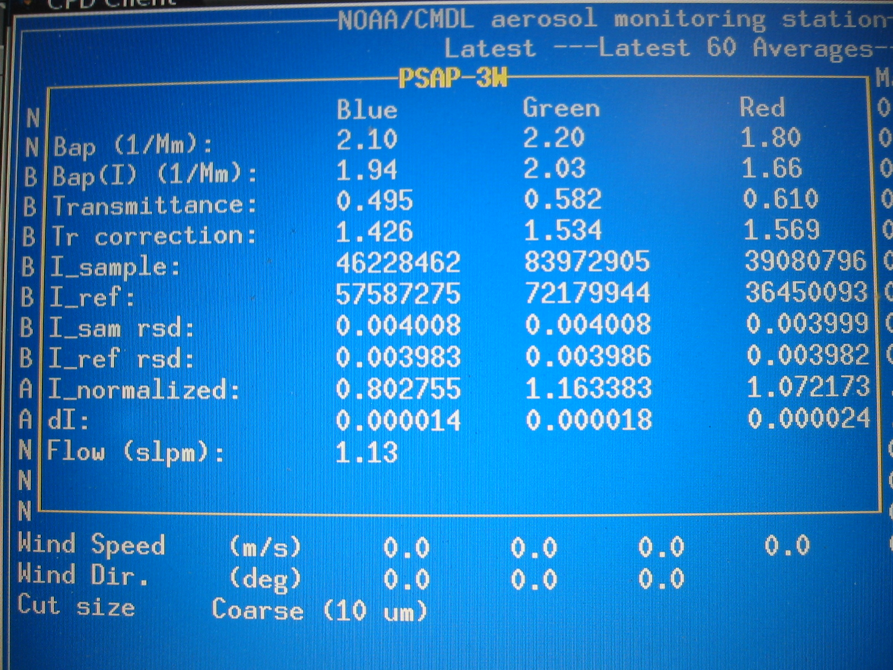 | 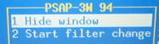  the purpose of the PSAP menu is to note when a filter change takes place.

Window hide/Window unhide <1> changes visibility of status window

Start filter change/ End filter change <2> Context-sensitive menu to start/end a filter
Use this function to prevent data logging during a PSAP filter change, and to generate automatic log file entries when PSAP filters are changed.

CLAP Menu <enter> <L> <M> or <enter><R><M>
Window hide/Window unhide <1> changes visibility of status window

Start filter change/ End filter change <2> Context-sensitive menu to start/end a filter
Use this function to prevent data logging during a CLAP filter change, and to generate automatic log file entries when PSAP filters are changed. The protocol is to use this function to indicate the start of the filter change but to let the CLAP autodetect feature figure out when the filter change is done.

Start white filter check <3> This feature (run only when you’ve started a new box of filters or some sort of servicing has been done to the instrument) determines the characteristics of a white filter. One puts a new filter into the CLAP and then begins this check. During this check the flow is zero and the red light is lit. The white filter check will not automatically end, you must select this command a second time ("End white filter check") to terminate the white filter measurements and begin normal sampling.

Advance spot <4> This feature allows you to move to a different spot on the filter. I.e., if you are on filter spot#6 and want to move to filter spot#7. Note: this is probably more useful for field campaigns than day-to-day operations

Various display options <D> this feature has seven possible display modes you can cycle through in order. They are:
→display intensities - These are the raw intensities of all spots for all four sample modes (red, green, blue, and dark) as reported by the instrument.
→display intensities relative standard deviation (RSD) – The RSD of the raw intensities over the”normalization” period (normally 60 seconds, but can be changed in the configuration file).
→display normalized intensities – This is the ratio of each sample spot and its corresponding reference spot. For example, the first normalized intensities is the second raw spot over the last raw spot, both with the respective dark value subtracted before division.
→display normalized intensities RSD – The RSD of the above over the normalization period.
→display white filter ratios – The ratio of the current normalized intensities over the normalized intensities of the last white filter. This is similar to the transmittance relative to the last white filter (the difference being that the white filter normalized intensities do not account for filter flexing due to flow). At the end of a white filter check, with no flow, all these will be 1.0.
→display filter start ratio – The ratio of the current normalized intensities over the normalized intensities from the end of the last filter change. This is similar to the transmittance except that it does not acount for filter flexing due to flow (this can often be seen by there being a distortion away from 1.0 on unsampled spots for all the even or odd channels, depending on what reference is currently in use). With no flow, all unsampled spots would nominally be 1.0, and sampled spots would be their last transmittance.
→standard display (this is the typical display mode with flows and transmittances, etc)
To move among these you would select <M> then <D> until you get the desired display mode.

Filters Menu <enter> <F> <M>
Window hide/Window unhide <1> changes visibility of status window

Filter change <2> context-sensitive function to notify system that the filters will be changed. Changes to “Filter start” when changing.

Filters bypass/Filters unbypass <3> context sensitive function to allow manual bypassing of filter samples

NOTE: to cycle through filters to be sure they are all changing, a parameter in cpd.conf file needs to be adjusted. Talk to station scientist to figure this out.

Humidograph Menu <enter> <arrow keys to ’humidograph’ option><M>
Window hide/Window unhide <1> changes visibility of status window

Disable/enable scanning <2> start or stop the humidifier from humidifying

Change Setpoint <3> displays submenu for changing setpoints manually

Set Channel A <A> Sets RH set point of reference nephelometer

Set Channel B <B> Sets RH set point of humidified nephelometer

Set Channel C <C> Sets pump direction and speed. (range between -20 and 100)
0 = not pumping
15 = pumping water at 15% power into humidifier
-20 = pumping water backwards out of humidifier at 20% power

Set Channel D <D> Sets whether the high-range flow valve is open (H) or closed (L).

CCN Menu <enter> <D><M>
Window hide/Window unhide <1> changes visibility of status window

Enable/disable setpoint scanning <2> toggle switch

Change delta T <4> enables user to change delta T

Display housekeeping info <H>

Display cumulative number distribution <N> makes a simple plot of CCN N(dp)

CCN housekeeping info | CCN cumulative distrib. plot
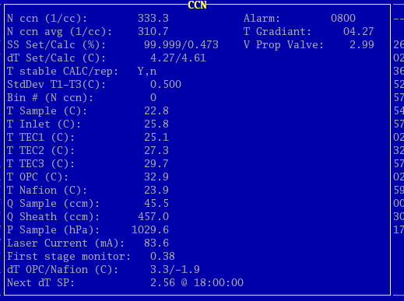 | 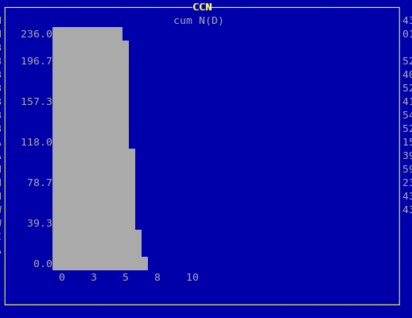

Safety

Heater Control
If the pump fails, any of the heaters (stack, humidifier rack inlet, preheater, humidifier, filter rack inlet) could overheat because the PID sensors don’t have flow past them. There is a high-temperature cut out switch on the heaters, which limits the temperature on the outer tube to about 80 degrees Celsius.

Electrical Safety
We have insulated the electrical connections inside the rack, so that it is safe to perform standard tasks inside the rack (e.g., changing impactor films) with the power on. However for non-standard tasks (e.g., replacing the humidifier), you should always remove power from the rack and the instruments you are working on..

Specifications

Power Draw at 115 V AC
Equipment | Draw (A) | Surge (A)
Carbon vane pump | 8.6 | 20
Diaphragm pump | 2.4 | 12
Bypass blower | 1.3 | 3
Cooling fan | 2.7 | 3.5
Aerosol System | 9.0

Additional Computer info

Data flow
The 'cpd' server logs data in the /aer/stn/log directory, where "stn" is the identifier of the station. Every six hours (or 24 hours), the current data are archived in a tar.gz file, for subsequent transmission to GMD in Boulder. The program that does the archiving is /aer/prg/cpd2/bin/cpd2.senddata, which is scheduled to run by the cron daemon. The configuration file for cron is /aer/prg/crontab/crontab.stn. The archived data are stored locally in the /aer/stn/log/sent directory. In Boulder, the data are initially put in the /ftp/incoming/aer/stn directory on the ftp.cmdl.noaa.gov server.

Aerosol Server Program (cpd)
Operation of cpd is controlled by a plain-text configuration file /aer/prg/cpd2/etc/cpd.conf. Configuration information for different stations are contained in separate files; for example, the SPO configuration file is /aer/prg/cpd2/etc/cpd2.spo.conf. Normally, cpd.conf is a symbolic link file that points to the station-specific configuration file. Detailed information on the entries in cpd.ini can be found in /aer/prg/cpd2/doc/conf.txt.

The server program is designed to run as a daemon, which means that the user does not directly interact with the program. It is started with the 'cpd -d' command, and terminated with the 'cpd2.stop' command. To verify that the server program is operating, type 'cpd2.ps' from a command prompt. This will display the processes associated with the cpd program.

The latest version of the cpd2 software can be downloaded from our ftp site:
ftp://ftp.cmdl.noaa.gov/aerosol/etc/cpd/livecpd2.iso

User account
The computer is configured to automatically log into the 'cpd' user account, which is used for running the cpd program at field stations.

Location of this document
This document is stored in /aer/doc/ops_man/oper_man_gen_cpd2.doc.
Both MicrosoftWord and Adobe pdf versions can be downloaded from: ftp://ftp.cmdl.noaa.gov/aerosol/doc/operations/

Station specific appendix

