I. General information:

1. Mission name: SENEX 2013

2. Instrument name: In Situ Airborne Formaldehyde (ISAF)

3. What is measured: Gas phase formaldehyde

4. Short description of measurement technique: The ISAF instrument uses laser induced fluorescence (LIF) to measure formaldehyde in a continuous flow of sampled air. A tunable laser is used to excite formaldehyde in the sampled air. A photon counting photomultiplier tube (PMT) collects the fluorescence. The signal from the PMT is linear with respect to the abundance of formaldehyde in the sampled volume.

5. Contact information for all personnel going to the field with this instrument:
(for multiple investigators, please list the PI or primary contact person first)

Name | Email | Office phone | Cell phone
1.Thomas F. Hanisco (Co-PI) | Thomas.hanisco@nasa.gov | 301-614-6598 | 781-521-0244
2. Frank N. Keutsch (Co-PI) | keutsch@chem.wisc.edu | 608-262-7904 | 608-443-7492
3. Glenn M. Wolfe | glenn.m.wolfe@nasa.gov | 301-614-6008 | 206-920-6242
4. Heather L. Arkinson | heather@atmos.umd.edu | 301-614-6925 | 571-255-0817
5. Andrew K. Swanson | aswans1@umbc.edu | 301-614-6925 | 410-530-6569
6. Katherine Skog | skog@chem.wisc.edu | 608-262-0269 | 608-217-6484
7. Jennifer Kaiser | kaiser@chem.wisc.edu | 608-262-0269 | 330-329-5711

II. Specific information:

1. Total installed weight:
(rack, gas cylinders, hoses, cabling, pumps, inlets, permeation tubes, etc.)

The ISAF instrument will share a rack with the PTR-MS instrument in Station 8. The Total weights are listed in the PTR-MS document.

Rack weight and balance info | Allowed | Actual
Weight, lbs.:
Overturning moment, in-lbs.:

Pod weight and CG:

NOTE: Please also provide weight-and-balance information for all installed equipment. Templates for standard electronics racks are available for download here. PIs with non-standard installations will need to provide relevant information in a similar format.

2. Individual subassembly info (weights should sum to total listed above)

Component name | Location name and flight station | Weight, lbs
ISAF P-3 Interface Box | Forward bay station 8 | 12.4
ISAF Instrument | “ | 62
ISAF Cal Deck | “ | 10 (est.)
ISAF Laptop | “ | 6.5
ISAF Inlet Interface | “ | 1.5
ISAF Pump | “ | 10 (est.)
Mounting brackets, cables, plumbing | “ | 4 (est.)
 |  | 106.4

3. Component power consumption in Amps

Please provide an electrical power diagram in Appendix A

Component name | Location name | 400 Hz  3Ø | 400 Hz  1Ø | 60 Hz | 28VDC | 28VDC  WOW
1. ISAF P-3 Interface Box | Station 8 |  | 5 A
 | Totals: |  | 5A
 |  | 400 Hz  3Ø | 400 Hz  1Ø | 60 Hz | 28VDC | 28VDC  WOW

4. Inlet and exhaust information:

Please provide an inlet/exhaust line diagram in Appendix B

Inlet/exhaust name | Location name and flight station | Hole size through hull, inches
1. PTR-MS (shared) | Sta8 camera port | 3.75
2.
3.
4.
5.
6.

5. Source of flow (name and location of pump or venturi)

Pump name | Location name and flight station
1. Diaphragm pump. Vacuubrand MD-1 Vario-SP | Sta8 rack forward bay
2.
3.
4.
5.
6.

6. Installed hazardous materials or equipment:
(only for items installed in the aircraft for use during flight)

A. Lasers

Type: Tunable fiber laser
Class: IIIb
Wavelength: 353 nm
Output power: 15 mW
Eye-safe? NO
Beam fully contained within instrument during normal operation? YES

For non-eye-safe lasers, please attach a description of safety measures taken (safety interlocks, beam fully enclosed within instrument, etc.) and a procedure for safe instrument operation during testing and laser alignment. Please contact the AIC for an example of laser safety documentation from TexAQS 2006.

B. RF transmitters: NONE

C. Radioactive materials: NONE

D. Compressed gases: NONE

E. Chemicals (solids and liquids):

Chemical number: | 1. Drierite (Calcium Sulfate) | 2. Activated Charcoal
Concentration | Pure | Pure
Amount | 250 cc (1 lb) | 100 cc (0.5 lb)
Container description | Plastic cylinder | Aluminum cylinder
Purpose | Air purification | Air purification
Solution pH | N/A | N/A
Spill kit provided? | NO | NO

F. Cryogens: NONE

G. UPS and battery installation: NONE

H. Motors

Description: Papst ECA7010 Brushless DC motor (Used on the Vacuubrand Diaphragm pump)

Motor current draw:
24 VDC 7A max. 4A continuous
Thermal interlock enabled? YES

I. Operator seat requests -
Test flights: TBD
Transit flights: 0
Science flights: 0

7. Data and plumbing drops

Network (Cat. 5/6 ethernet) drops requested: TBD

Serial drops requested: TBD

IRIG-B drops (BNC coax connector) requested: TBD

Vacuum/exhaust/ emergency dump lines: NONE

Ground gas service lines (number, location, type of service): NONE

Other gas lines (number, location, type of service): NONE

Will you be sending data to the AOC data station? NO

8. Aircraft access

a. flight days:
Pre-flight time requested at aircraft (hours): 1

Routine pre-flight ground support required? NO
(stands, ladders, forklifts, covers, external equipment, etc.)

Routine post-flight time requested at aircraft (hours): 0.25

Routine post-flight ground support required? NONE
(stands, ladders, forklifts, covers, external equipment, etc.)

b. non-flight days:
Routine external access to inlets or zenith mounts required? NO
(please describe location, how often, for how long, type of ground support equipment needed, weather constraints, etc.)

Please note there is zero access and zero power to the aircraft (including pods) on hard-down days. These occur at least once every seven calendar days while in the field.

9. Aircraft maneuvers: NONE

10. Miscellaneous

1. Hazmat for preflight/postflight calibrations: Please describe fully any additional hazardous materials - compressed gases, solvents, radioactive ion sources – that you anticipate temporarily bringing onto the aircraft for periodic instrument calibration purposes (e.g., n-butanol in a CN counter, ²¹⁰Po in a DMA, a UPS for power, compressed gas cylinders for calibrations, etc.)

We will occasionally (on non-flight days) calibrate the ISAF instrument with gas reference standard: trace formaldehyde in Nitrogen (UN1956). The reference standard is stored in a 300 cc stainless steel cylinder at 65 psia.

2. Fabrication and sheet metal support: Please describe fully any anticipated requests for fabrication or sheet-metal support during installation in Tampa. This list should be kept to an absolute minimum; please recognize that this superb AOC resource is quite limited. To ease the strain on the AOC shop, we will work with each PI to ensure they arrive in Tampa with as much in hand as possible.

NONE

3. Ferry flight/check flight procedures. On occasion, AOC will perform an aircraft check flight, during which the instruments may be flown without power. Aircraft maintenance needs may also dictate a ferry flight without science crew or SED techs on board. Instruments should be designed with these eventualities in mind. However, if your instrument requires standby power during this kind of flight, this may be provided at the discretion of AOC personnel.

If so, the flight crew will need to be briefed well ahead of time to ensure proper instrument operation. Please provide with this document a bare-minimum checklist of instrument startup and shutdown procedures requested for these flights.

NONE

III. Ground laboratory space

1. Tampa space requests:

Power requirements: 115VAC/15A

Special requests: NONE

2. Field space requests:

Workspace, ft²: 100
Number of tables/chairs: 1/2
Power requirements: 115VAC/15A
Storage space, ft²: 25 (5 BOXES + 1 CYLINDER)
Other requests: NONE

APPENDIX A: Electrical Diagram of the ISAF instrument

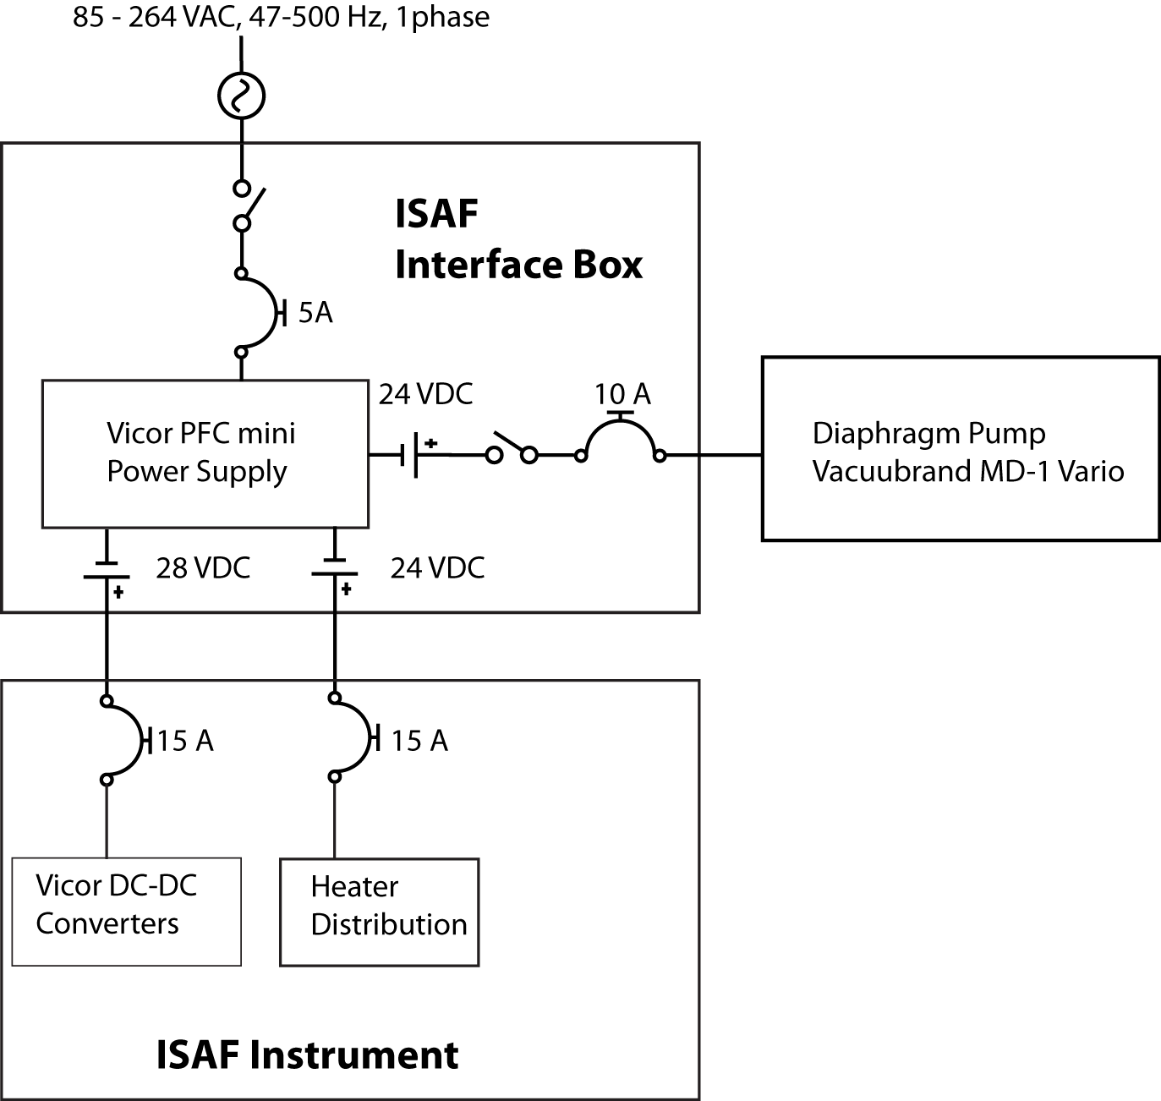

ISAF Heater Circuits Summary

The ISAF instrument has 5 heater circuits. Three of the circuits use the Minco CT325 temperature controller. These circuits are also equipped with bimetallic thermostats mounted on the heated part. These three heater circuits share the same 3A fuse. All heater circuits are powered with 28V.

- Detection cell. This is located inside the ISAF enclosure. Two 48W cartridge heaters (Sun electric H087-35-24-01) are wired in series to reduce the power to 24W. The cartridge heaters are mounted inside an aluminum block used to transfer heat to the detection cell. The bimetallic safety thermostat (Honeywell 3100U -31440) is mounted on the same block. The Minco controller controls the temperature at 35°C.
- Reference cell. This is located inside the ISAF enclosure. Two 48W cartridge heaters (Sun electric H087-35-24-01) are wired in series to reduce the power to 24W. The cartridge heaters are mounted inside an aluminum block used to transfer heat to the detection cell. The bimetallic safety thermostat (Honeywell 3100U -31440) is mounted on the same block. The Minco controller controls the temperature at 35°C.
- Pressure Controller. This is located inside the ISAF enclosure. One 10 W polyimide foil heater (Omega KHLV-102-P) is mounted on the stainless steel base of the pressure controller. The bimetallic safety thermostat (Honeywell 3100U -31440) is mounted on the same base. The Minco controller controls the temperature at 35°C.

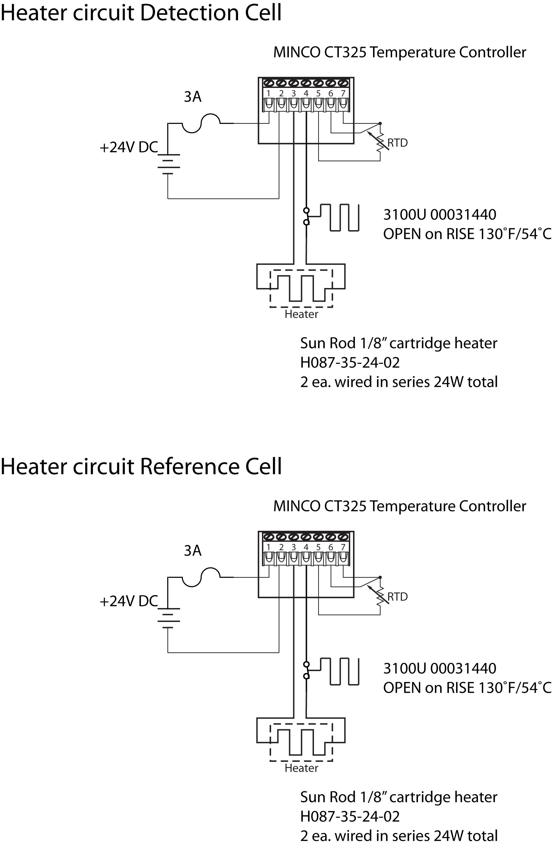

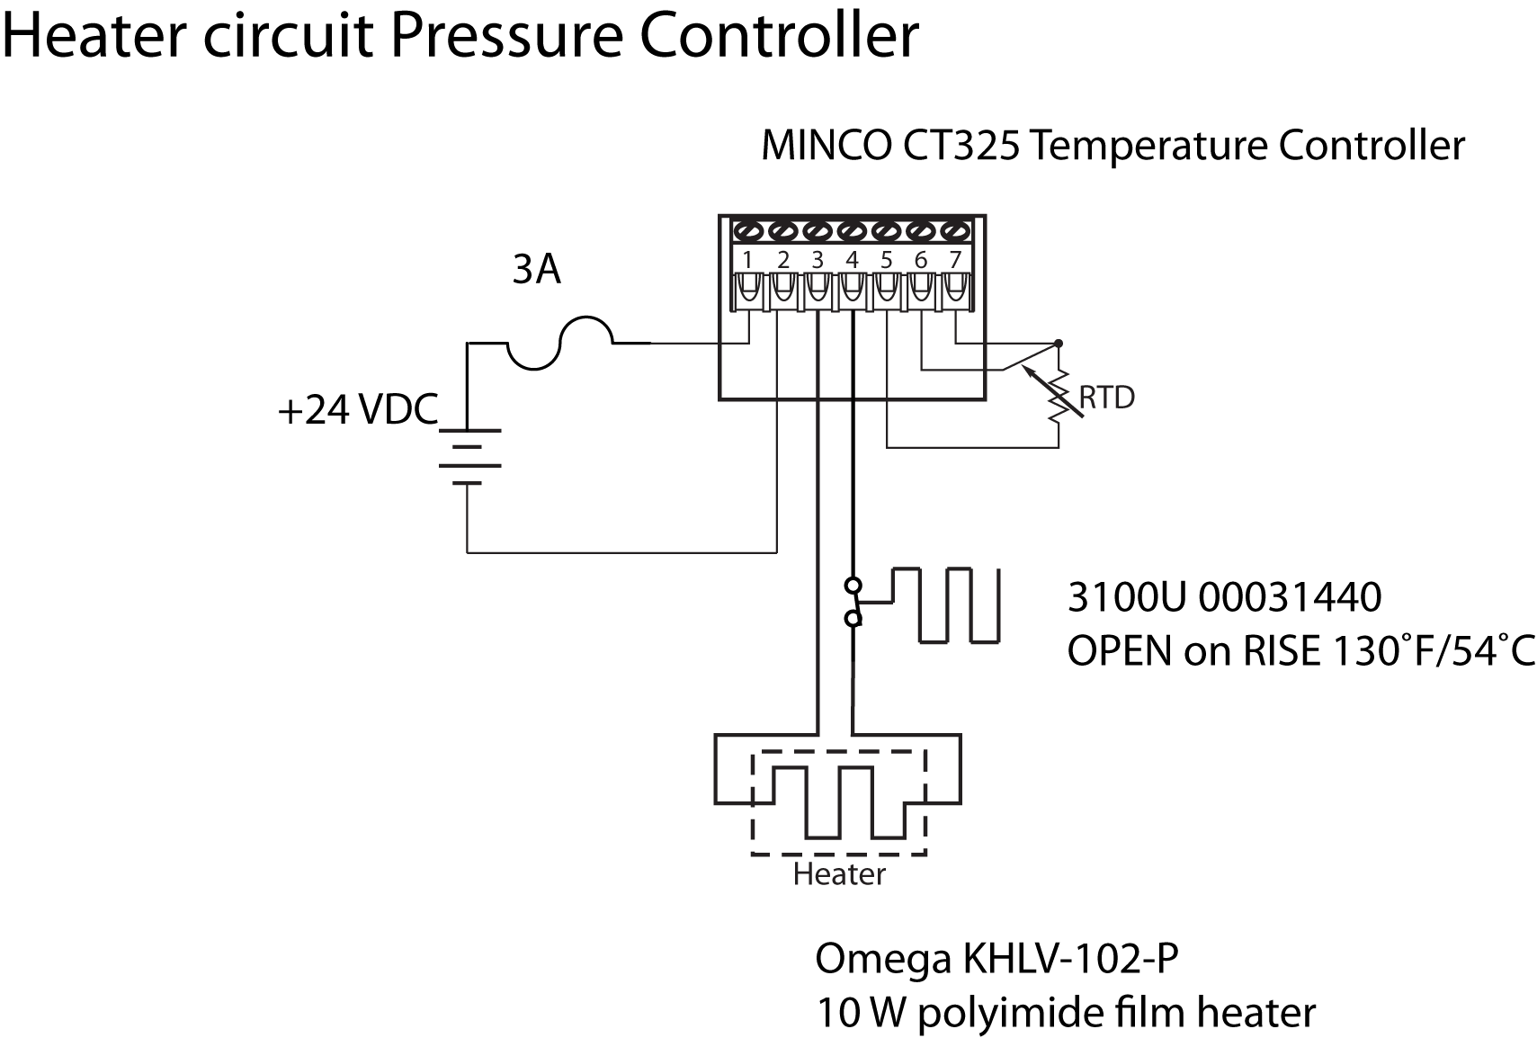

APPENDIX B: PROCEDURES FOR LASER USE

The In Situ Airborne Formaldehyde (ISAF) instrument detects formaldehyde using laser induced fluorescence (LIF). The LIF technique uses a tunable, pulsed laser to excite a small volume of flowing gas inside a sample cell. The laser that we use in this instrument is the NovaWave TFL series tunable fiber laser. The laser and power supply are shown in Figure 1. The laser is pulsed (AO Q-switch) and tunable (DFB seed laser). The laser output is 353 nm, pulsewidth 25 ns, repetition rate 300 kHz, pulse energy 50 nJ/pulse. The beam characteristics are single mode with a divergence < 1 mRad in a 1 mm² circular beam. This laser is Class IIIb.

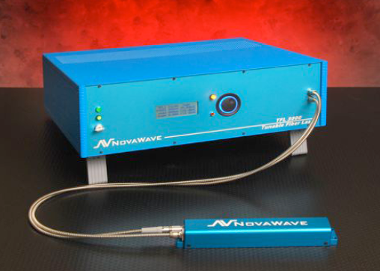
Figure 1. The Novawave TFL 300 fiber laser. The laser is integrated into the ISAF instrument. The laser can be turned on only with the full instrument operation. The laser can be turned off with the interactive instrument software or a hardware switch mounted externally on the instrument chassis.

Figure 2 shows the conceptual layout of the experiment. In this experiment the laser light is directed to a small cell that contains the sample gas. Turning mirrors are used to direct the beam into the cell. The beam exits the cell and is split with a 0.95/0.05 beamsplitter. The smaller fraction (0.05) terminates in a power detector. The larger fraction (0.95) is directed to a reference cell and terminated in a power detector. The total laser beam path (from the exit aperture of the laser to the power detector) is less than a meter.

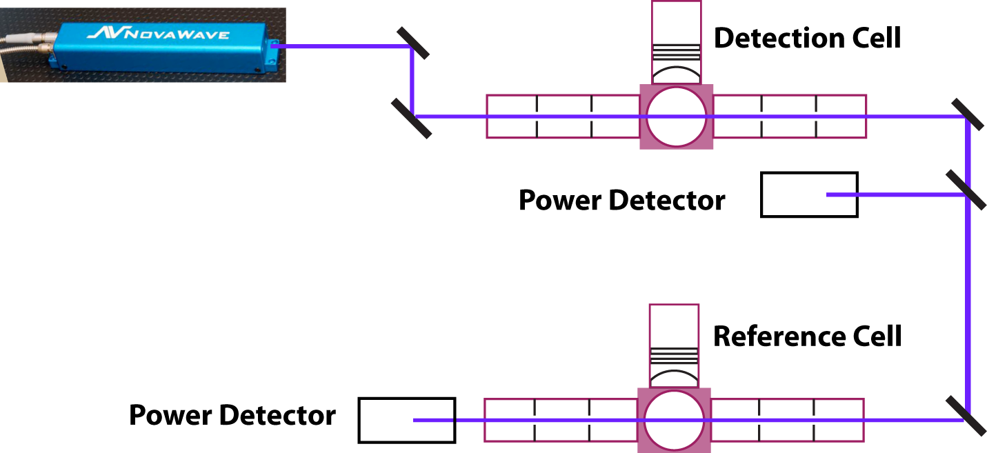
Figure 2. Experimental layout. The laser is directed into the detection cell with turning mirrors. The laser beam terminated in a power detector. The entire optical system is mounted on an optical table. The laser beam does not leave the optical table. The instrument is fully enclosed during normal operation.

Figure 3 shows the front and rear views of the instrument, in this case mounted in the rack for operation on the DC-8.

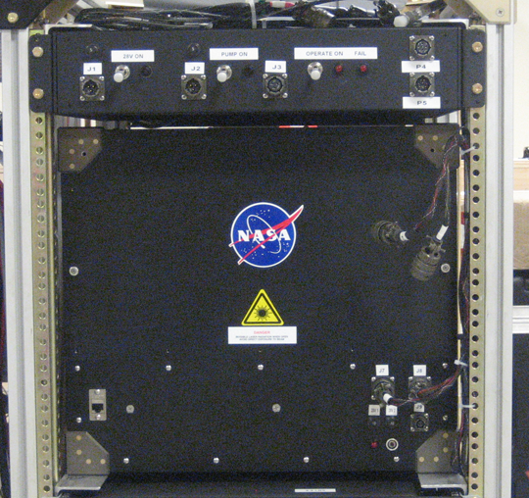 | 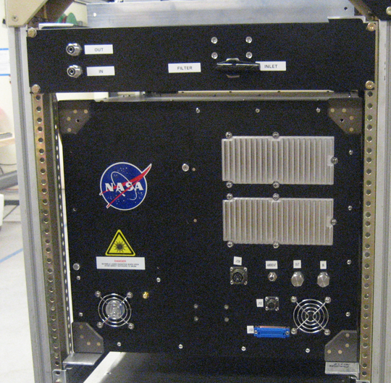
Figure 3. The front (left) and back (right) of the ISAF instrument. In normal operation the instrument is fully enclosed. Laser warning labels are placed on access panels. A “laser ON” warning light and a laser shutdown switch are mounted on the front of the instrument.

Step-By-Step Laser Maintenance Procedures

During normal operation the laser beam is fully enclosed and not a hazard. However, if the laser or some other component of the instrument fails, it might be necessary to operate the laser with the access panels removed. In this event the maintenance may occur on the aircraft or in the lab. We use the following operational procedures to ensure safe operation while operating the instrument with the access panels removed.

- Mount temporary laser barriers (curtains and beam blocks).

- Hang the laser safety warning sign.

- Issue the appropriate laser safety goggles.

- Verify that all personnel in the lab or immediate area are wearing laser safety goggles.

- Warn all personnel in the room and/or immediate area that laser operation is about to begin.

- Verify that the laser optical layout is safe.
  - Verify that beam blocks and barriers are in place.
  - Verify that no foreign objects obstruct the beam path.

- Begin laser operation.

- At the completion of the laser task:
  - Turn off the laser and issue a verbal all clear.
  - Return laser safety goggles and laser operation key to the storage location
  - Turn off the laser warning light.

Control Methods

- Warning signs:
  - Permanent laser warning signs are mounted on the instrument.
  - Additional signs will be mounted during laser alignment.
- Access:
  - The door to the lab is closed during laser operation.
  - The laser is equipped with a hardware shutoff switch.
  - Temporary barriers that fully enclose the laser beam path will be mounted on the instrument.

