In-Situ Measurements of Aerosol Optical Properties for SENEX

Daniel Lack* (PI), Charles Brock (Co-I), Justin Langridge* (Co-I), and Nick Wagner*(Co-I)
NOAA Earth System Research Laboratory, Boulder, CO
* also with: Cooperative Institute for Research in Environmental Science
University of Colorado, Boulder, CO

The NOAA ESRL cloud and aerosol processes group will operate an aerosol optical properties (AOP) instrument package on the NOAA P3 during the SENEX mission. The AOP package provides multi-wavelength, multi-RH aerosol extinction and absorption measurements with fast response and excellent accuracy and stability on aircraft platforms. The instruments will also characterize the optics of black carbon (BC) mixing state, brown carbon, and water uptake of aerosol.

Two instruments, a cavity ringdown (CRD) aerosol extinction spectrometer and a photoacoustic absorption spectrometer (PAS) comprise the AOP package. The CRD instrument (Langridge et al., 2011) is composed of 8 separate ringdown cells (Fig. 1). A laser light pulse propagates between two highly reflective mirrors in each cell, and the light leaking from a mirror is monitored with a photosensor. The time constant of the decay of the signal strength is proportional to the extinction due to scattering and absorption by gases and particles within the cell. The CRD measures dry (<10% RH) extinction at 405, 532, and 662 nm wavelength. A dedicated cell samples filtered, particle-free air to correct for gas-phase interferences at 405 nm. Two additional 532 nm cells measure extinction at two elevated RH values between 60% and 95%, while two 405 nm and 532 nm cells sample air heated to 250ºC in a thermodenuder to volatilize condensed coatings . The CRD has a 1 Hz sensitivity of 0.1 Mm⁻¹, and accuracy of <2%, and a precision of ~10% for extinctions in the range of 10-100 Mm⁻¹. The precision improves to ~1% with sample averaging to 60 s.

The PAS instrument (Lack et al., 2011) is composed of 5 separate multi-pass optical cells. A continuous-wave laser is intensity-modulated at the acoustic resonance frequency of each cell. Light-absorbing particles heat the air, producing acoustic pulses that are detected with a sensitive microphone. A companion chamber is used to detect and remove background acoustic noise from each cell. Because the resonance frequency varies with pressure and temperature, a speaker is used to actively determine the resonance frequency and tune the laser modulation to match. The PAS measures dry absorption from the same sample stream as the CRD, using 405, 532, and 660 nm wavelengths. One PAS channel samples air from the 250ºC thermodenuder and measures residual light absorption at 405 nm. This channel allows the quantification of the contribution of the "lensing" effect of clear coatings and of absorbing brown carbon to the total light absorption. A second, 532 nm channel will measure either a humidified sample (matched to a CRD elevated-RH channel) to evaluate the impact of water coatings on light absorption, or a thermodenuded sample to further constrain lensing and brown carbon effects. Accuracy of the PAS is ~10% and sensitivity is ~1 Mm⁻¹ for 1 Hz sampling.

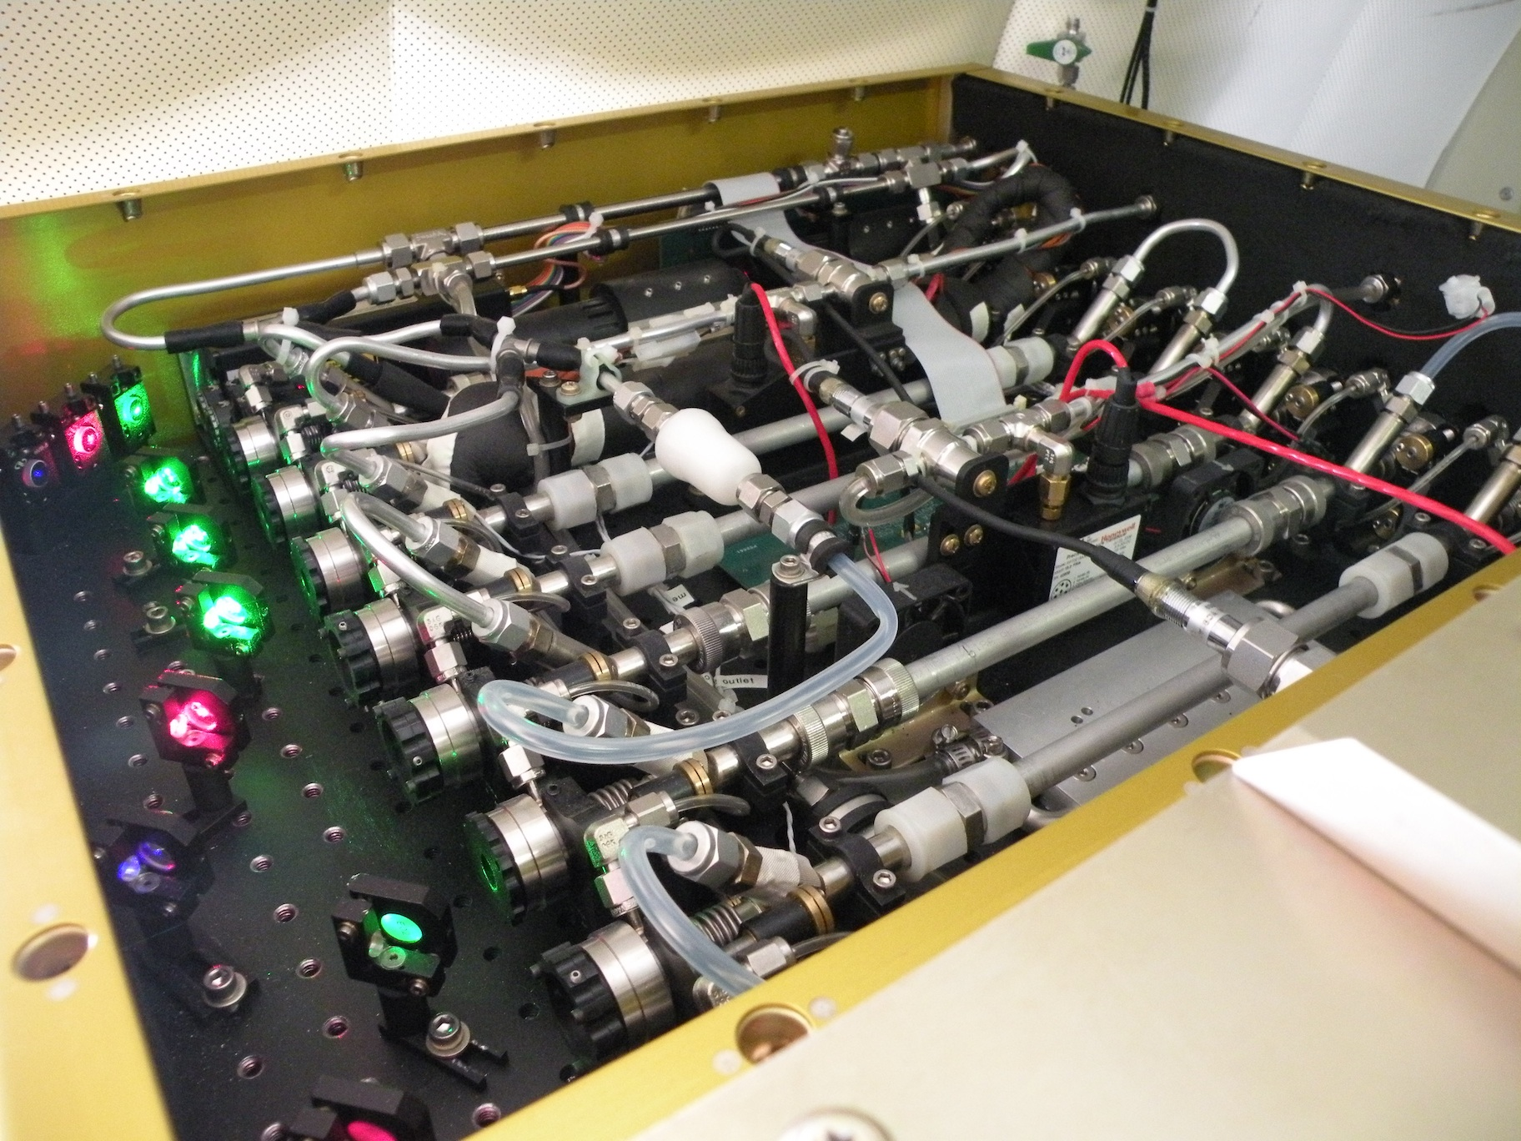
The combined AOP instrument package measures the aerosol properties necessary for calculations of radiative forcing and atmospheric heating rates. Further, the measured parameters can be directly compared to those derived from remote sensing measurements from satellite, airborne, and ground-based sensors. Additional measurements, such as the change in aerosol absorption and extinction as condensed coatings are thermally evaporated from absorbing cores, will improve mechanistic understanding of the role of clear and brown carbon coatings in controlling aerosol optical properties, and the sources and evolution of these coatings in the atmosphere. Finally, the absorption of the refractory cores can be compared to the BC mass measurements expected to be on the SENEX payload, allowing a direct linkage between atmospheric loadings of BC and radiative effects and helping constrain simulations of aerosol impacts on climate.

References
Daniel A. Lack, Mathews S. Richardson, Daniel Law, Justin M. Langridge, Christopher D. Cappa, Richard J. McLaughlin & Daniel M. Murphy (2012): Aircraft Instrument for Comprehensive Characterization of Aerosol Optical Properties, Part 2: Black and Brown Carbon Absorption and Absorption Enhancement Measured with Photo Acoustic Spectroscopy, Aerosol Science and Technology, 46:5, 555-568 (2012)
http://dx.doi.org/10.1080/02786826.2011.645955

Langridge, J. M., Richardson, M. S., Lack, D. A., Law, D. C., and Murphy, D. M.: Aircraft Instrument for Comprehensive Characterization of Aerosol Optical Properties, Part I: Wavelength-Dependent Optical Extinction and Its Relative Humidity Dependence Measured Using Cavity Ringdown Spectroscopy, Aerosol Science and Technology, 45:11, 1305-1318, (2011)
http://dx.doi.org/10.1080/02786826.2011.592745

