Measurements of Volatile Organic Compounds (VOCs) via the
Improved Whole Air Sampler with Immediate Analysis System (iWAS2)
during SENEX 2013

Principal Investigators:
Jessica B. Gilman Jessica.Gilman@noaa.gov CIRES and NOAA Chemical Sciences Division
Brian M. Lerner Brian.Lerner@noaa.gov CIRES and NOAA Chemical Sciences Division

iWAS2 consists of 3 independent systems
1. Onboard in-situ sample collection via whole air sample (WAS) canisters located in AMPS pod on WP-3D.  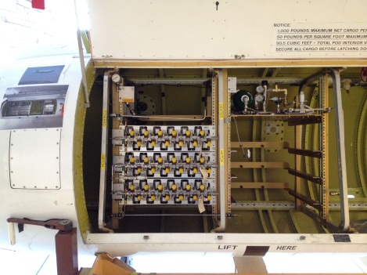 | 2. Immediate in-field analysis of WAS canisters via GC-MS  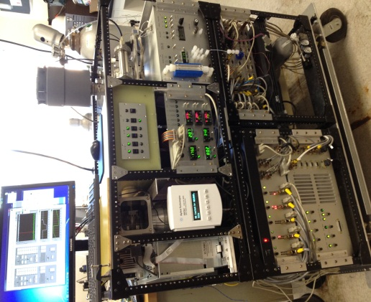 | 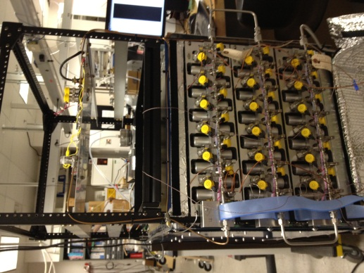  3. In-field cleaning and conditioning of canisters to prep for sample collection.

The iWAS2 is designed to speciate and quantify a variety of VOCs including alkanes, alkenes, biogenic VOCs (BVOCs), oxygenated VOCs (OVOCs), and VOCs containing nitrogen, and halogens (see Table 1 for an example list of species). This instrument provides chemically detailed and highly sensitive measurements with detection limits in the 1-20 pptv range depending on the VOC. Each VOC is identified by its chromatographic retention time and electron-impact mass fragmentation pattern and will be individually calibrated for using commercial and custom-made calibration standards.

Each ambient air sample is collected aboard the NOAA WP-3D aircraft in 1.3 L electro-polished stainless steel canisters that are pressurized to ~40 psi by a stainless steel bellows compressor during sample acquisition. Total sample acquisition time is <10 seconds and dependent upon aircraft altitude. The canister design, collection and conditioning protocols have been adopted from the NCAR AWAS system [Blake et al. (1994)].

Each canister is immediately analyzed post-flight in the field via gas chromatography-mass spectrometry (GC-MS). The custom-built GC-MS consists of two channels optimized for “light VOCs” (channel 1) and “heavier VOCs” (channel 2) with a single quadrupole mass spectrometer detector run in selective ion mode for increased signal-to-noise [Gilman et al. (2010)]. Two 240 sccm samples are simultaneously collected from each canister. There is enough sample volume in each canister for replicate analysis if necessary; however, most canisters will only be analyzed once.
VOCs are pre-concentrated via cryogenic trapping at temperatures between -165 and -145°C for channels 1 and 2, respectively. Prior to cryo-trapping, H₂O is removed from the sample stream via a cold trap (-45 and -35°C, respectively), and CO₂ is removed from the channel 1 sample via an ascarite scrubber. The samples are analyzed sequentially. The channel 1 sample trap is rapidly heated from -165 to 35°C, injecting the sample onto an Al₂O₃-KCl PLOT column. The column effluent goes through a 4-port valve at the inlet to the mass spectrometer. After channel 1 analysis is complete, channel 2 sample trap is then rapidly heated from -145 to 35°C, injecting the sample on a DB-624 column and the 4-port valve is re-positioned so that the effluent from channel 2 is directed to the mass spectrometer while channel 1 is vented. The entire sample pre-concentration (4 min) and analysis (16 min) is automatically repeated for subsequent canisters. Each canister requires a minimum of 20 minutes for analysis. All 72 canisters collected per flight will be analyzed within 24-36 hours post-flight. Preliminary field data from the canisters should be available within 48-72 hours post-flight.

After the canisters have been analyzed, they must be prepared and conditioned for reuse. Each canister is evacuated and checked for leaks. The canisters are then heated to 75°C under vacuum, then filled with high purity nitrogen and re-evacuated. The nitrogen flush process is repeated a minimum of 3 times. Humidified air may also be added during the final flushing process if necessary. A full set of 72 canisters will require up to 12 hours of cleaning and conditioning before they are ready to re-use.

Table 1. Compound classes and select VOCs to be measured from the iWAS2 during SENEX 2013. A total of 40-60 VOCs will be analyzed for each canister sample. Hydrocarbons and biogenic VOCs are priority compounds for analysis. Alkyl nitrates and oxygenated VOCs will be analyzed and reported but with higher uncertainty until sampling artifacts are accounted for and calibrations are finalized post-SENEX.

C2-C10 Alkanes: ethane, propane, iso-butane, n-butane, iso-pentane, n-pentane, hexane, decane, etc.
C2-C5 Alkenes: ethyne, ethene, propene, butenes, pentenes, etc.
Biogenic VOCs: isoprene, methyl vinyl ketone, methacrolein, and speciated monoterpenes
Aromatic VOCs: benzene, toluene, ethyl benzene, xylenes (ortho and sum of meta and para), speciated C9- aromatics such as the trimethyl benzenes

Oxygenated VOCs: methanol, ethanol, propanal, acetone, 2-butanone
Nitrogen VOCs: acetonitrile, alkyl nitrates
Halogen VOCs: CCl₄, CF₂Cl₂, methyl chloride, methylene chloride, etc.

References:

Gilman, J. B.; Burkhart, J. F.; Lerner, B. M.; Williams, E. J.; Kuster, W. C.; Goldan, P. D.; Murphy, P. C.; Warneke, C.; Fowler, C.; Montzka, S. A.; Miller, B. R.; Miller, L.; Oltmans, S. J.; Ryerson, T. B.; Cooper, O. R.; Stohl, A.; de Gouw, J. A., Ozone variability and halogen oxidation within the Arctic and sub-Arctic springtime boundary layer. Atmospheric Chemistry and Physics 2010, 10 (21), 10223-10236.

D. R. Blake, T. W. Smith, Jr., T.-Y. Chen, W. J. Whipple, and F. S. Rowland, Effects of biomass burning on summertime nonmethane hydrocarbon concentrations in the Canadian wetlands, Journal of Geophysical Research 1994 (99), 1699-1719.

