Measurement of Nighttime Nitrogen Oxides and Ozone by Cavity Ring Down Spectroscopy during SENEX 2013
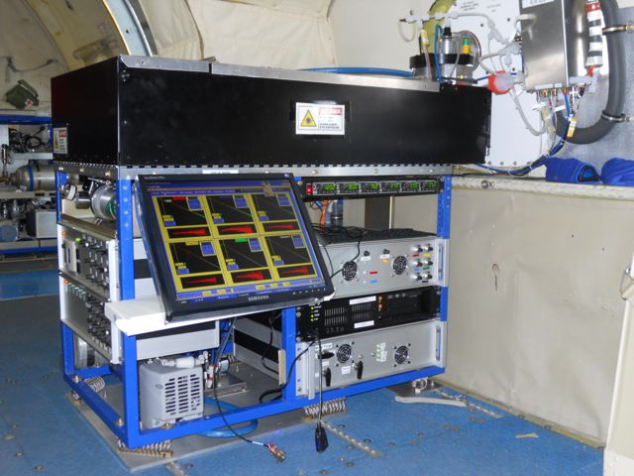

Principal Investigator: Peter M. Edwards
NOAA ESRL Chemical Sciences Division
Peter.m.edwards@noaa.gov

Co-investigator: William P. Dubé
NOAA ESRL Chemical Sciences Division
William.p.dube@noaa.gov

Co-investigator: Steven S. Brown
NOAA ESRL Chemical Sciences Division
Steven.s.brown@noaa.gov
Figure 1. Nitrogen oxide CRDS instrument during CalNex 2010

Nitrogen oxides play important roles in numerous atmospheric chemical cycles. Daytime chemical cycling of NO and NO₂ is the mechanism for tropospheric ozone production, while nighttime chemistry of NO₃ and N₂O₅ is important to nitrogen oxide and ozone budgets, biogenic VOC oxidation, aerosol formation, and halogen activation. Cavity ring-down spectroscopy (CRDS) is a high sensitivity optical technique for the measurement of trace gas concentration applicable to the measurement of nitrogen oxides. The NOAA CRDS instrument for nitrogen oxides and ozone is based on two visible diode lasers at 662 nm (for detection of NO₃) and 405 nm (for detection of NO₂) [Wagner et al., 2011]. Inlet conversions allow the measurement of additional species. Figure 2 shows a schematic of the instrument.

Figure 2. Schematic of the nitrogen oxide CRDS instrument

One 662 nm channel provides a direct measurement of NO₃, while a second 662 nm channel with a heated inlet provides a measurement of the sum of NO₃ and N₂O₅ via thermal dissociation of N₂O₅ to NO₃. Both channels are zeroed by addition of NO to the inlet, which reacts rapidly with NO₃, but not with other species that absorb 662 nm light, such as ambient NO₂, O₃ or water vapor.[Dubé et al., 2006]

NO₃ + NO → 2NO₂ (1)

The NO₂ produced in this reaction has an absorption cross section nearly 10⁴ times smaller than NO₃ and does not interfere with the NO₃ measurement.

There are three channels at 405 nm. The first detects NO₂ directly by total optical extinction at this wavelength, which is specific to NO₂. The second channel has an addition of excess O₃ to convert NO to NO₂ to measure total NO_{x} (=NO + NO₂) via reaction (2) [Fuchs et al., 2009].

NO + O₃ → NO₂ + O₂ (2)

A third 405 nm channel has an addition of excess NO to quantitatively convert O₃ to NO₂ to measure total O_{x} (=O₃ + NO₂), also via reaction (2) [Washenfelder et al., 2011]. Differencing between the NO_{x}, O_{x} channels and the NO₂ channel provides measurement of NO and O₃, respectively. The zero for the 405 nm channel consists of addition of scrubbed air to the inlet. All channels operate at a repetition rate of 4 Hz, with 1 Hz measurement precision (2σ) of < 3 pptv for NO₃ and N₂O₅, < 100 pptv for NO₂ and < 150 pptv for NO and O₃.

The CRDS operation during SENEX will be similar to that of the CalNex 2010 campaign, although with several design improvements for ease of calibration and instrument automation.

References

Dubé, W. P., S. S. Brown, H. D. Osthoff, M. R. Nunley, S. J. Ciciora, M. W. Paris, R. J. McLaughlin, and A. R. Ravishankara (2006), Aircraft instrument for simultaneous, in-situ measurements of NO₃ and N₂O₅ via cavity ring-down spectroscopy, Rev. Sci. Instr., 77, 034101.
Fuchs, H., W. P. Dubé, B. M. Lerner, N. L. Wagner, E. J. Williams, and S. S. Brown (2009), A sensitive and versatile detector for atmospheric NO₂ and NO_{x} basd on blue diode laser cavity ring-down spectroscopy, Environ. Sci. Technol., 43, 7831-7836.
Wagner, N. L., W. P. Dubé, R. A. Washenfelder, C. J. Young, I. B. Pollack, T. B. Ryerson, and S. S. Brown (2011), Diode laser-based cavity ring-down instrument for NO₃, N₂O₅, NO, NO₂ and O₃ from aircraft, Atmos. Meas. Tech., 4, 1227-1240.
Washenfelder, R. A., W. P. Dubé, N. L. Wagner, and S. S. Brown (2011), Measurement of atmospheric ozone by cavity ring-down spectroscopy, Environ. Sci. Technol., 45, 2938-2944.

