Ammonia (NH₃)
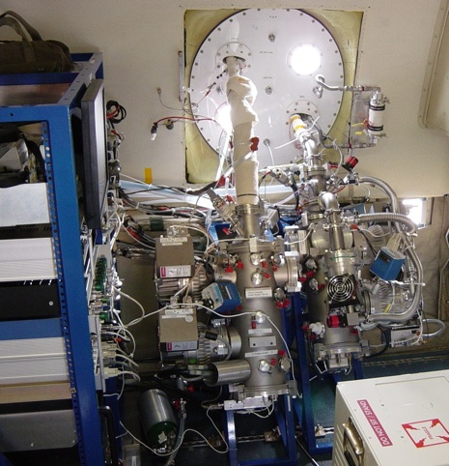

Principal Investigator:
John Nowak:
NOAA ESRL Chemical Sciences Division
John.Nowak@noaa.gov

Principle of the Measurement
Chemical Ionization Mass Spectrometry (CIMS) using protonated acetone dimer ((C₃H₆O)H⁺(C₃H₆O)) ion chemistry

Species Measured
Ammonia

Time Response
1 Second

Detection Limit
Precision on 1s data: 35 - 80 pptv (1 sigma) depending on field project

Accuracy
±(25% + 70 - 125 pptv) depending on field project

Manufacturer
custom built
Field Projects
ANARChE 2002 (non-NOAA project)
ICARTT 2004
TexAQS 2006
2008 ARCPAC (used to measure nitric acid, sulfur dioxide, and halogens with SF6- ion chemistry)
CalNex 2010

Key Publications
Nowak, J. B., J. A. Neuman, R. Bahreini, A. M. Middlebrook, J. S. Holloway, S. A. McKeen, D. D. Parrish, T. B. Ryerson, and M. Trainer, Ammonia sources in the California South Coast Air Basin and their impact on ammonium nitrate formation, Geophys. Res. Lett., 39, L07804, doi:10.1029/2012GL051197, 2012.
Neuman, J. A., T. B. Ryerson, L. G. Huey, R. Jakoubek, J. B. Nowak, C. Simons, and F. C. Fehsenfeld, Calibration and evaluation of nitric acid and ammonia permeation tubes by UV optical absorption, Environ. Sci. Technol., 37, 1975-2981, doi:10.1021/ES06422L, 2003.
Nowak, J. B., et al, Analysis of urban gas phase ammonia measurements from the 2002 Atlanta Aerosol Nucleation and Real-Time Characterization Experiment (ANARChE), J. Geophys. Res., 111, D17308, doi:10.1029/2006JD007113, 2006.
Nowak, J. B., J. A. Neuman, K. Kozai, L. G. Huey, D. J. Tanner, J. S. Holloway, T. B. Ryerson, G. J. Frost, S. A. McKeen, and F. C. Fehsenfeld, A chemical ionization mass spectrometry technique for airborne measurements of ammonia, J. Geophys. Res., 112, D10S02, doi:10.1029/2006JD007589, 2007.
Nowak, J. B., J. A. Neuman, R. Bahreini, C. A. Brock, A. M. Middlebrook, A. G. Wollny, J. S. Holloway, J. Peischl, T. B. Ryerson, and F. C. Fehsenfeld, Airborne observations of ammonia and ammonium nitrate formation over Houston, Texas, J. Geophys. Res., 115, D22304, doi:10.1029/2010JD014195, 2010.

